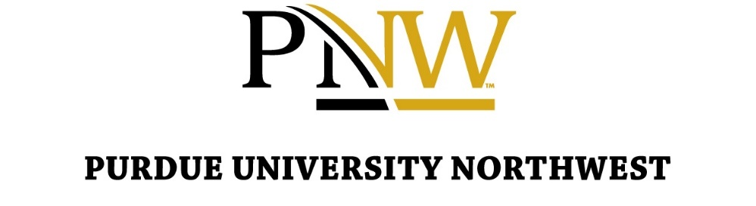
In June 2021, the Purdue University Board of Trustees adopted a civics literacy graduation requirement for undergraduates, including all transfer students. This requirement applies to all undergraduate students who enter Purdue University Northwest in Fall 2022 or any subsequent semester.
The campus community is encouraged to submit their events with a focus on civics to the Civics Literacy Proficiency page. To be listed as a Civics Literacy Proficiency event, the event must be designed to address one or more of these:
- Increase understanding of important contemporary political issues
- Grow student engagement in American politics
- Expand awareness of processes and options for civic participation
- Increase civics knowledge
Please complete this form to submit your upcoming campus event as a potential Civics Literacy Proficiency event. If you have any questions, please contact pnwcivics@pnw.edu.
Link to Event Submission Form: https://purdue.ca1.qualtrics.com/jfe/form/SV_2uwFKNqmni8XVS6
Your Name
Your Email
Event Title
Host Department/Unit
Event Short Description
Event Date (MM/DD/YYYY)
Event Time
Event Location
Event Format
If proposing a virtual or hybrid event, please provide meeting access information for virtual participants (i.e., meeting link, meeting ID, passcode, etc.).
In the spaces below, please describe how your event will fulfill one or more of the requirements to be considered for the Civics Literacy Proficiency.
- Please describe how your event will increase Purdue Northwest students' understanding of important contemporary political issues.
- Please describe how your event will contribute to growth in student engagement in American politics.
- Please describe how your event will expand Purdue Northwest students' awareness of and options for civic participation.
- Please describe how your event will increase Purdue Northwest students' civics knowledge.

