
ACADEMIC PROGRAM REVIEW
INSTRUCTIONS

OFFICE OF ACADEMIC AFFAIRS
Effective Spring 2020
Revised Spring 2026
Revised Fall 2026 to Include State 7 yr Program Review Draft
TABLE OF CONTENTS
Section Page
Introduction and Purpose 3
Academic Program Peer Review Corps (APPRC) 5
Appointments /Membership 5
Roles & Duties 5
Master Calendar 6
APR Timeline and Deadlines 10
Academic program Self-Study 11
Guidelines for Self-Study Completion 11
Program Details for 7 YR ICHE Executive Summary Template 12
Self-Study Template 15
Presentation Guidelines 21
Appendices 22
Full CV Template 23
Standardized Data Set Examples 25
External Review 31
APPRC Scoring Rubric 35
Sample Final Report/Letter Template 38
Addendum 40

Purdue University Northwest Academic Program Review
Introduction and Purpose
Purdue University Northwest's Academic Program Review (APR) is intended to be a collaborative process involving each department and/or school, college, the Academic Program Peer Review Corps (APPRC), and the Vice Chancellor for Academic Affairs and Provost. It is designed to be a reflective and analytical process that will lead to program improvement, and its results can be used as input into a variety of strategic and programmatic decisions.
The PNW Academic Program Review self-study also serves as the vehicle for completing the Indiana Commission for Higher Education's (ICHE) 7-Year Institutional Degree Program Review. Departments complete a single self-study while the Office of Academic Affairs is responsible for extracting and submitting the required ICHE Summary
The APR's purpose is:
To promote the faculty-driven, continuous quality improvement of academic programs and the larger University through a process that is responsive to the mission, focused, collegial, data-informed, contextual, and adaptive, and that results in a plan of action.
Each component of the statement of purpose is clarified below:
(1) Faculty-driven: The faculty is responsible for curriculum; therefore, APR is a faculty responsibility. The AAPRC is composed of faculty from all colleges and is charged to oversee the process of Academic Program Review across the University.
(2) Continuous quality improvement: The improvement of overall academic quality is an ongoing objective. The intent of APR is to support each program in developing and maintaining its own continuous system of academic program review. Within such a system, periodic academic program review serves as an opportunity for a global consideration of the program.
(3) Individual academic programs and the larger University: Quality is systemic. While APR originates at the individual program level, the analysis expands to incorporate activities and support services at the department or school, college, and university levels.
(4) Responsive to the mission: The review of a particular program aims to situate it in the context of Purdue University Northwest's unique mission and values statements and its strategic plan. In so doing, APR seeks to enhance learning within a particular unit and across units, and to further the evolution of a university culture characterized by ongoing institutional self-analysis leading to continually improved practices.
(5) Focused: To be efficient, APR's are conducted within a clearly limited time frame. Thus, each unit is asked to identify important issues during the APR planning stage, investigate them along with those required by the process, and report accordingly. The aim is meaningful reflection in areas identified by the program's faculty.
(6) Collegial: The APR process seeks to support and sustain conversations among various university constituents that lead to the identification and analysis of a particular program's strengths and areas for improvement. The inclusion of multiple diverse perspectives is intended to help programs share their strengths as well as facilitate improved university-wide understanding of the varied disciplinary and professional languages and norms that compose the University. In addition, the self-study stimulates a culture of continuous reflection, internal research, and collegial accountability that is both program-based and university-wide.
(7) Data-informed: The APR process seeks to facilitate the development of plans of action supported by analyzed data. In so doing, APR seeks to support internal research and, through its ongoing activity, continually refine the University's academic information systems to support decision-making at the program, department or school, college, and university levels.
(8) Contextual: AAPRC's review encourages a cross-discipline/cross-profession dialogue and accountability for the University's curricular programs as a whole. The APR process combines the strengths of internal review, best understood within the context of Purdue University Northwest's mission and array of programs, with external discipline-specific review, ensuring that academic programs represent current practice within the discipline.
(9) Adaptive: The APR process is dynamic, reflective, and evolving. While the overall purpose of continuous improvement is paramount, specific features of the process may be modified as needed for any individual program to ensure the purpose is met. Ongoing assessment of the process will result in modifications as indicated by results.
(10) Plan of Action: The outcome of the APR process is the identification of sound initiatives for improving quality that are supported by both data and broad-based understanding of a wide array of PNW stakeholders (e.g., students, faculty, residents of northwest Indiana, etc.).

Deliverables

From each program: A completed program review self-study including quantitative and qualitative analysis of the program consistent with the PNW APR guidelines as described in the following pages.
From the AAPRC: A thorough review of the program self-study which results in a final report that situates the program within the larger structure of the University in a way that both highlights actual and potential connections between the program and other units or university stakeholders and suggests opportunities for growth.
From the APR process: A set of initiatives for improvement agreed upon by the program, the department or school, the college, and the University. An official plan of action outlines agreed-upon courses of action that the program will take over the next several years to support improved academic quality. It also identifies resource support priorities for academic improvement.
Indiana CHE 7-Year Review: An official plan of action also satisfies ICHE's requirement for a Progressive Program Improvement determination (program enhancement, maintenance, reduction in scope, consolidation, or suspension/teach-out) and a set of three planned strategic improvements with success indicators and completion dates.

Purdue University Northwest Academic Program Review
Academic Program Peer Review Corps (APPRC)
The Purdue Northwest APR is faculty-driven as noted above; the faculty is responsible for curriculum; therefore, APR is a faculty responsibility.
The Academic Program Peer Review Corps (APPRC) is composed of faculty from all colleges and is charged to oversee the process of Academic Program Review across the University. The APR Review Committee is drawn from this body.
The APPRC is constituted as follows:
- The APPRC is comprised of eleven (11) faculty members, with two representatives from each of the five PNW academic Colleges and one from the Faculty Senate, with "faculty" being defined as full-time, benefits-eligible, and current voting members of the instructional staff.
- Representatives will be selected by the end of the Spring semester, with terms beginning the following Fall.
- The members from each college will be decided by a College-level nomination process and college-wide vote. The single Faculty Senate member should be nominated and voted on by the Faculty Senate.
- No APPRC member will participate in the review of the programs in their home department. Thus, the calendar below should be considered when selecting representatives.
- The term of service will be for two years, with staggered terms so that half of the APPRC membership is replaced each academic year. Any given member may serve more than one successive term.
- Before each Fall term begins, the Associate Vice Chancellor for Academic Affairs will provide orientation and information/guidance on the duties and functions of the APPRC. The AVC will also serve as an ongoing resource, support, and ex-officio member of the body.
The duties and responsibilities of the APPRC include:
- Participating as active members of the PNW Academic Program Review process.
- Serving as members of the Academic Program Review Committee, reviewing program self-studies as submitted and actively participating in reviews each semester.
- Providing feedback to each Program being reviewed, and forwarding recommendations to the Vice Chancellor for Academic Affairs and Provost.
- Acting as a resource for Programs participating in the APR process.

PURDUE UNIVERSITY NORTHWEST ACADEMIC PROGRAM REVIEW MASTER CALENDAR
Revised 5/01/2026
College Department/Program | Review  Semester | Self-Study  Due Dates | Presentation Dates  First Friday  March/October | Feedback Due  First Friday  April/Nov | Provost  Letter  End of Semester | Midcycle  Review  (if needed) | Accreditation  Date/Cycle  External Review
CHESS/SoEC  BS Elementary Education | Spring 2027 | Dec 1, 2026 | March 5, 2027 | April 2, 2027 | May, 2027 | Fall 2029 | CAEP  Spring 2027  7 years
CON/Nursing  BSN Nursing (pre); BSN Nursing (Post); MSN Nursing; DNP  Post-master's Cert in Family Nurse Practice  Post-master's Cert in Adult Gerontology  Post-master's Cert in Nurse Executive | Spring 2027 | Dec 1, 2026 | March 5, 2027 | April 2, 2027 | May, 2027 | Fall 2029 | ACEN  Fall 2027  8 years
CES/Computer and Electrical Engineering  BS Computer Engineering; BS Electrical Engineering; MS Electrical and Computer Engineering | Fall 2027 | May 1, 2027 | Oct 1, 2027 | Nov 5, 2027 | Dec 2027 | Spring 2029 | ABET  Fall 2027  6 years
CES/Civil and Mechanical Engineering  BS Civil Engineering; BS Mechanical Engineering; MS Civil; MS Mechanical | Spring 2028 | Dec 1, 2027 | March 3, 2028 | April 7, 2028 | May 2028 | Fall 2030 | ABET  Fall 2027  6 years
COB/Quantitative Business Studies  BSA Accounting; BSB Finance; BSB Business Analytics; Master of Accountancy  Post-bac Cert in Business Analytics | Fall 2028 | May 1, 2028 | Oct 1, 2028 | Nov 3, 2028 | Dec 2028 | Spring 2030 | AACSB  2028-29  6 years
COB/Managerial Studies & Grad  BSB Management; BSB Marketing; MBA  Certificate in Organizational Leadership and Supervision  Certificate in Human Resources  Certificate in Entrepreneurship and Innovation | Spring 2029 | Dec 1, 2028 | March 2, 2029 | April 6, 2029 | May 2029 | Fall 2031 | AACSB  2028-29  6 years
COB/HTM  BS HTM  Certificate in Hospitality, Certificate in Food Service and Lodging Supervision | Spring 2029 | Dec 1, 2028  External reviewer selected | March 2, 2029 | April 6, 2029 | May 2029 | Fall 2031 | Materials to reviewer 1/12  Review Completed 2/16
CHESS/SoEC  MS/MSEd | Spring 2029 | Dec 1, 2028 | March 2, 2029 | April 6, 2029 | May 2029 | Fall 2031 | CACREP  Spring 2029  8 years
CES/Biological Sciences  BS Biological Sciences; BS Integrative Human Health; MS Biological Sciences  Certificate in Biotechnology | Fall 2029 | May 1, 2029  External reviewer selected | Oct 5, 2029 | Nov 2, 2029 | Dec 2029 | Spring 2031 | Materials to reviewer 8/17  Review Completed 9/14
CHESS/CCA  BA Communication; MA Communication | Spring 2030 | Dec 1, 2029  External reviewer selected | March 1, 2030 | April 5, 2030 | May 2030 | Fall 2032 | Materials to reviewer 1/11  Review Completed 2/15
CHESS/History, Politics, and Economics  BA History & Politics; MA History; BLS | Spring 2030 | Dec 1, 2029 | March 1, 2030 | April 5, 2030 | May 2030 | Fall 2032 | Materials to reviewer 1/11  Review Completed 2/15
CES/Computer Science  BS Computer Science; MS Computer Science | Fall 2030 | May 1, 2030  External reviewer selected | Oct 4, 2030 | Nov 1, 2030 | Dec 2030 | Spring 2032 | Materials to reviewer 8/16  Review visit Completed 9/13
CES/Mathematics and Statistics  BS Applied Mathematics and Statistics | Fall 2030 | May 1, 2030  External reviewer selected | Oct 4, 2030 | Nov 1, 2030 | Dec 2030 | Spring 2032 | Materials to reviewer 8/16  Review visit Completed 9/13
CES/Chemistry and Physics  BS General Physical Sciences | Fall 2030 | May 1, 2030  External reviewer selected | Oct 4, 2030 | Nov 1, 2030 | Dec 2030 | Spring 2032 | Materials to reviewer 8/16  Review visit Completed 9/13
CHESS/BHS  BSW; MSW; CFT; BS Criminal Justice; BA/BS Sociology | Spring 2031 | Dec 1, 2030 | March 7, 2031 | April 4, 2031 | May 2031 | Fall 2033 | CSWE  MSW F 2030 BSW S 2031 8 years  COAMFT S 2031 7 years
COT/CIT  BS CIT; BS Cybersecurity  Post-bacc Cert in Information Systems Post-bacc Cert in Information Systems E-Business | Fall 2031 | May 1, 2031 | Oct 4, 2031 | Nov 1, 2031 | Dec 2031 | Spring 2033 | ABET  Fall 2030  6 years
COT/Graduate  MS AAI; Doctor of Technology | Fall 2031 | May 1, 2031  External reviewer selected | Oct 4, 2031 | Nov 1, 2031 | Dec 2031 | Spring 2033 | Materials to reviewer 8/15  Review visit Completed 9/12
COT/CMET  BS Construction Management Engineering Tech | Spring 2032 | Dec 1, 2031 | March 5, 2032 | April 2, 2032 | May 2032 | Fall 2034 | ABET  Fall 2030  6 years
COT/ET  BS Engineering Tech; BS Mechanical Engineering Tech | Spring 2032 | Dec 1, 2031 | March 5, 2032 | April 2, 2032 | May 2032 | Fall 2034 | ABET  Fall 2030  6 years
COT/Graduate  MS Technology | Spring 2032 | Dec 1, 2031  External reviewer selected | March 5, 2032 | April 2, 2032 | May 2032 | Fall 2034 | Materials to reviewer 1/9  Review visit Completed 2/13
CHESS/English and World Languages  BA English; Certificate in Writing Interactive Media | Fall 2032 | May 1, 2032  External reviewer selected | Oct 1, 2032 | Nov 5, 2032 | Dec 2032 | Spring 2034 | Materials to reviewer 8/13  Review visit Completed 9/10
University College  BS Multidisciplinary Studies | Fall 2032 | May 1, 2032  External reviewer selected | Oct 1, 2032 | Nov 5, 2032 | Dec 2032 | Spring 2034 | Materials to reviewer 8/13  Review visit Completed 9/10
CHESS/Psychology  BS Psychology; MS Psychology; Doctor of Psychology | Fall 2032 | May 1, 2032 | Oct 1, 2032 | Nov 5, 2032 | Dec 2032 |  | APA  TBD  10 years

Purdue University Northwest Academic Program Review
Timeline and Deadlines
FOR ALL REVIEWS (ANNUALLY)
End of Spring semester (May) | Members of the APPRC/Review Committee named for upcoming year
End of Spring semester (May) | IR provides standardized data sets to all programs
Beginning of Fall Semester (August) | Orientation for APPRC

FALL REVIEWS (18-month process beginning in July of the year preceding the review)
July (year 1) | Program notified of upcoming review
December 1 (year 1) | IR provides market analysis data to program
May 1 (year 2) | Self-study due to reviewing team
First Friday in October (year 2) | Program's presentation to reviewing team
First Friday in November (year 2) | Reviewing team provides feedback to program
Third Friday in November (year 2) | Program responses due to reviewing team
December 1 (year 2) | Reviewing team provides final report to the Provost
End of Fall semester (year 2) | Provost's Review

SPRING REVIEWS (18-month process beginning in January of the year preceding the review)
January (year 1) | Program notified of upcoming review
May 1 (year 1) | IR provides market analysis data to program
December 1 (year 1) | Self-study due to reviewing team
First Friday in March (year 2) | Program's presentation to reviewing team
First Friday in April (year 2) | Reviewing team provides feedback to program
Third Friday in April (year 2) | Program responses due to reviewing team
May 1 (year 2) | Reviewing team provides final report to the Provost
End of Spring semester (year 2) | Provost's Review

Purdue University Northwest Academic Program Review
Guidelines for Self-Study Completion
Each academic program will participate in the PNW Academic Program Review (APR) process during its assigned slot in the master calendar (see pages 6-9).
For the purposes of the PNW APR process, a "program" is defined as the degree credential approved for inclusion in the Indiana State Academic Program Inventory (API), e.g., BA/BS, MA/MS (and other named degrees), Doctorates, and Certificates with more than 12 hours. Majors will be treated as separate programs, while concentrations within those degree programs/majors will be addressed in the same self-study/review process.
For ease of scheduling and to reduce repeated departmental effort, the master calendar is arranged by academic department/school, with all programs in those departments participating in the APR process at the same time (e.g., the BA and MA in Communication are reviewed in the same semester, with two separate review processes).
The APR process includes faculty review of assessment of student learning results, analysis of statistical data, the completion of a self-study document, an external review, and an in-person presentation to the APPRC.
The Self-Study Template (see pp. 12-20) includes the elements included in the document, word limits, and the parties responsible for providing the information/data (in the blue and red arrow tabs). Wherever possible, information will be supplied to the departments by the Institutional Research Office (IR) or Academic Affairs. A Microsoft Word template, which will be used for completion of the self-study document, will be provided to each program at the time of its review.
Guidelines for the in-person presentation are included on page 21.

Purdue University Northwest Academic Program Review
Program Details for 7 YR ICHE Executive Summary Template

Program Information
Program
Program Name:
Degree Award Level:
CIP Code and CIP Title:
Academic Unit(s) Offering Program (College, School, Department(s)):

Review Cycle
Name of and link to Programmatic Accreditor (if applicable):
Date of Last Program Review:
Period of Review:
Date of Next Anticipated Program Review:
IR

Degree Program Enrollment and Completions During Review Period
Fiscal Year | Enrollment (Headcount) | Completions
2021
2022
2023
2024
2025

Enrollment Trends
[1-2 sentence explanation of Enrollment Trends]

IR
IR (all entries)
Teaching and Learning

Fiscal Year | 2021 | 2022 | 2023 | 2024 | 2025 | 2021-2025 % Change
Completions
Most recent 3-year average degree completion |  |  | 3-Yr Avg.
Enrollment (Headcount)
On-Time Completion Rate (100%)*
Extended Completion Rate (150%)*
Retention Rate (Persistence)*
Credit hour production
*Pertains to undergraduate degree programs only: Associate and Baccalaureate programs.
Program Writing Your Journal Article in Twelve Weeks: A Guide to Academic Publishing Success a

Optional: Provide additional information to contextualize the above quantitative measures (e.g., explaining completion constraints due to accreditation requirements limiting headcount, program capacity capping enrollments, accredited curriculum requiring longer than typical completion times, good fiscal practice, and workforce needs) (500 Word Maximum)

Alignment
Program
Alignment with Institution Strategic Plan
[1-2 sentences indicating program fit within current institution strategic plan.]
Workforce Alignment
[1-2 sentences indicating service to regional, state, and/or national workforce and societal talent needs.]
Graduate Outcomes
[1-2 sentences indicating the fields where graduates pursue careers and percentage of graduate employed or enrolled in graduate study]

Program Quality & Effectiveness
Teaching & Learning
[2-3 sentences indicating teaching and learning goals of the program, alignment with programmatic accreditation standards where applicable, and assessment methods and outcomes]
Service (Internal/External)
[1-2 sentences indicating internal and external service by students, faculty, and staff in the program's closest academic unit]
Scholarship
[1-2 sentences indicating scholarly and/or creative endeavors by students, faculty, and staff in the program's closest academic unit]
Resource Usage
[1-2 sentences explaining resources that support the program]

Progressive Program Improvement
Program Review Outcome Adjustment:
Strategic Improvement/Adjustments and Goals
[1-2 sentence explaining rationale and goals for adjustment]
Timeline & Responsibility
[1-2 sentences naming each of the planned strategic improvements/adjustments and the party responsible for carrying them out]

*Note: Material from this page must fit onto one page
Purdue University Northwest Academic Program Review
Self-Study Template
Program
PROGRAM DESCRIPTION
Program Overview (500 Word Maximum)
Provide a comprehensive description of the degree program, including a very brief history. The program description should closely align with the overview on the institution's website (mission statement) and include a description of any program majors, concentrations, or tracks
Institutional Rationale: Mission and Strategic Alignment (500 Word Maximum)
Explain how the program harnesses and complements institutional mission, including relationship with other academic units and alignment with the institution's current strategic plan to wisely allocate limited resources to maximum effect. Provide three illustrative examples of strategic mission alignment.

PROGRAM VIABILITY, PRODUCTIVITY, AND QUALITY
Program
In this section, explain and provide data to illustrate how the program demonstrates viability, productivity, and quality across the following three areas with respect to institutional mission: (a) Teaching and Learning, (b) Scholarship, and (c) Service.
Programmatic Curriculum Features (1500 words maximum)
Summarize programmatic elements of teaching and learning distinction and provide data to illustrate, as necessary, the following categories as found by this program review and, if applicable, the most recent program accreditation review:
Summary for each major/concentration): (750 words maximum)
Elements to include:
- Curriculum - design, development, and assessment (Curriculum map)
- Career relevance – advising, coaching, readiness, work-based learning/experiential learning, and industry alignment/input
- Post-graduation student outcomes - Wages and graduate placement (i.e job placement or acceptance post-graduate degree/program)
- Recruitment, retention, and completions (including accelerated, on-time, and extended)
- Resource usage - deployment, optimization, and synergies across programs

Summary of Curriculum Development and Quality for each major/concentration (750 words maximum)
Elements to include:
- Provide evidence that your undergraduate and graduate curricula are current. Use benchmarks such as peer institutions or national disciplinary standards
- Briefly describe plans for program/curriculum development and how they tie to your strategic plan
- Describe outcomes for accelerated delivery (“Degree in 3;” 3+2; 4+1 for master's degrees)
- Describe any stackable credentials
- Describe resources needed to accomplish your planned development
Student Academic Achievement/Program Quality (500 word maximum)
Summarize the quality of each program in terms of student academic achievement. Data can be generated from assessment platform (Watermark Planning and Self-Study or other digital measures). Elements to include (for each major/concentration):
- Brief narrative describing learning outcomes and assessment measures used (results obtained since last APR)
- Assessment reports for graduate and undergraduate programs
- Your current Student Learning Outcome Improvement Plan
- Describe your methods of determining teaching effectiveness

Program Scholarship, Research, Creative Practice Narrative (500 word maximum)
Describe and provide examples of scholarship, research, and/or creative endeavors in the field by students, faculty, and staff involved in the program's closest academic unit as appropriate to the institution's mission.

Program

PROGRAM ENGAGEMENT & EFFECTIVENESS IN SERVICE AND CREATIVE AREAS

Program Service/Engagement Narrative (500 word maximum)
As appropriate to the institution's mission, describe and provide examples of the following service contributions by the program's closest academic unit:
a. Service contributions within the institution, such as general education, service courses, minors, and certificates.
b. External service contributions, such as community engagement and industry collaboration.

Civic Responsibility and Engagement (500 word maximum)
How does the program cultivate civic responsibility and commitment to the core values of American society? For example, how does the curriculum include components that emphasize civic engagement and the duties of citizenship in a free society?

Talent Pipeline Purpose: Workforce and Societal Need (500 word maximum)
Explain how the program has and will continue to responsively serve regional, state, and/or national workforce and societal talent needs. Specify whether the program provides preparation for professional licensure or certification, industry-recognized credential(s), and/or professional school.
a. Explain how the degree program advises students on career exploration and planning. How does the program advise students about labor market need and career pathways?
b. How does the program facilitate direct connections between students and employment opportunities?
c. List any required work experiences, experiential learning components, or integrated course-based career experiences. Specify work/practice/clinical hours or other requirements. Provide evidence of how these opportunities connect students with employment opportunities. If none, explain why there are none.

Program
Faculty Credentials
Faculty

Insert Name and Credentials Here (e.g., Robert Smith, PhD, MPA, RN)
Education/Professional Preparation [add or delete rows as necessary]
Degree | Major | University | Year
Highest degree first | Area of Study | University, City, State | Year earned or projected
Areas of Expertise and Experience:
List areas of expertise and how they align with teaching areas
Relevant Clinical, Professional, and Teaching Experience
Brief narrative describing your clinical/teaching experience supporting what you currently teach
Appointments [add or delete rows as necessary]
Job Title | Place | Dates of Employment | Brief role responsibilities
list your employment, most recent first | Institution, City, State | --/---- to --/---- | Brief description of duties (e.g., taught undergraduate courses)
list your employment, most recent first | Institution, City, State | --/---- to --/---- | Brief description of duties (e.g., taught undergraduate courses)
list your employment, most recent first | Institution, City, State | --/---- to --/---- | Brief description of duties (e.g., taught undergraduate courses)
Relevant Scholarly Work/Products/Grants/Patents (last 2-3 years). Include full citation information [title, author(s), date of publication/release, URL, website, etc. Include a one-sentence description.]
Items most closely related [add or delete rows as necessary)
1.
2.
3.
Other significant works/products [add or delete rows as necessary]
1.
2.
3.

EMPIRICAL PERFORMANCE MEASURES (FOR EACH MAJOR/CONCENTRATION
STANDARDIZED DATA SETS

Enrollment Measures
IR (all entries)
Number of majors/minors
Service courses
Billing hours generated
Effectiveness Measures
Degrees (Completions)
On-time completion rate
Retention rate (Persistence)
Credit hour production (as a percent change)
Efficiency Measures
Number of faculty
Courses taught
Competitive Advantage Measures
Regional competitors
Student demand
Environmental scan
Labor department statistics
Resource Usage
Operating cost of the program
Operating Revenue
Faculty numbers and FTE
Staff numbers and FTE
Faculty/student ratio
Post-Graduation Student Outcomes
Job placement
Affordability (student wages and debt)
Workforce Alignment
Alignment with workforce and societal needs
Advancing state/national economic competitiveness, national security, and/or a key state/national interest
In-state graduate retention rate
Program
Quality Measures
Accreditations Click or tap here to enter text.
Honors Click or tap here to enter text.
Awards Click or tap here to enter text.

SUMMARY OVERALL EVALUATION, FUTURE PLANS
Program
Assessment of Empirical Performance Measures (1000 words maximum)
Overall, what do these quantitative performance measures reveal about the strengths, weaknesses, opportunities, and challenges of the program, its students, and its performance? Elements to include are:
- Describe how your program contributes to state needs (i.e. workforce development, regional impact, public service)
- Strategic plan/goals for next five years
- Progress toward goals developed as a result of last program review (future)
Progressive Program Improvement
a. Based on the review's findings and recommendations, select one of the following adjustment outcomes to realize progressive improvement in the context of the current institutional strategic plan:
☐ Degree program enhancement
☐ Maintenance at its current level
☐ Degree program reduction in scope
☐ Consolidation or merging with another degree program(s)
☐ Suspension and teach-out toward elimination

b. Describe and provide the rationale for the above adjustment outcome in the context of the current institutional strategic plan. Specify the goal(s) and anticipated date of completion. (500 Word Maximum)
c. Based on the above adjustment outcome, summarize 3 planned strategic improvements and adjustments for the program's progressive improvement and evidence for success in the context of the institution's current strategic plan. (750 Word Maximum)
i. Strategic Improvement/Adjustment:
(1) Planned Strategy
(2) Success Indicator(s)
(3) Anticipated Milestone(s) and Expected Completion Date(s)
ii. Strategic Improvement/Adjustment:
(1) Planned Strategy
(2) Success Indicator(s)
(3) Anticipated Milestone(s) and Expected Completion Date(s)
iii. Strategic Improvement/Adjustment:
(1) Planned Strategy
(2) Success Indicator(s)
(3) Anticipated Milestone(s) and Expected Completion Date(s)
d. For programs deemed “unsuccessful,” describe the plan of action for program adjustment and continuous improvement in the context of the institution's current strategic plan. An institution shall determine whether a program is “unsuccessful” in relation to its expectations for quality, viability, and productivity across teaching and learning, scholarship, and service. (500 Word Maximum)
GUIDELINES FOR PRESENTATION
Presentations will be scheduled for a 30-minute time slot. Presentations should be 20 minutes in length, allowing an additional 10 minutes for questions from the Reviewers. Programs must leave the last 10 minutes for Review Committee questions, so it is recommended to practice the timing.
The presentation will be based on a PowerPoint presentation. Programs must provide a copy of the PowerPoint to the Review Committee Chair no later than the Close of Business on the day prior to the presentation. The Academic Program Review Committee will be evaluating the presentation as one component of the overall academic program review.
This is the to present additional information about the program and share details of successes that are not already in the report submitted at the start of the process in the Self Study. Be sure to incorporate only new findings from the data throughout the presentation. Presentations must address the following areas:
1. Who is this program ideally suited for (both students and employers)?
2. How does this program prepare students for employment or advanced education?
3. What are the program's strengths?
4. What are the program's challenges? How will those be addressed?
5. How will your program meet the needs of students and the community in the future?
6. How does the program incorporate new technology into the curriculum.
7. Answer any written questions that have been provided to you by the committee.

APPENDICES

Purdue University Northwest Academic Program Review
Faculty Credentials Template
Insert Name and Credentials Here (e.g., Robert Smith, PhD, MPA, RN)
Education/Professional Preparation [add or delete rows as necessary]
Degree | Major | University | Year
Highest degree first | Area of Study | University, City, State | Year earned or projected
Areas of Expertise and Experience:
List areas of expertise and how they align with teaching areas
Relevant Clinical, Professional, and Teaching Experience
Brief narrative describing your clinical/teaching experience supporting what you currently teach
Appointments [add or delete rows as necessary]
Job Title | Place | Dates of Employment | Brief role responsibilities
list your employment, most recent first | Institution, City, State | --/---- to --/---- | Brief description of duties (e.g., taught undergraduate courses)
list your employment, most recent first | Institution, City, State | --/---- to --/---- | Brief description of duties (e.g., taught undergraduate courses)
list your employment, most recent first | Institution, City, State | --/---- to --/---- | Brief description of duties (e.g., taught undergraduate courses)
Relevant Scholarly Work/Products/Grants/Patents (last 2-3 years). Include full citation information [title, author(s), date of publication/release, URL, website, etc. Include a one-sentence description.]
Items most closely related [add or delete rows as necessary)
1.
2.
3.
Other significant works/products [add or delete rows as necessary]
1.
2.
3.

Recent relevant Professional Development [for last 2-3 years date/title; add or delete rows as necessary]
Title | Date
Title of activity | Month, Year
Title of activity | Month, Year
Title of activity | Month, Year
Recent relevant Engagement/Synergistic Activities that demonstrate broader impact of professional and scholarly activities [for last 2-3 years date/title; add or delete rows as necessary]
Title | Date
Title of activity | Month, Year
Title of activity | Month, Year
Title of activity | Month, Year

Purdue University Northwest Academic Program Review
Standardized Data Set Examples
The following pages reproduce the standardized data set examples exactly as provided by the Institutional Research Office, including the sample charts and market analytics used to illustrate the Empirical Performance Measures section of the self-study.

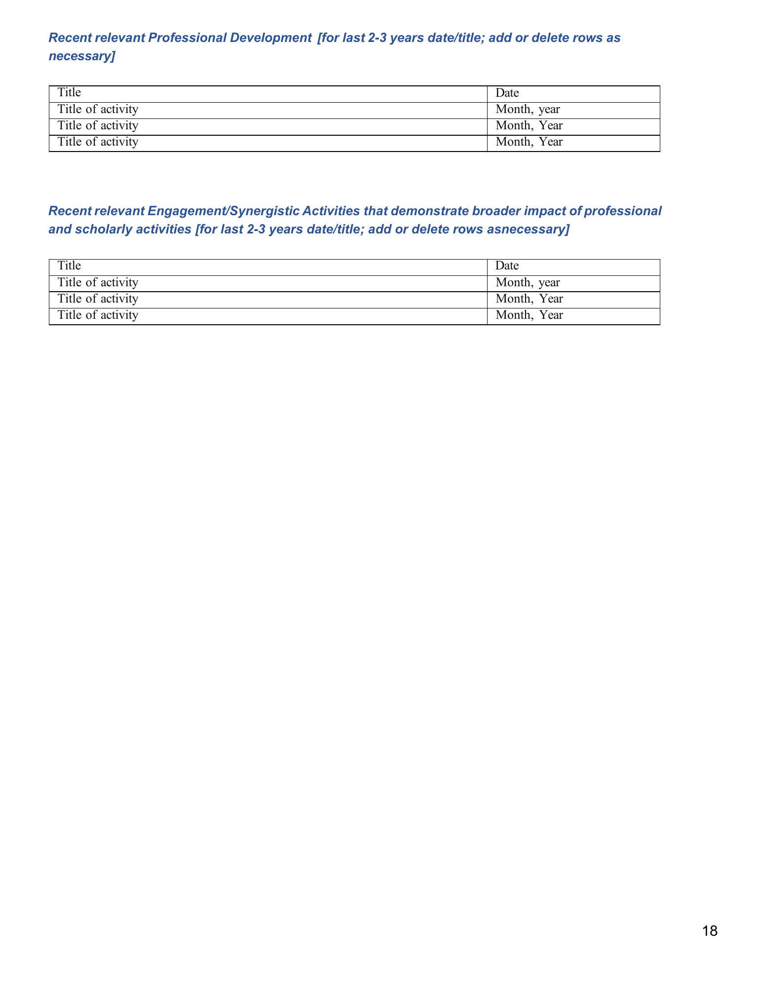
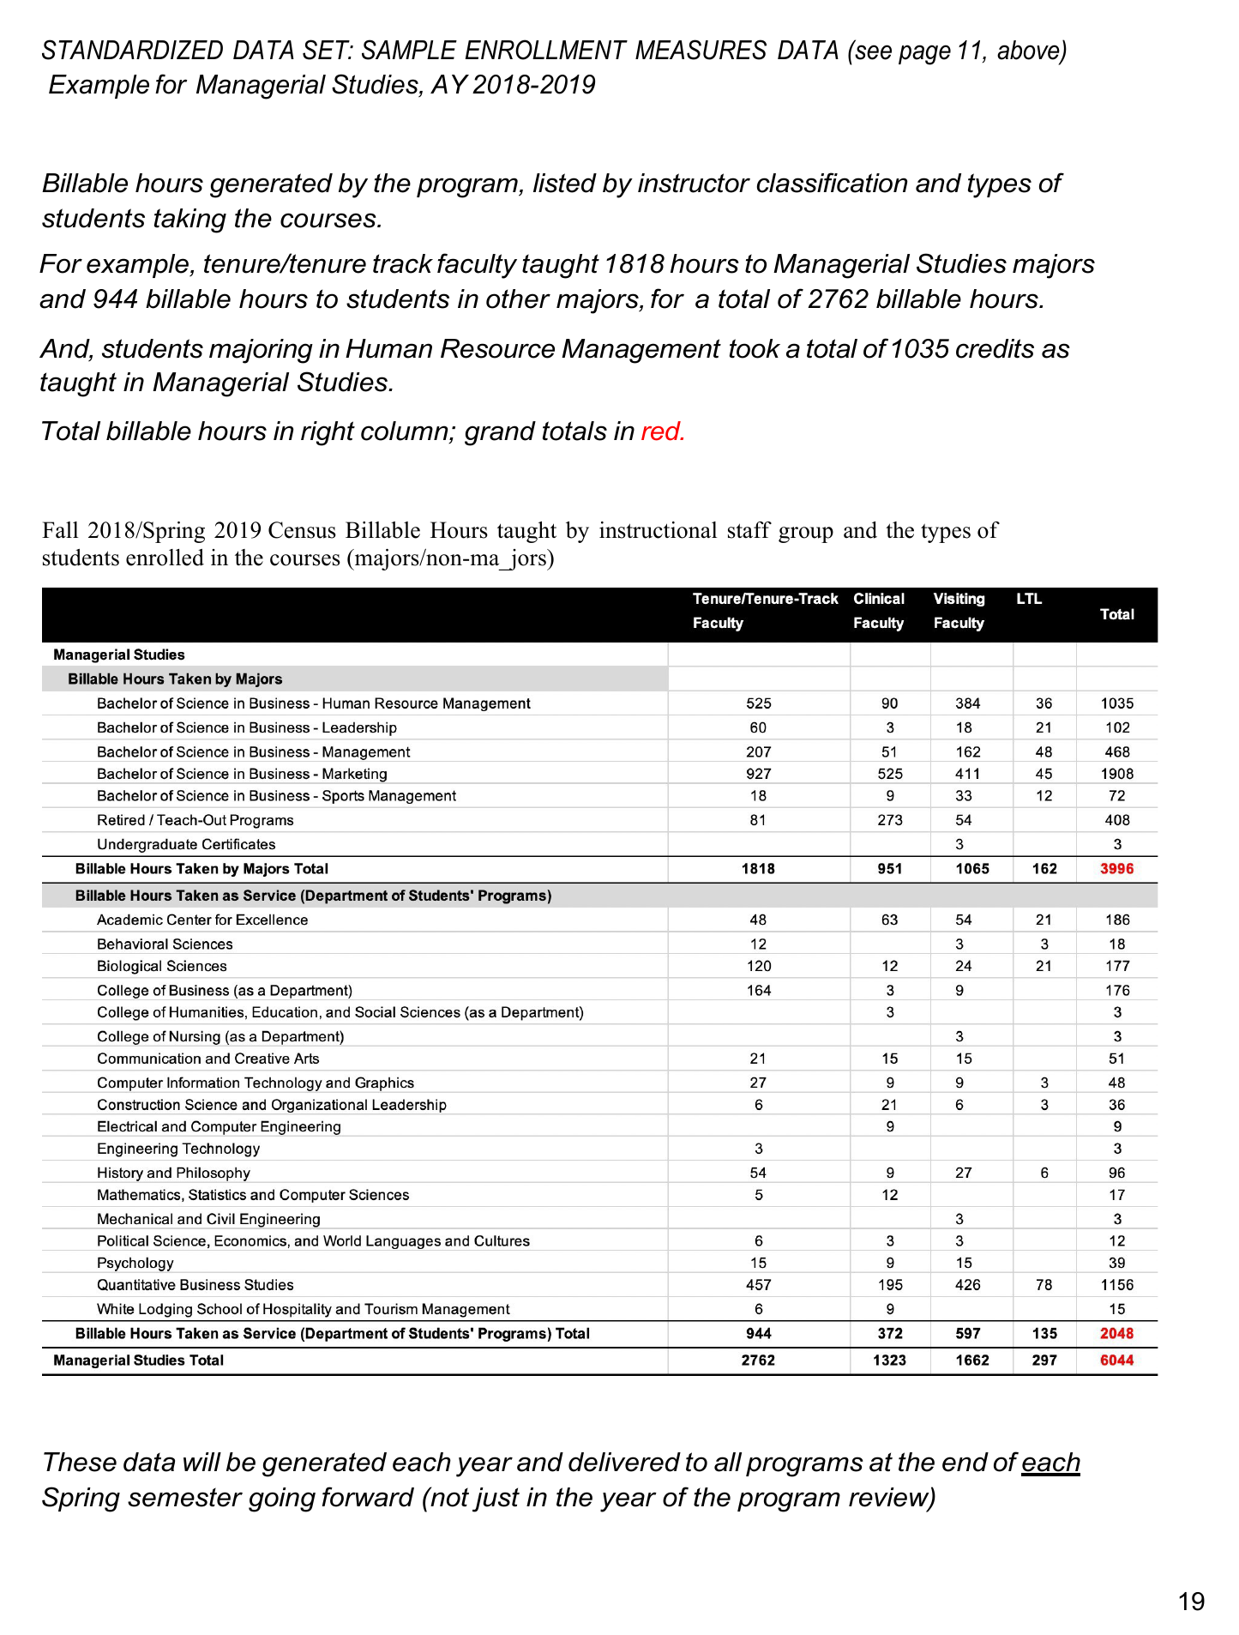

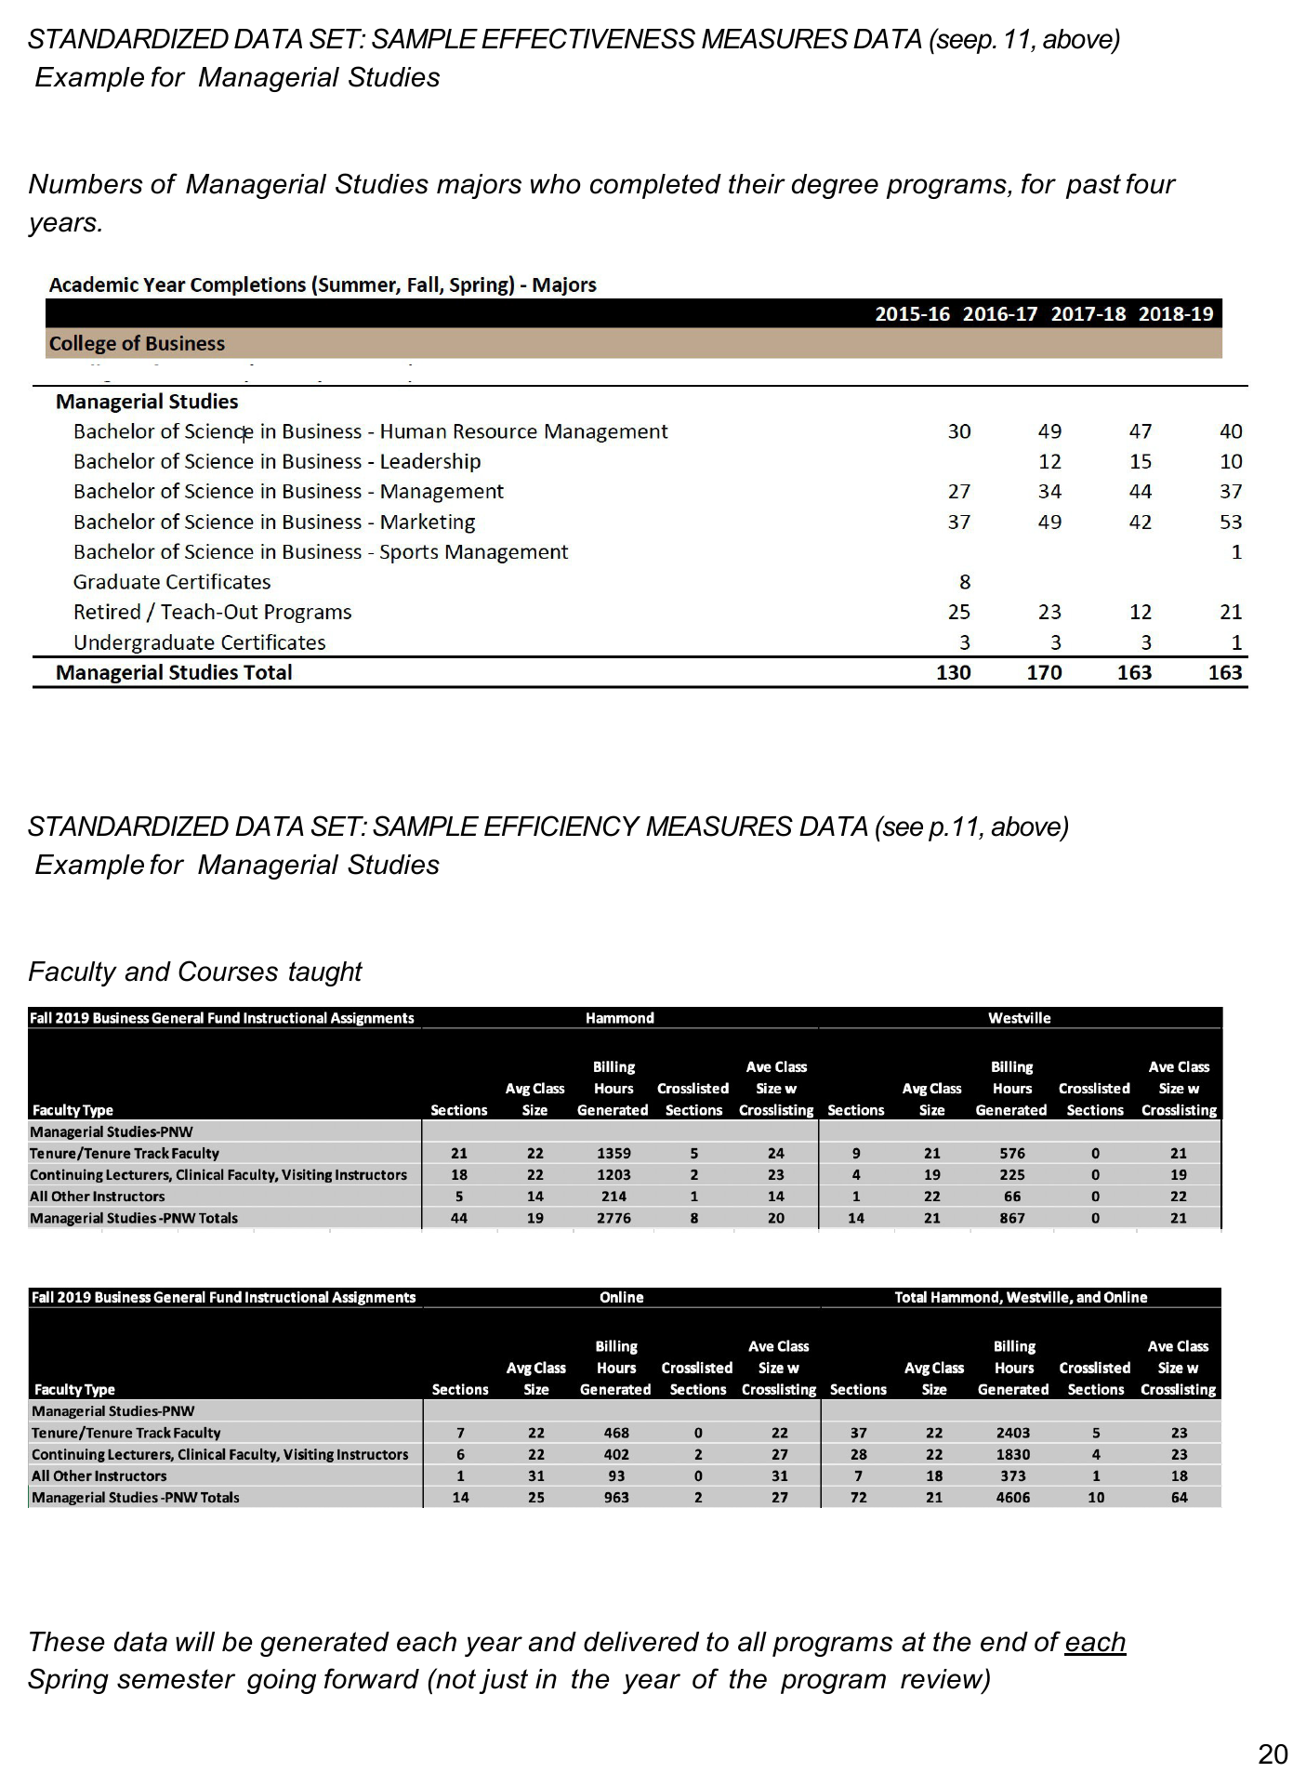

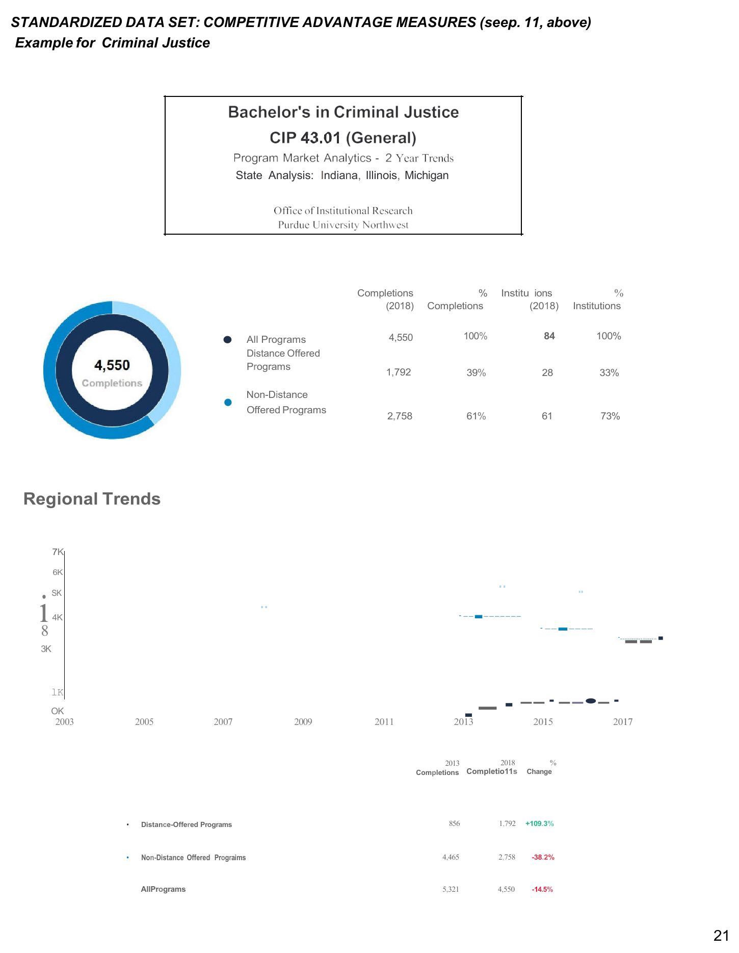

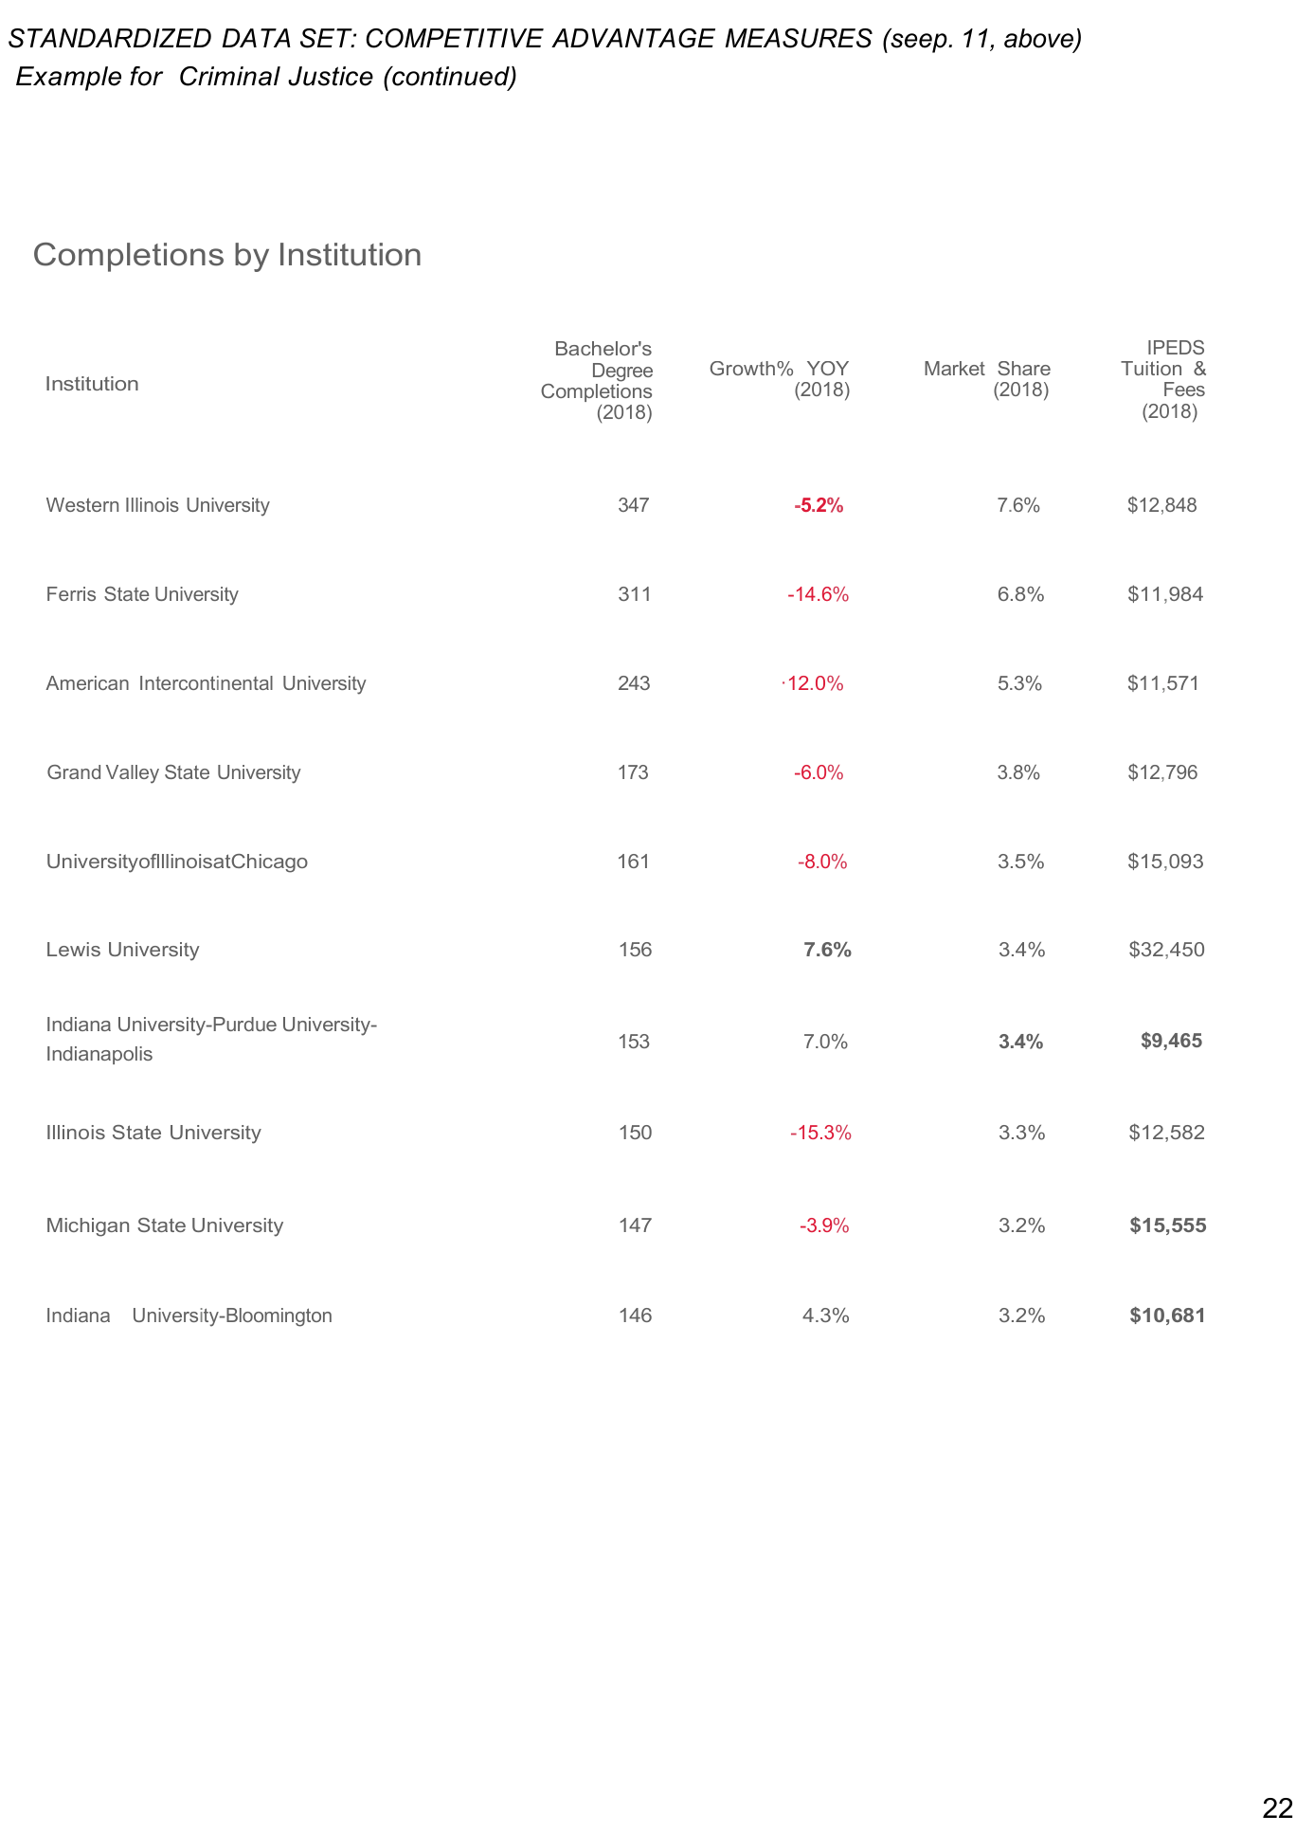

PNW External Review
External Reviewer Selection
NB that reviews by a programmatic accrediting agency (e.g., AACSB, ABET, ACEN) will serve as the external review for those accredited programs.
The role of the external reviewer is to evaluate the quality of the program(s) in the following areas: Curriculum, Assessment, Faculty, Student Satisfaction, and Resources. The ideal reviewer is up to date on curriculum discussions and debates within the discipline. They understand that curriculum can be structured in a variety of ways, all of which can be effective, in addition to understanding a wide range of issues related to faculty roles and resource allocation. The program should select an objective reviewer who has no previous ties, either professional or personal, with the university or individual faculty members. Reviewers may not conduct more than one program review of a single program.
The reviewer approval request form is due by [date]. The form can be found on the APR website.
The following are criteria to consider when selecting a potential reviewer.
The external reviewer:
- Does not currently and has not previously worked at PNW.
- Has served as a reviewer for other institutions' programs or has evaluated other programs.
- Has been active in educational and professional organizations aligned with the discipline.
- Has related work experience and exposure to different types of programs.
- Has experience at an institution similar to PNW in terms of mission and vision.
External Reviewer Site Visit
After the external reviewer has been approved by the dean and the Executive Director of Academic Effectiveness, the chair will contact the reviewer to determine general availability for the visit, which is two full days of meetings, preferably on a Monday and Tuesday. Prior to confirmation, dates must be cleared with the Chair of the APPRC to avoid scheduling overlap with other programs undergoing a review, and to verify the availability of the following individuals and groups:
- Provost and Executive Vice President of Academic Affairs
- Vice Provost
- Executive Director of Academic Effectiveness
- Academic Program Peer Review Committee
- Dean of the program's college
- Program chair and faculty
- Program staff
- Office of Graduate Studies, as appropriate
- Undergraduate and/or graduate students in the program
- Other key stakeholders, as appropriate

The external reviewer is required to attend meetings over the course of two full days (approximately 16 hours). The APR coordinator (Chair of the APPRC?) will initiate a draft of the site visit itinerary, scheduling meetings with the Provost, dean, and the APPRC. The chair will schedule the remainder of the itinerary for the site visit.
The chair will ensure that the external reviewer has a clear understanding of the conditions of the job, which primarily consists of two full days of meetings, and the timely delivery of a findings report evaluating the six main areas of focus outlined above.
Example Site Visit Itinerary
The chair serves as host to the reviewer for the duration of the 2-day visit. The APR coordinator (Chair of the APPRC?) initiates development of the itinerary by scheduling required meetings with the APPRC, Provost, and deans. From there, the chair organizes the remainder of the reviewer's itinerary.
An ideal itinerary includes meetings/observations with the following:
- Dean and associate deans at the end of day one, and end of day two
- Director, Graduate Studies, if applicable
- VCAA and Provost
- Students in the program
- Classroom observations
- Alumni, where available
- Program faculty members, staff, advisors, and other relevant stakeholders
- Program faculty members and staff from related programs, if applicable
- Advisory council, if applicable
- APPRC
An external reviewer's itinerary should include any meetings essential to a fully informed campus visit. Chairs should add any additional meetings necessary to create the most comprehensive visit possible.

Example itinerary:
Program/Department: Accounting  External Reviewer: Dr. Cat Tooth  Visit Dates: October 12-13, 2026 |  | Meetings and locations determined by chair, with the exception of the APPRC, provost, and dean meetings.
Monday, October 12th | Location
8:00-8:30 | Coffee in hotel lobby; walk to department building | Meetings and locations determined by chair, with the exception of the APPRC, provost, and dean meetings.
8:30-9:30 | Tour facilities with chair
9:45-10:45 | Meet with faculty
11:00-12:15 | Classroom observation
12:15-1:15 | Lunch
1:30-2:30 | Meet with students
2:30-3:00 | Break
3:00-4:00 | Meet with dean (1 of 2)
4:00-5:00 | Meet with AVP of Graduate Studies
Tuesday, October 13th | Location
8:00-9:15 | Coffee with faculty and staff | Meetings and locations determined by chair, with the exception of the APPRC, provost, and dean meetings.
9:30-10:45 | Classroom observation
11:00-12:00 | Meeting with Academic Program Review Committee
12:00-1:00 | Lunch
1:00-2:00 | Meeting with provost
2:15-3:15 | Meet with students
3:30-4:30 | Meet with dean (2 of 2, exit meeting)
4:30 | Depart to airport
Example only. Adjust based on the needs of the program/department.

External Reviewer Travel Arrangements and Payment
The Office the Provost provides payment for the approved travel expenses and work provided. After the visit date is set, the APR coordinator (Chair of the APPRC?) will work directly with the reviewer to arrange travel and collect the forms necessary for payment. The program is not responsible for collecting or processing any paperwork or forms related to reviewer travel and payment.
The reviewer will receive a $1,500 payment from the Office of the Provost for conducting the review and preparing a report, which is due within 30 calendar days following the visit. The external reviewer will not be paid until the Office of the Provost has received the reviewer's report. If the report is received between 31 and 45 days following the visit, payment is reduced to $1,200. If the report is received between 46 and 60 days following the visit, payment is reduced to $750. The purpose of a reduction in payment is to encourage timely completion of the report, which helps the APPRC avoid a bottleneck in workflow during the concurrent review of programs. The Office of the Provost will process all necessary paperwork for payment in accordance with university policy.
I. Materials to be Supplied by the Chair
Chairs, with help from faculty members, will supply the following materials to the APR coordinator by the middle of January (for a spring semester review) or August (for a fall semester review); see the dates as outlined in the master calendar.
- Up-to-date curriculum vitae for all full-time faculty
- Strategic plan for the program/department
- Program review self-study narrative
- Program marketing materials
- Advising checklists/plans
Materials should be uploaded to [tbd] folder/site.
II. Dissemination of Information to the External Reviewer
Information about the program will be sent from the APPRC coordinator to the external reviewer at least two weeks prior to the reviewer's visit. Among the items included are the materials submitted by the chair (listed in section V), payment forms required by Accounting Services, and program data and previous program review reports from the Office of the Provost.

Purdue University Northwest Academic Program Review Rubric
Program Name________________________________________ Evaluator __________________________________________________
 | Exemplary/ Exceeds (4) | Meets (3) | Developing (2) | Lacks Evidence (1) | Comments
The program's teaching and learning, scholarship, and service are appropriate to the institution's mission. | The program's teaching and learning, scholarship, and service efforts are aligned with the institutional mission. Program has a scheduled process for reviewing its alignment to the university mission. | The program's teaching and learning, scholarship, and service efforts are aligned with the institutional mission. | The program's teaching and learning, scholarship, and service efforts are not directly aligned with the institutional mission. The program is aware of its need to fit with the institution's mission. | The program shows little to no awareness aligning its teaching and learning, scholarship, and service efforts with the institutional mission.
Strategic Plan/Goals for next five years Progress towards goals since last review | Program uses data and broad-based input from stakeholder groups, accreditors, and peers to develop strategic goals; program shows substantial and demonstrable progress, and is building on those successes to formulate new goals. | Program uses data and input from a broad range of groups to develop strategic goals; program shows demonstrable progress in meeting stated goals. | Program has formulated strategic goals but the methodology used and data to inform them is unclear; program has made some progress in meeting stated goals, but work still needs to be done. | Program does not cite any strategic goals for the next five years; program does not cite any substantial progress in meeting stated goals OR does not have any existing stated goals.
Curriculum:  • Reviewed regularly  • Current  • Relevant  • Tied to strategic plan | All courses (including electives) are organized to scaffold students' developing knowledge and skills; the entire faculty regularly reviews the curriculum using input from advisory boards, and national accrediting standards, to align with emerging trends and the institution's strategic plan; clear, exit outcomes are written at the appropriate level. | Required courses are organized to scaffold students' developing knowledge and skills; the curriculum is reviewed regularly to align with national trends and the institution's strategic plan; clear, exit outcomes are written at the appropriate level. | Course outcomes are aligned haphazardly or inconsistently with program exit outcomes; reviews of the curriculum are done only sporadically; skills or content are not intentionally developed to align with trends or the institution's strategic plan. | Individual course outcomes are not aligned to program and/or degree exit outcomes; the process used to review the curriculum is not cited.
Quality, viability, and productivity of efforts in teaching and learning | A clearly defined process is systematically followed for frequent, formal review of instructional effectiveness of all faculty. Complete program outcomes exist and appropriate measures are used to assess them; outcomes and results are published. Gaps in student learning are analyzed. Improvement plans have been formulated/ implemented. | A clearly defined process for the evaluation of teaching is systematically followed Program outcomes include knowledge and skills; outcomes are assessed and results are published. The program analyzes gaps in student learning and is working on an improvement plan. | The review of the teaching quality of program instructors is erratic, incomplete or informal. Incomplete or unclear learning outcomes are identified. Assessment results are incomplete or unclear with no improvement plans. | The review of the instructional quality of faculty is haphazard or nonexistent. Degree and program learning outcomes are not articulated. They are not assessed.
Quality, viability, and productivity of efforts in scholarship | All faculty have required credentials, extensive research/scholarly/ engagement records. | All faculty have required credentials, appropriate research/scholarly/ engagement records, and participate in professional organizations. | Faculty has required credentials, and research/scholarly/ engagement records. | Faculty have required credentials, but no or little evidence of scholarship.
Quality, viability, and productivity of efforts in service | All faculty participate nationally and regionally in professional organizations and service | All faculty participate in professional organizations and service. | Faculty participate in professional organizations or service. | Faculty do not participate in professional organizations or service.
Program Enrollment | Quantitative and qualitative data demonstrate program is strongly positioned. Little to no competition for enrollment. Job market statistics show strong employment opportunities for graduates. | Quantitative and qualitative data demonstrate program is competitively positioned. Job market statistics show opportunities for graduates. | Quantitative and qualitative data demonstrate the program is not competitively positioned. Job market statistics show mediocre job market offerings. | Quantitative and qualitative data demonstrate the program is positioned below competitors. Statistics show a weak job market with limited employment opportunities for graduates.
Progressive Improvement | The program uses the findings and recommendations from program review for the progressive improvement and adjustment in the context of the institution's strategic plan. A clearly defined process is used for the periodic review of performance measures to ensure alignment with the institution's strategic plan; scheduled reviews are integrated into long-range planning. | The program uses the findings and recommendations from program review for the progressive improvement and adjustment in the context of the institution's strategic plan. A clearly defined process is used for the periodic review of performance measures to ensure alignment with the institution's strategic plan; program effectiveness data is used to revise policies and plans for improvement. | The program does not consistently use the findings and recommendations from program review for the progressive improvement and adjustment in the context of the institution's strategic plan. Performance measure reviews are erratic, episodic or informal; improvement plans rarely include alignment with the institution's strategic plan. | The program does not use the findings and recommendations from program review for the progressive improvement and adjustment in the context of the institution's strategic plan. Performance measure reviews are episodic.
Program's overall summary; future plans | The program demonstrates a strong record of continuous improvement, with systematic, structured planning and assessment activities which are utilized for data-informed planning. | The program demonstrates a record of continuous improvement, with systematic planning and assessment activities which are utilized for planning. | The program presents a record of non-structured planning and assessment activities which are utilized for planning. | The program does not present a record of planning and assessment activities; no processes for improvement are cited.

SAMPLE FINAL REPORT/LETTER TEMPLATE
Date
Dear [Program Chair]:
Program Review is an integral part of assessing and maintaining the integrity of our degree and certificate programs at PNW. In AY [date] the XX program went through the review process. This letter serves to document the determinations and recommendations of the Academic Program Review Committee (APPRC) as well as the Vice Chancellor for Academic Affairs and Provost.
I support the recommendation of the APPRC of CONTINUANCE for the XX program, and I commend the program on its strong program review presentation. The following recommendations from the APPRC should frame the work that needs to be done in the coming five years to prepare for the next program review:
Commendations:
1. The assessment of PLOs is clearly a strength for the XX program. Faculty have been diligent in collecting data, and this has paid off in the program's ability to make improvements that have a positive impact on students.
2. Participation in the [professional/accrediting organization] enables this program to articulate with all other programs at Indiana institutions, a real benefit to students. The faculty work to keep current with updated outcomes every three years at a minimum. Thanks to this participation, the students in this program have greater employment opportunities upon graduation.
3. This program has a good balance of both students and faculty that are representative of our service area.
4. The faculty in this program provide an extensive amount of service to the college.
5. The XX program has a very strong understanding of its strengths and challenges and works to overcome the challenges. Continuous quality improvement is particularly evident in the use of student assessment data to make improvements to outcomes and curriculum.
6. The presentation was informative. The committee thanks program faculty for stepping in when the chair was not available.
Program-Specific Recommendations:
The program needs to work on the following areas and provide a brief update to the APPRC Committee on progress on a yearly basis until the next program review, which is scheduled for AY [date]:
1. X shows good numbers of graduates; however, the time to graduate in the BS degree remains a bit high. The suggestions about better sequencing, contact reports, and relationship building are all good ones that the program should implement.
2. The program is encouraged to consider pursuing [xx] accreditation.
3. An advisory committee is strongly encouraged for all programs with applied degrees. The program is encouraged to develop relationships with area business partners as soon as possible.
4. Enrollment remains a strength in this program. The program offers evening and online courses to meet student demand. We recommend that, if possible, the entire degree be made available online. XX faculty have identified several steps to improve enrollment. We recommend that the program implement these steps over the next few years. Suggested strategies for improving enrollment in our program are as follows:
a. Enhance student success in ABC 12100 (course name) and ABC 11100 (course name) in the BS degree so that the "word" in the community is that the XX program courses at PNW can be accomplished and are a positive experience for enrolled students.
b. Identify and work with students who are taking program and/or service courses as part of their meta-major to explore the possibility of entering their desired field of employment.
c. Work with the Dual Credit High School Outreach coordinator to resume visits to high schools to encourage matriculation at PNW.
d. Offer dual credit [XX program] courses at local High Schools to "hook" students into potential enrollment at PNW.
e. Notify the chair/adviser when new students declare into the [program] degree. A strong initial relationship will set students up for successful guidance through degree progression. A positive experience also speaks loudly to other potential internal and external students who are considering enrollment in our program.
5. The committee continues to have concerns about the pass rates for ABC 11001, 12100, and 12200. We recommend that the program faculty investigate a 1- credit emporium support lab, similar to [another course], as a possible way to improve student outcomes. Adding a reading prerequisite may also be helpful.
6. Strategic Planning: As an added strategic goal, XX program should develop strategies to close the equity gap. Thinking about how we address gaps in success across race, ethnicity, and gender may lead to improvements. Consider professional development for faculty to develop instructional strategies to increase success rates for students of color.
7. The program is encouraged to work to increase success rates in online sections. Professional development may help to develop strategies.
8. By [date], present a plan to your dean to address the above recommendations.
General Recommendations:
1. Conduct learning assessment of all program-level learning outcomes, and collect and analyze data related to the results.
2. Continue to update and post results in the Program Assessment section of TaskStream/Watermark
3. Implement assessment of Essential Skills Outcomes {ESOs} in any courses designated as General Education as directed.
4. Work to implement your strategic plan goals. The program Strategic Plan must also be updated each year.
5. Ensure that your program courses are updated on a five-year cycle. Continue to work with the Curriculum Committee to move forward with your related metamajor.
You will meet with the VCAA and Provost and the Dean to go over these recommendations and plan the next steps for moving forward. Again, thank you for your hard work in this program review cycle. I look forward to working with you to make your program even stronger.
Sincerely,
Signature
ADDENDUM
A. Process for Preparing and Submitting the 750-Word Executive Summary to ICHE
Following completion of each Academic Program Review (APR), Purdue University Northwest shall prepare a 750-word Executive Summary for submission to the Indiana Commission for Higher Education (ICHE). Preparation of the summary is initiated upon issuance of the Provost's official determination letter. The Executive Summary serves as the University's formal external report documenting the review process, key findings, and agreed-upon actions for program improvement and sustainability.
The Executive Summary shall be drafted by the Program Chair (or designee) in consultation with the Dean and with support from appropriate Institutional department to ensure the accuracy of quantitative data. The summary must be based on the final self-study, the review report, the program's response to reviewer feedback, and the Provost's final recommendations. It shall include: (1) a brief description of the program and its alignment with the University's mission; (2) an overview of enrollment trends, market positioning, and student learning outcomes; (3) key strengths identified in the review; (4) areas for improvement; (5) agreed-upon action steps and resource priorities; and (6) the final determination of the review. The tone must be concise, analytical, and appropriate for state-level reporting.
The draft Executive Summary shall be reviewed by the Dean and submitted to the Vice Chancellor for Academic Affairs and Provost for final approval. The appropriate Institutional department will verify reported data prior to submission. Upon approval, the Office of Academic Affairs will submit the document to ICHE within n (n) days of the Provost's determination and archive it in the University's appropriate platform for compliance and accreditation purposes.
B. Who will write the 750-word executive summary to be submitted to ICHE
Following completion of each Academic Program Review and issuance of the Provost's official determination letter, the Program Chair, or a designated program representative, shall be responsible for preparing the initial draft of the 750-word Executive Summary to be submitted to the Indiana Commission for Higher Education (ICHE).
The Executive Summary should be developed in consultation with the Dean, the Department Chair, Program Coordinator and with support from the appropriate Institutional office to ensure that all quantitative information, including enrollment, completion, market, and assessment-related data, is accurate and consistent with the final Academic Program Review record.
The Executive Summary shall be based on the final Program Self-Study, the Academic Program Review Committee's report, the program's response to reviewer feedback, and the Provost's final recommendations. The summary should briefly address the following areas: program mission and alignment with the University's mission; enrollment trends, market positioning, and student learning outcomes; major strengths identified through the review; areas for improvement; agreed-upon action steps and resource priorities; and the final review determination.
After the Program Chair or designee completes the draft, the Dean shall review it for accuracy, completeness, and alignment with college priorities. The draft shall then be submitted to the Vice Chancellor for Academic Affairs and Provost for final approval. Once approved and data-verified, the Office of Academic Affairs shall submit the Executive Summary to ICHE and archive the final version in the appropriate University platform (Planning and Self-Study or P&SS) for compliance and accreditation purposes.
C. Face-to-face meeting with the Provost, Dean/Dept Chairs to discuss the review (Becky)
D. Workflow in the P&SS to access APPRC
A folder in the Planning and Self-Study (P&SS) will be created to archive all the APPRC documents and relevant supporting information for each curricular PNW programs starting Fall 2026.

