Use this QRC when completing a mileage only expense report.

Log In To Concur
Go to the Employee Portal page.  Choose Travel System (Concur) to log in to Concur using Purdue Career Account and password.  Enter Career Account ID and password.  Click Login. | www.purdue.edu/employeeportal    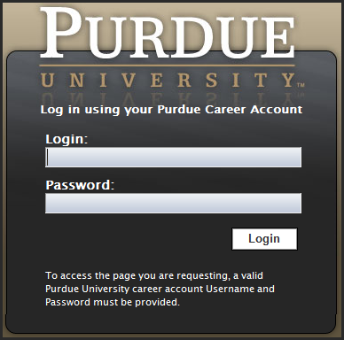
If you are booking on behalf of another traveler, click Profile. | 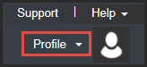
Under Administer for another user… select user name from drop-down menu, or search by entering name.  Click Apply. | 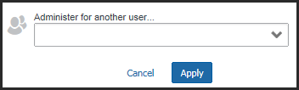

Expense Report
Select the Expense tab.  Click Create New Report. | 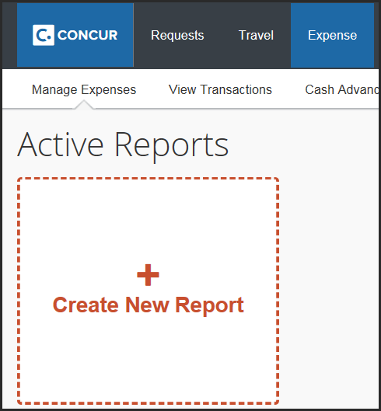
Complete all required fields on the Report Header (all required fields are noted with a heavy red bar).
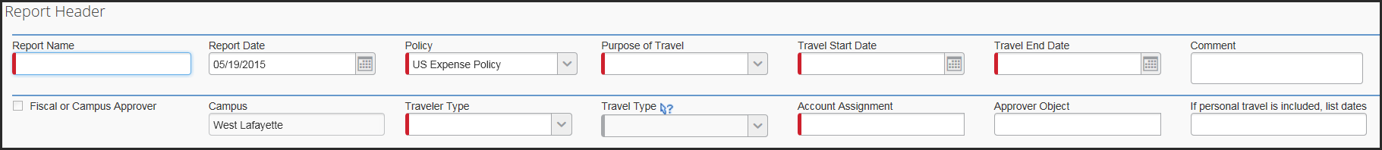
Report Name | Type a name. Use the naming convention supplied by business office (40 characters max).
Report Date | Automatically set to current date.
Policy | Defaults to US Expense Policy.
Purpose of Travel | Select best option from drop-down menu. Some selections (research related activities) require an explaination in the Comment section.
Travel Start Date | Type date or choose the date from the calendar.
Travel End Date | Type date or choose the date from the calendar.
Traveler Type | Select Employee (EMP).
Travel Type | Select In State or Out of State.
Account Assignment is a required field.  Click in the Account Assignment text box.  The CODE radio button is selected by default.  - Type an asterisk (*), followed by the account number.  Or  Search by TEXT:  - Change the radio button to TEXT and type an asterisk (*) followed by the account name.  Note: Use the primary and most restrictive account assignment. If all accounts are equally restrictive, list the account that is paying for the majority of the cost. Additional cost assignments will be allocated within itemized expenses.  Choose the correct fund/cost center combination from list generated by Concur.  Refer to the business office with questions about account assignments. | 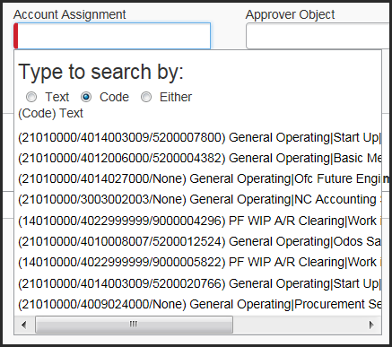  Tips:  Use as many digits of the account assignment as possible.  Use scroll bar at bottom of window to see full account assignment name.
Select Next >>. | 
Select Cancel to create mileage only expense.  Note: Travel allowance (i.e., Fixed Meals or Subsistence) is created by Completing Itinerary Stops when travel time is greater than 12 hours.  If travel exceeds 12 hours, refer to Create and Edit Blanket Travel Expense Report in Concur Travel and Expense QRC. | 
Create Expenses – Personal Car Mileage
Select Personal Car Mileage under New Expense. | 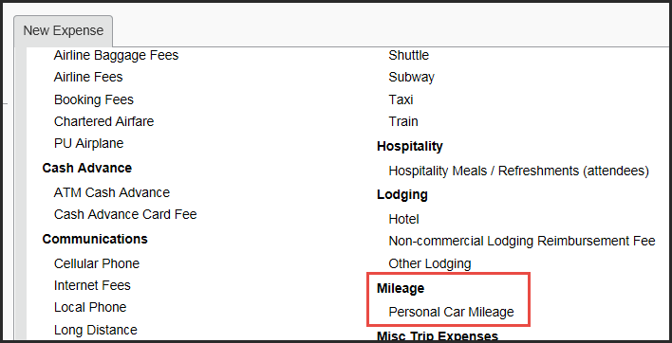
Type Transaction Date, Purpose of Travel, From and To Location. | 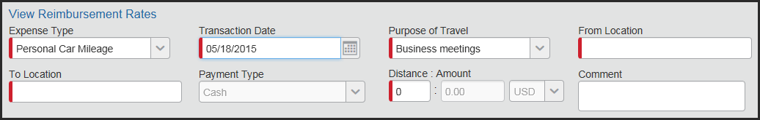
Select appropriate Rate using the Vehicle ID field. IRS Federal Rate Vehicle is the default selection.  NOTE: For County Extension, see Create a Mileage Only Expense Report in Concur Travel and Expense for County Extension Offices QRC. | 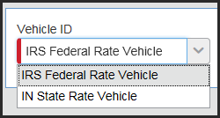
Click Mileage Calculator. | 
Enter addresses for A, B and/or C Waypoints.  Click Calculate Route.  Click Make Round Trip, if applicable.  NOTE: For travel to multiple locations, create mileage for all stops to ensure the most accurate mileage reimbursement. | 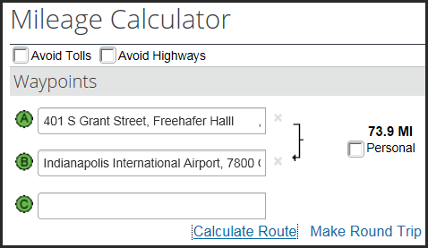
Select Suggested Route under Directions. | 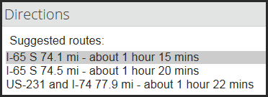
Route is highlighted on map. | 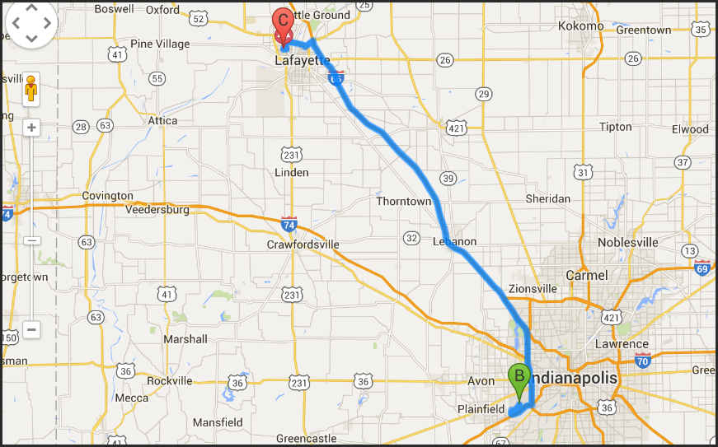
Click Add Mileage to Expense. | 
Click Save.  Repeat above steps for each leg to be reimbursed. | 

Allocate Expense
Personal Car Mileage is displayed as an unallocated expense.  Click the expense title or check the box to the left of the expense to display expense details. | 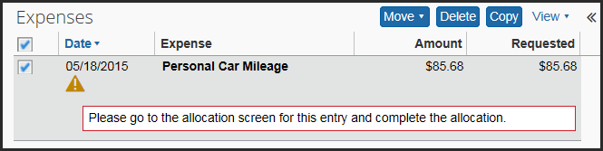
Click Allocate. | 
Select Add New Allocation to allocate costs to an additional account assignment than the one noted previously on the Report Header.  Click Allocate By and select Percentage or Amount.  Enter amounts. | 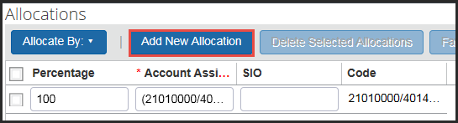  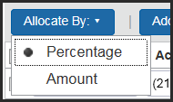
Click Save. | 
Click OK. | 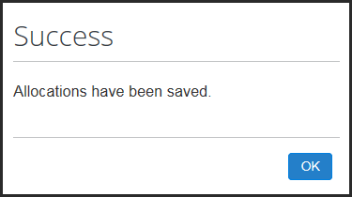
Click Done. | 
Verify that all exceptions are cleared.  Verify that all expenses are allocated. | Exceptions are noted with the following icons:  or   Allocated expenses are noted with the following icon: 

Submit Expense Report
Click Submit Report. | 
If preparing on behalf of the traveler, exit Expense Report and notify traveler that report is ready for submission.
Read Final Review.  Click Accept & Submit. | 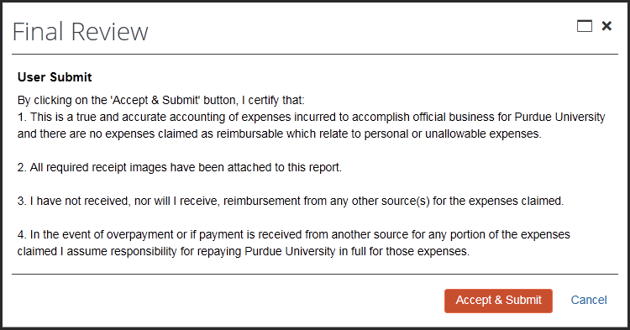
Report Submit Status provides disbursement information and identifies the fiscal approver.  Amount Due Employee will be provided in a check (mostly likely directly deposited to the same account identified for payroll direct deposits), once expense report is approved through the system.  Amount Owed Company will be payroll deducted the next payroll cycle.  Select Close. | 