Purdue Webclock
Guide
Approving, Rejecting and Editing Time

Contents
Policies & Concepts 3
Employee Responsibilities 3
Supervisor Responsibilities 3
Delegation 3
Resources 3
Support 3
Technical Requirements 4
Notifications 4
Rounding 4
Overtime 4
Holidays, Moving Holidays, Holiday Emergency Work 5
Review Employee’s Time Pairs 6
Review, Approve, or Reject Time Pairs 6
Edit / Add Time Pairs for Employee 9
Edit Time Pair 9
Add Time Pair 11

Policies & Concepts

Employee Responsibilities
In Purdue Webclock Employees are responsible for:
- Accurately recording time worked using the appropriate access point
- Selecting the appropriate job when recording time (if employee records time for multiple jobs using the webclock)
- Proactively working with their supervisor to resolve issues as needed (i.e. missing time, missed punches, etc.)
- Ensuring that their time is recorded completely and accurately for each pay period by the deadline required by their supervisor
- Remember: The time entered into the system will be considered true and accurate as of the end of an employee’s pay period. It is the employee’s responsibility to review their time often (at least at the end of each shift and at the end of the pay period) to make sure the recorded hours are true and correct; and to review and confirm the accuracy of any changes that a supervisor makes to time entries.

Supervisor Responsibilities
In Purdue Webclock, Supervisors are responsible for:
- Proactively working with their employees to resolve issues as needed (i.e. missing time, missed punches, etc.)
- Reviewing/approving all time pairs for all of their employees by 12:00pm on the Tuesday following the end of each pay period
- Proactively working with their business office to update employee work schedules and report costing exceptions for their employees’ time worked
- The Purdue Webclock inherits SAP Org Structure. Supervisors are only responsible for and able to access/edit time pairs of employees of whom which they are the supervisor of record in SAP.
- Remember: The time entered into the system will be considered true and accurate as of the end of an employee’s pay period. It is the employee’s responsibility to review their time often (at least at the end of each shift and at the end of the pay period) to make sure the recorded hours are true and correct; and to review and confirm the accuracy of any changes that a supervisor makes to time entries.

Delegation
Delegation is not available in the webclock. Delegations set in SuccessFactors are not inherited by the webclock.
Approved time pairs will be transferred to SuccessFactors; in the event that a supervisor does not approve, unapproved time pairs will also be transferred. The time pairs remain viewable and editable by the supervisor even after being transferred. The supervisor should review and approve the time pairs at their earliest convenience.

Resources
The most current versions of all timekeeping resources for Employees and Supervisors can be found on the Payroll’s SuccessFactors Timekeeping website. https://www.purdue.edu/timehelp

Support
Please contact your supervisor with any Webclock-related questions or concerns.

Technical Requirements
Supported browsers: Chrome, Safari, Edge, Firefox, Internet Explorer
Mobile access: Device must have a web browser and a WIFI or data connection

Notifications
The WebClock provides a Notification Center for Employees (one Notification Center per position held).
Employees receive notifications when a time record is changed (edited/added), time pairs are approved, time pairs are rejected, and when punches are missed.
Supervisors do not receive notifications.

Rounding
- The webclock utilizes interval rounding: each employee’s total time for the day is calculated and then rounded to the nearest tenth for payroll processing.
- Adjustments/management of an employee’s hours in order to exactly match their full CUL (or FTE) is not required.
Minutes Translated to Decimals | Rounding to the Nearest Tenth of an Hour | Example  Punch Time Punch Type Time Recorded  7:05 AM IN 7:05 AM  12:02 PM OUT 12:02 PM  1:06 PM IN 1:06 PM  3:55 PM OUT 3:55 PM  = 7:48  Recorded Daily Total 7.8 Hours
0:06 = .1 | 3 minutes to 8 minutes = .1
0:12 = .2 | 9 minutes to 14 minutes = .2
0:18 = .3 | 15 minutes to 20 minutes = .3
0:24 = .4 | 21 minutes to 26 minutes = .4
0:30 = .5 | 27 minutes to 32 minutes = .5
0:36 = .6 | 33 minutes to 38 minutes = .6
0:42 = .7 | 39 minutes to 44 minutes = .7
0:48 = .8 | 45 minutes to 50 minutes = .8
0:54 = .9 | 51 minutes to 56 minutes = .9
1:00 = 1.0 | 57 minutes to 2 minutes = 1.0

Overtime
The Purdue Webclock adheres to the University policy regarding overtime. When a full time employee works over 40 hours in a workweek, the time will be designated as overtime when it transfers to SuccessFactors for payroll. “Hours worked” in a work week will consist only of hours actually worked. (Exception: Worker’s Compensation, University Holidays).

Overtime for employees with multiple positions will be calculated when the time recorded using the webclock is moved to SuccessFactors prior to Payroll running. Overtime will be charged to each position based on the ratio of hours worked across the employee’s positions for that week.

Overtime is viewable by the supervisor and employees on the Timesheet accessible via SuccessFactors. (Found on the employee’s record in the My Info section – click the Timesheet tile)

Holidays, Moving Holidays, Holiday Emergency Work
Holidays
Holiday premiums are auto-calculated when time recorded using the webclock is moved to SuccessFactors to be paid.

Moving Holidays
Moving Holidays takes place within SuccessFactors Time Off tile (not within the Webclock). Individuals whose work schedule does not include a given University Holiday can use the time off feature within SuccessFactors to request Holiday on any day during the week (Monday through Sunday; Sunday through Saturday (dispatchers only)) of the holiday. Exception: Police and Fire may request Holiday leave at any time throughout the year.

Unplanned Work on a Holiday or During an Emergency
Per University policy, when an employee works during an emergency or unscheduled holiday work, they qualify for their hours to be paid at time and a half. In the event that an essential personnel are required to work during an emergency or unscheduled on a holiday, the employee or their supervisor must enter the time on the employee’s timesheet in Employee Central Time (ECT) using time type Campus Service Disruption. (In addition to recording time in the webclock. For details on how to enter time in ECT, see www.purdue.edu/timehelp. (Quick Reference Guide: Time Entry – Positive Duration)

Accessing the Purdue Webclock
The Purdue webclock can be accessed via three different access points. Your department will designate a best practice as far as which access method you should utilize.
Employee Launchpad  SuccessFactors | Web Browser | Kiosk
Navigate to the One Campus Employee Portal (one.purdue.edu/)  Click Employee Launchpad.  Log in using your BoilerKey.  On the homepage, click the Webclock tile. | - On your computer or mobile device’s web browser, navigate to webclock.purdue.edu  (This link can be bookmarked or saved as a favorite for convenience)  - Log in using Purdue User ID and BoilerKey passphrase. | At the kiosk, swipe your Purdue ID Card through the card reader.

Review Employee’s Time Pairs
For each pay period, supervisors must approve each time pair for each employee prior to 12:00pm Tuesday the week following the end of the pay period. Unapproved time will be transferred to SuccessFactors to be paid, but the supervisor must review, edit, and approve the time pairs at their earliest convenience upon their return.

Supervisors have access to run the report SuccessFactors Time Details Report for Managers at any time using the SuccessFactors Report Center. This report provides an overview of Time and Time Off entries for each employee. Note: Only approved time pairs will appear in the report.

Review, Approve, or Reject Time Pairs
Optional: Use the Position filter to view a specific group  Note: Supervisors of individuals with multiple positions will only see time recorded for the position(s) that they supervise. | 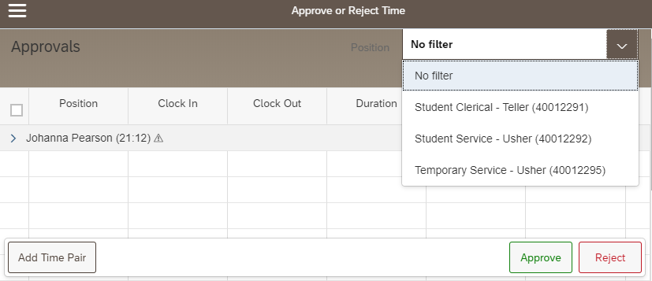
Click an individual’s name to view their time pairs  Exceptions are indicated by an alert icon next to the individual’s name ()  Color Indicators  - Orange  - Time pair was added or edited (by employee or supervisor)  - Type column: Correction or Manual  - Red  - Missed punch  - No data in clock in or clock out, alert icon displayed  - Type column: Clock  - Blue  - Location Services were not enabled by the user | 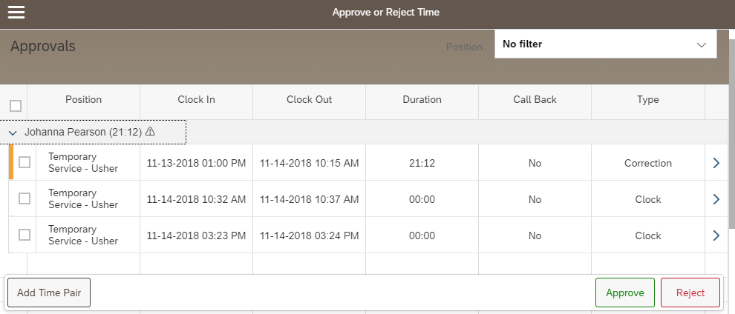
Click the arrow at the end of each line to view details and edits and/or reason for edit (if applicable) | 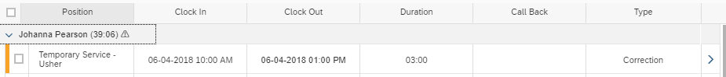
Click Map to view clock in and clock out locations  - Employees are instructed to enable location services if using a mobile device (phone or tablet).  - The precision of location services on desktop and laptop computers will vary. | 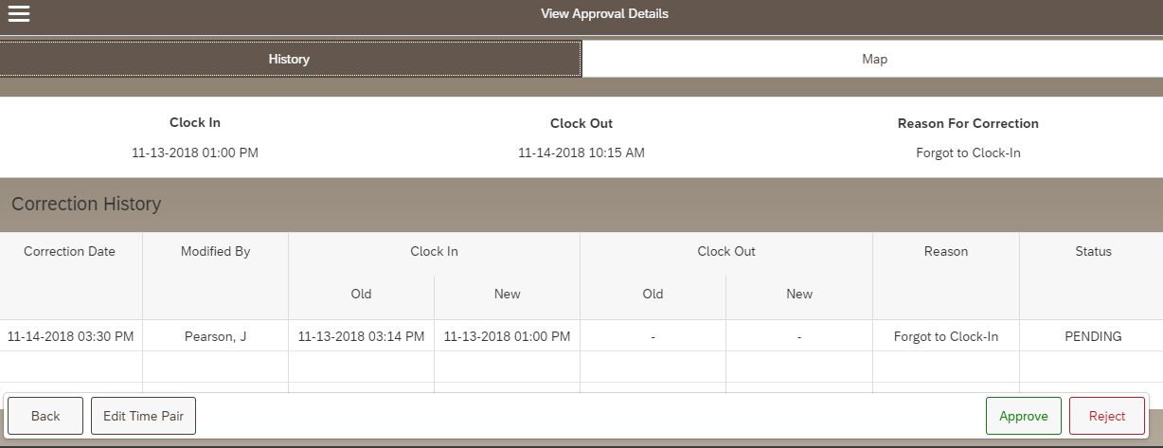
Clock in (green pin) and clock out (red pin) locations are displayed | 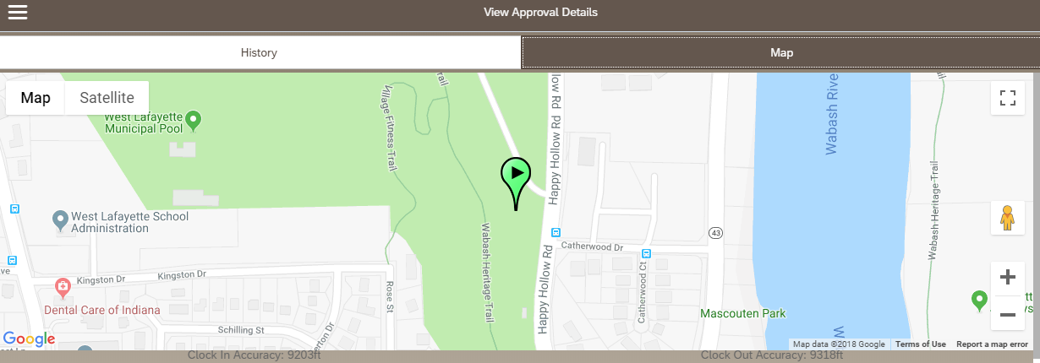
Approving Time Pairs  - Mark the box next to each time pair to be approved  -or-  - Click Select All.  This selects all time pairs for all employees whose records are expanded. See step 4 to select all without expanding records.  - After completing Steps 1 or 2, Click Approve  - Another option is to use the Approval All or Reject All buttons. This action will apply to all time pairs for all employees, even if the record is not expanded | 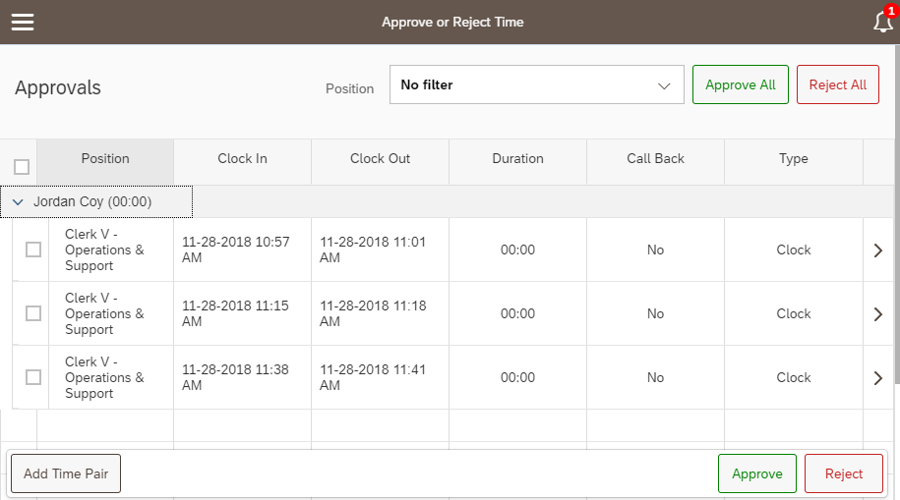  4  3  2  1
Employees can edit time pairs after the supervisor has approved. The pair will re-appear in the supervisor’s queue as PENDING. Employees are instructed to notify their supervisor if they edit after they believe their supervisor has completed their final edits for the pay period.

To view/edit an employee’s time after approving it, access their Timesheet in SuccessFactors. (Log in to SuccessFactors, search for employee’s name, click Timesheet tile)

If an approved time pair needs to be edited, the edit must be completed by the employee.
Rejecting Time Pairs
Mark the box next to each time pair to be rejected or click Select All.
Click Reject.
Employees receive a notification in their Notification Center if time pairs are rejected and the time pair will be marked DECLINED in their History. If applicable, the employee must submit a new time pair for approval to replace the rejected pair(s).

Edit / Add Time Pairs for Employee
In the instance that an employee is unavailable to edit their time records, a supervisor may edit them on their behalf. Employees receive a notification in their Notification Center that their time record has been edited.

Edit Time Pair
Employees or Supervisors can edit time pairs at any time within the current or previous two pay periods. Newly added pairs will be added to the supervisor’s queue as PENDING. Employees are instructed to notify their supervisor if they edit or add a time pair after they suspect the supervisor has completed their final review prior to Payroll running.
Optional: Use the Position filter to view a specific group

Click an individual’s name to view their time pairs
Click the arrow at the end of the line to be edited.

Note: Supervisors can only edit time pairs with missed punches after the individual has been clocked in for 12 hours. If an edit is needed sooner, the employee must complete the edit.
Click or tap Edit Time Pair | 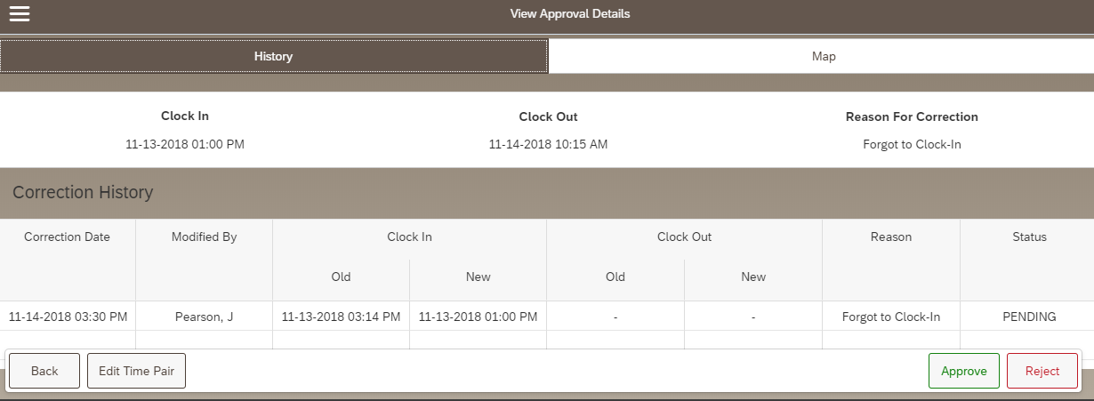
- Use the Reason drop-down menu to select the reason for the edit.  - Tap or click the calendar icon on the appropriate line to edit the Clock In or Clock Out.  - Use the calendar and/or time sliders to indicate the new date or time.  - Click OK  - Click Submit Changes | 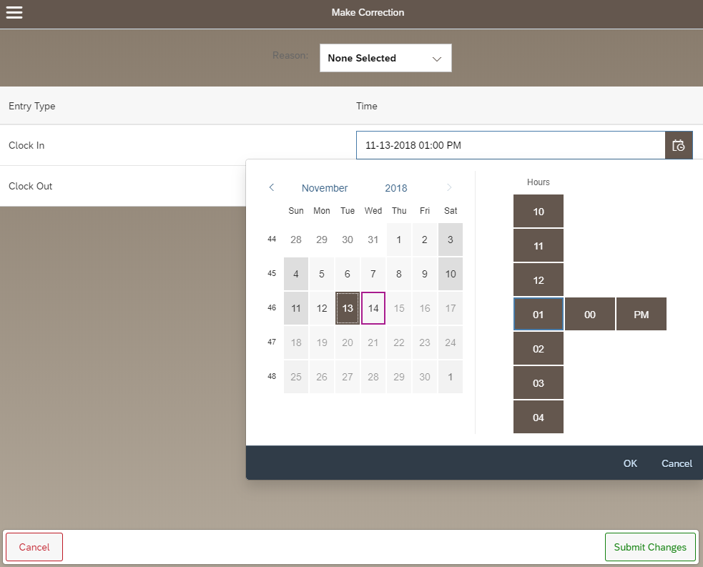  5  4  3  2  1
The Approval Details screen is displayed.  This time pair can be Approved on this screen, or click Back to return to your approval queue. | 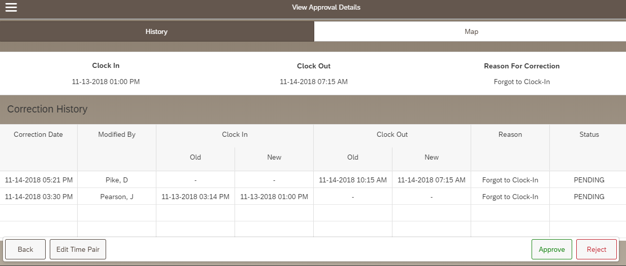

Add Time Pair
Employees or Supervisors can add time pairs at any time within the current or previous pay period. Newly added pairs will in the supervisor’s queue as PENDING. Employees are instructed to notify their supervisor if they edit or add a time pair after they suspect the supervisor has completed their final review prior to Payroll running.
Optional: Use the Position filter to view a specific group
Click an individual’s name to view their time pairs.

Click Add Time Pair to add a new time pair.

IMPORTANT  Use the drop-down menus to select:  - Employee  - Position | 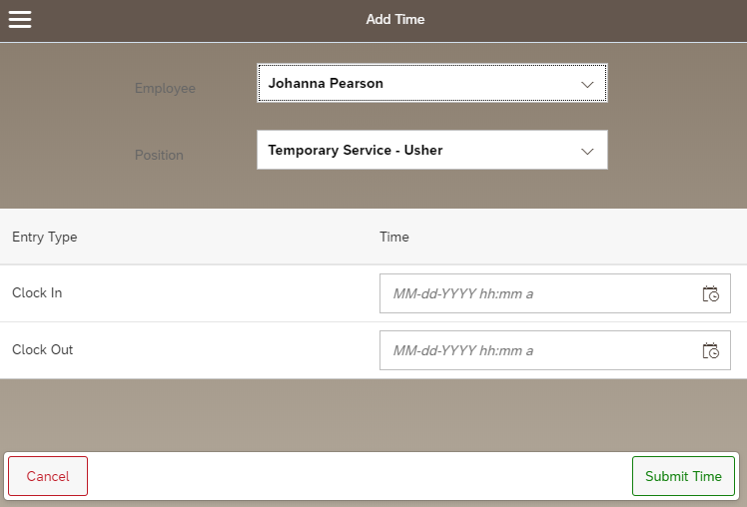
- Tap or click the calendar icon on the appropriate line to edit the Clock In and Clock Out date and time.  - Use the time sliders to indicate the new date and the “In” time and “Out” time.  - Click OK  - Click Submit Time | 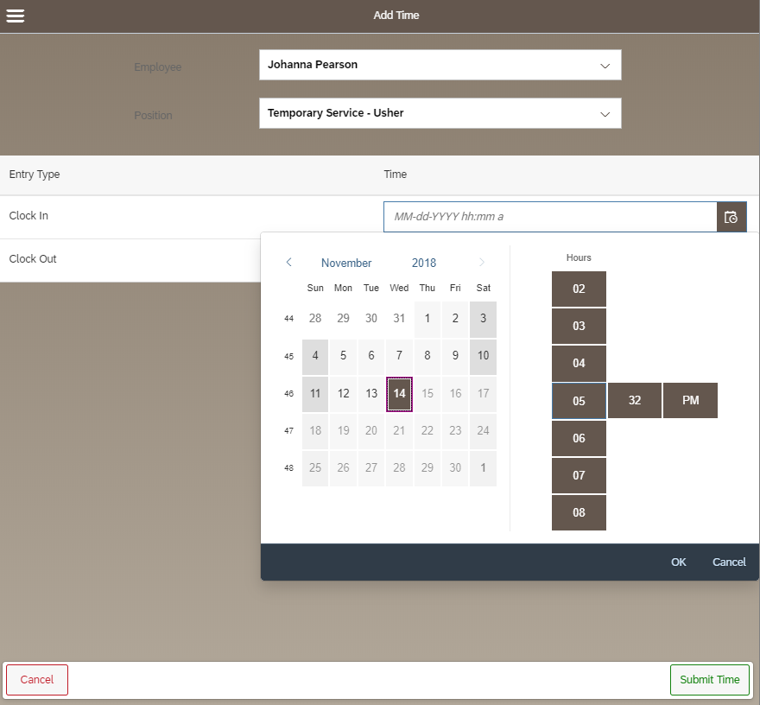  4  3  2  1
The time is now visible in the supervisor’s queue in PENDING status (awaiting approval).

