Employees assigned the Negative Duration time entry profile are only required to edit their time sheet if they work more hours than their regular schedule indicates (example: Overtime or Call Back).
- If you worked fewer hours than your regular schedule indicates for a week, submit a Time Off request to cover the missing hours. See the SuccessFactors Training Page (Time Off Tile) for instructions on submitting Time Off requests.

- If flexing time, a comment must be entered. The hours on the timesheet should not be adjusted.

Exception entries must be entered directly following your last shift of each week. When an exception entry is saved, it flows to your supervisor for approval.
For information regarding pay periods and calendars see the Payroll and Tax Services website.

Contents
Accessing SuccessFactors 1
Accessing the Timesheet 2
Entering Exception Time 3
Entering Flex Time 4
Entering Call Back Time 5
Amending Timesheet After Saving 6

Accessing SuccessFactors
Visit OneCampus and select Employee Launchpad. | https://one.purdue.edu/
Log in using Purdue Career Account ID and BoilerKey passcode.  For assistance using or stetting up BoilerKey, please contact ITaP at itap@purdue.edu or 765-494-4000. | 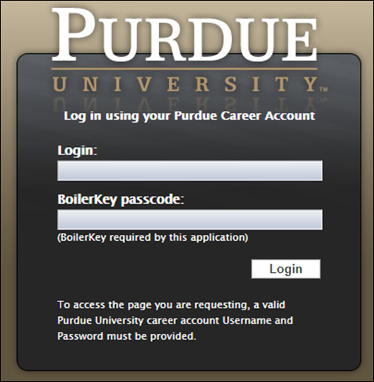

Accessing the Timesheet
Click the Time Sheet tile. | 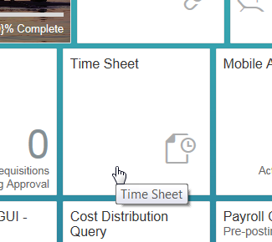
The current week’s timesheet opens.  The current day is highlighted.  Hours for Negative Time Entry employees are auto-filled at the beginning of each work day. | 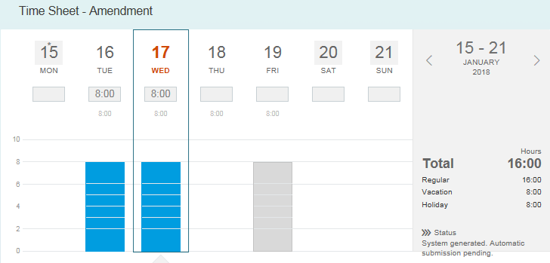
Navigate to the desired timesheet by clicking the back (left) arrow or the next (right) arrow on either side of the date range. | 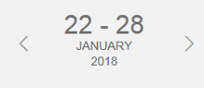

Entering Exception Time
Select the day on which additional hours are to be added.  To enter additional time to scheduled work hours, enter the total amount of time worked that day into a blank line of Working Time. This will void the original line of Working Time.  Ex. Worked 9 hours instead of the scheduled 8.  Click Save.  Note: Despite the presence of the +Add Absence button, Time Off requests must be submitted via the Time Off tile on the Employee Central homepage.  Instructions for submitting Time Off requests can be found on the SuccessFactors Training page. | 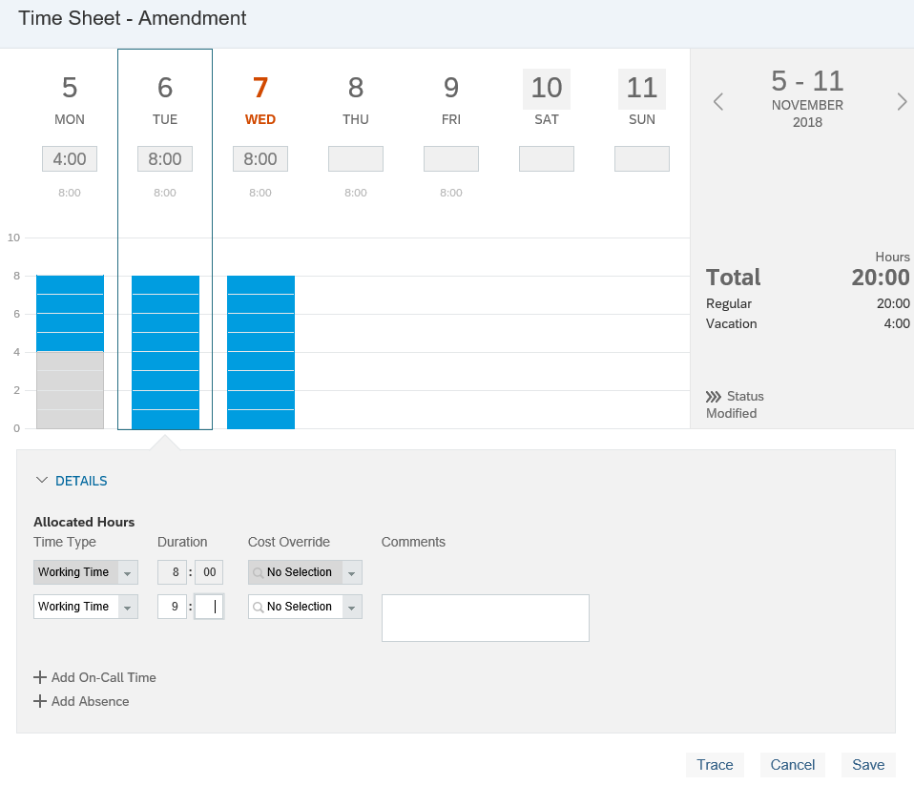
Status will change to “Modified” and manager will receive notification of request for approval. | 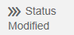

Entering Flex Time
Select the day on which Flex Time is to be noted. | 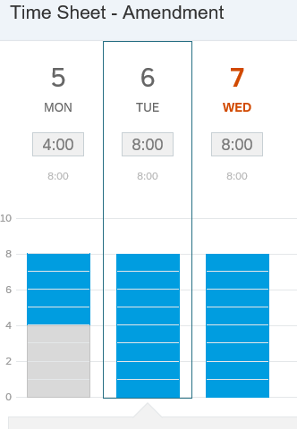
Copy the scheduled number of Working Time hours into a new line a new blank line of Working Time.  Note: If flexing, do not adjust the hours on each day to reflect exact hours worked. Since flexing results in the same total hours for the week, there is no need to adjust daily. Additionally, adjusting the hours daily will trigger a notification to your supervisor. Reports can be run on comments recorded in case of a need for a flex-time audit.  Click in the existing Comment box. | 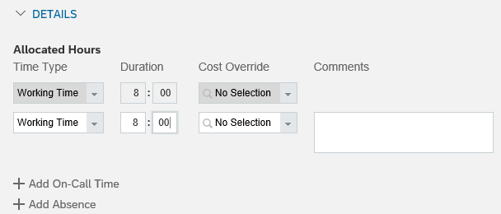
A new comment box will appear in line with the line reflecting the Working Time Hours.  Enter a comment in the new comment box that reflects the flex time. Example: “Worked 7 hours on 11/6 and 9 hours on 11/7.”  Click Save.  It is only necessary to add a comment to one of the days involved in each flex time situation. | 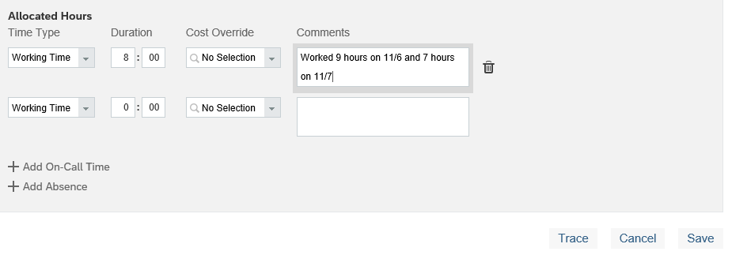
Flex Time entries only flow for supervisor approval if the entry is within a previous week.

Entering Call Back Time
Select the day on which Call Back time is to be added.  Click + Add On-Call Time | 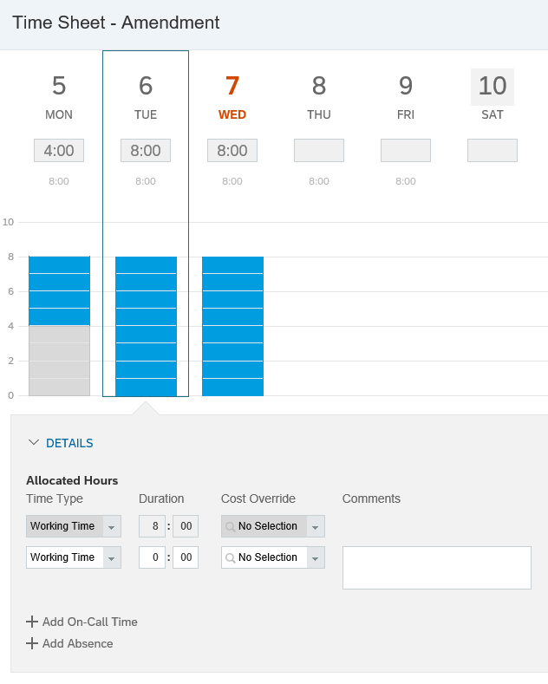
In the Duration field, enter 2:00  (In alignment with Purdue Call Back policy) | 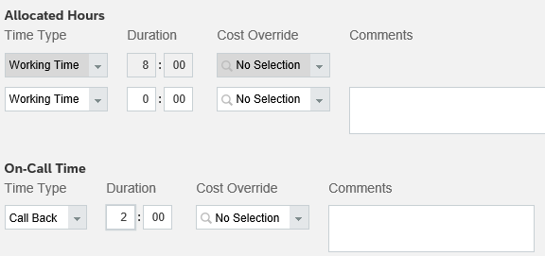
Enter the amount of hours worked during the Call Back instance within the Allocated Hours section  In the open Working Time Duration field, enter the total number of hours worked for the day.  In the example shown, the individual worked their 8 hour shift and then was called back and required to work 4 additional hours. Total Working Time for the day was 12 hours.  Click Save. | 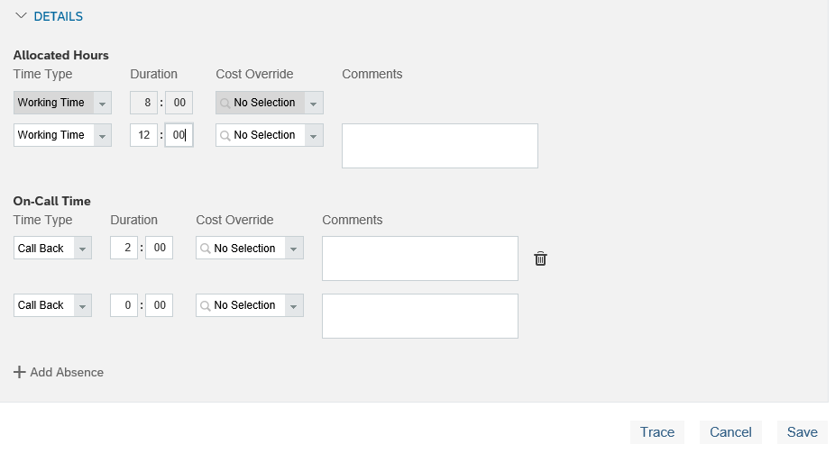
Status will change to “Modified” and manager will receive notification of request for approval.

Amending Timesheet After Saving
Locate the Timesheet to be changed (use the directional week arrows)  Click Withdraw or Make Amendment (button name varies depending on whether or not timesheet already contains exceptions). | 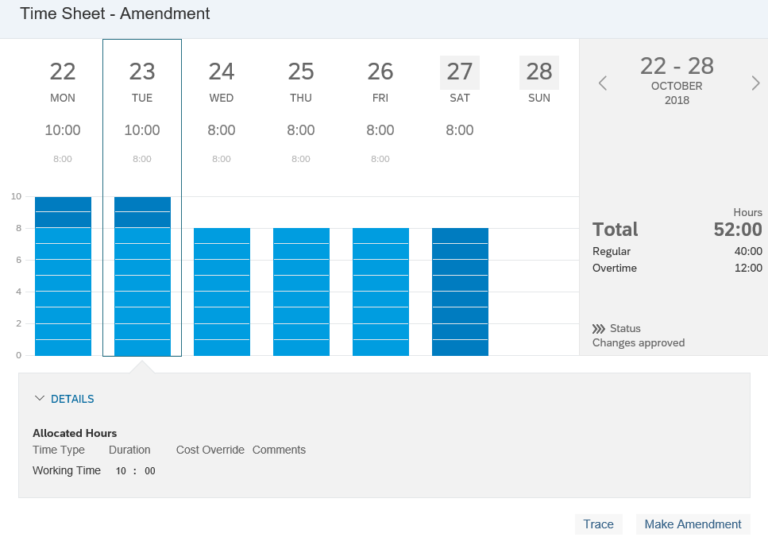
Status will change to “Draft Amendment.”
Make desired changes to the timesheet. | 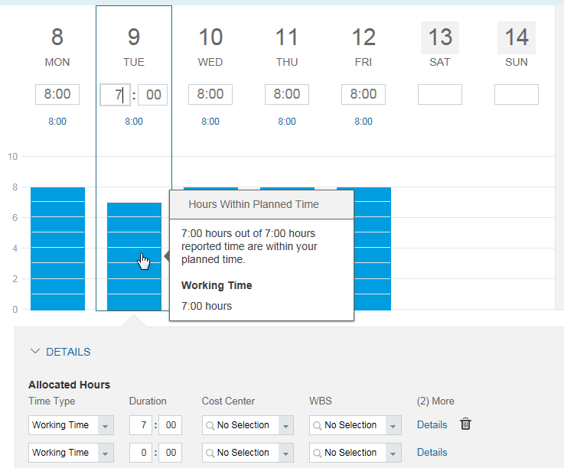
Click Resubmit. | 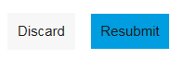
Status will change to “Modified” and manager will receive notification of request for approval.

