This QRG outlines the steps for closing a requisition, including sending emails to unselected candidates. These tasks will be performed by Department Recruiters (Faculty), Department Recruiters (Student), and Recruiters (Staff).
Closing the Job Requisition should happen after the candidate has been moved to Onboarding.

Access SuccessFactors
Visit OneCampus and select Employee Launchpad. | https://one.purdue.edu/
Log in using Purdue Career Account ID and BoilerKey passcode. | 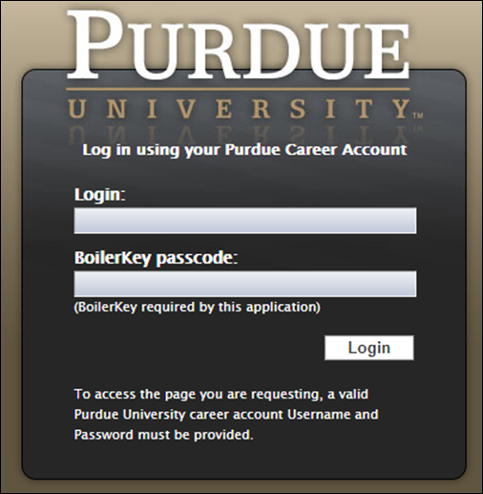

Job Requisition
From the Success Factors home page, click the Home drop-down menu and select Recruiting. | 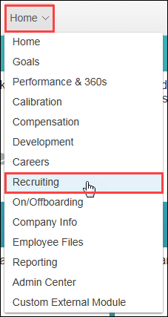
Click Job Requisitions.
Applicable Job Requisitions are displayed.

Under the Candidates column, click the Number.

Email Non-Selected Applicants
Applicants who weren’t selected will be in the Not Selected or Not Selected (HM) statuses. | 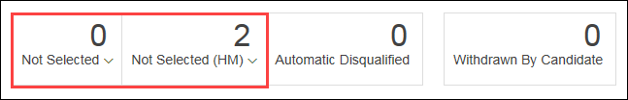
Click checkbox to select all applicants.  Click Action drop-down.  Select Email Candidate. | 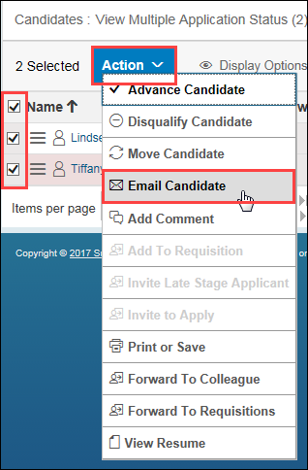
Select appropriate email Template. | 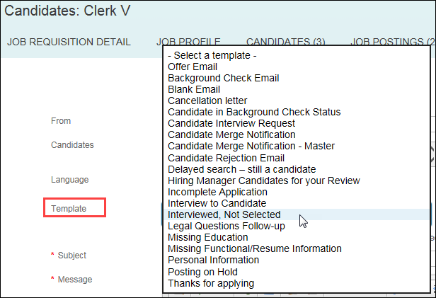
The selected template is displayed.  All items highlighted in yellow will be prepopulated from the candidate application and profile data.  Review template and make edits, if needed. | 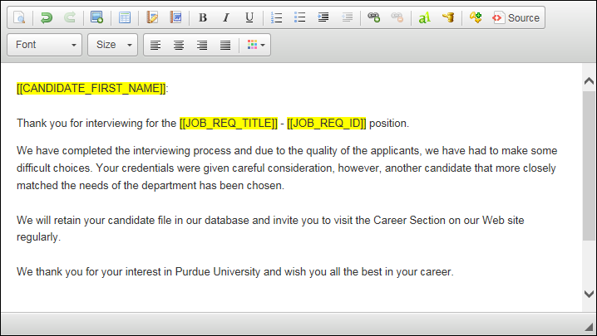
Click Next.
A preview of the email is displayed.  Perform a final review prior to sending. | 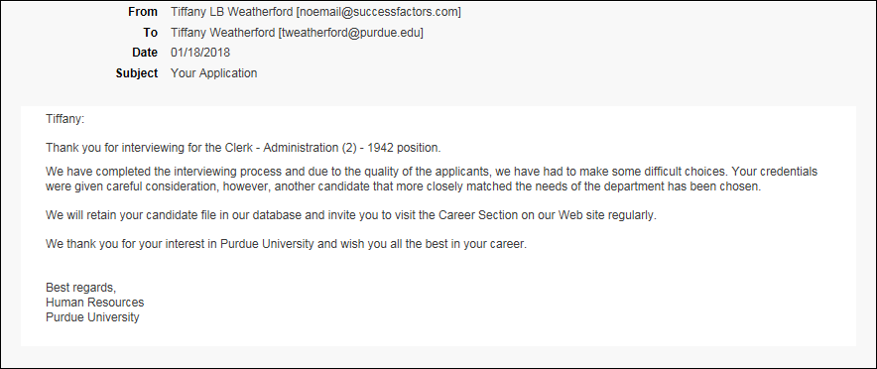
Click I’m Done. | 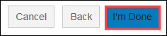
The email is immediately sent to the recipient(s).

Move Candidate to Hired
The selected candidate will be listed in the Ready to Hire status.  Click to select candidate and drag and drop in to the Hired status. | 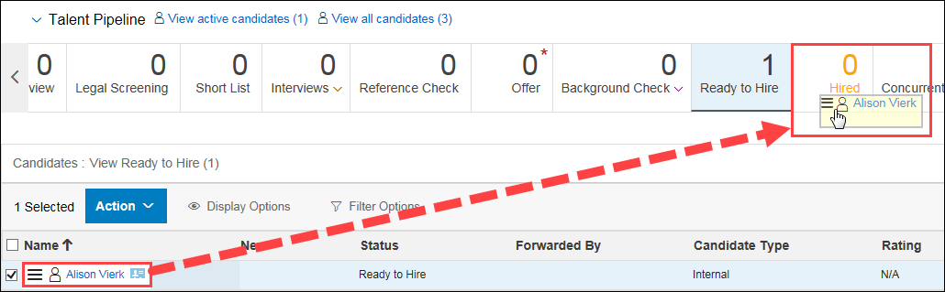
Click Apply Updates. | 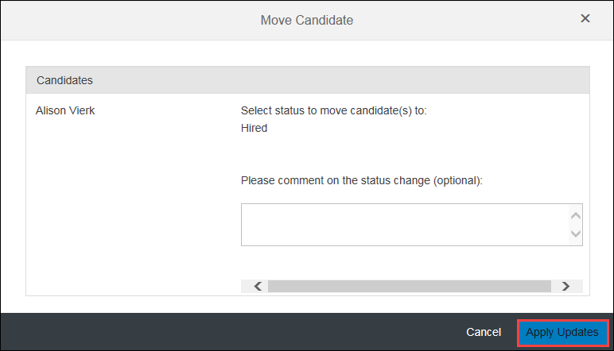
A confirmation message is displayed warning that completing the action will close the requisition.  Click OK. | 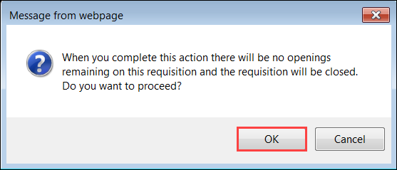
Candidates that were not selected for the next steps in the interview process should be moved into Not Selected. Candidates that were selected to move forward in the search process can remain in their respective bucket within the Talent Pipeline.

Mark Requisition Filled
Click Job Requisitions Details at the top of the page.
The job requisition is displayed.  Select Filled from the Status drop-down. | 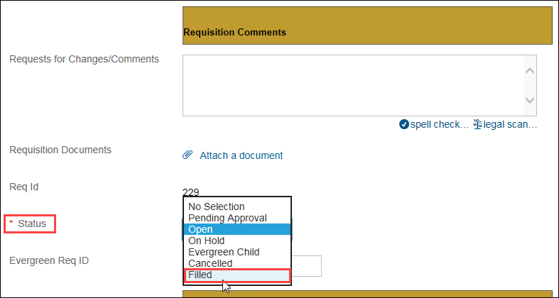
Click Save Changes.
The job requisition is filled and the posting is removed from the Career site.

