This Quick Reference Guide outlines the primary tasks employees might complete within their Employee Profile in SuccessFactors.

More detailed resources and documentation can be found on the SuccessFactors Training Page, found at https://www.purdue.edu/hr/successfactors/training/index.php.

Contents
Accessing SuccessFactors 1
Viewing Your Pay Statement 2
Recording Time - Positive Duration or Negative Duration 2
Recording Time - Webclock 2
Requesting Time Off 3
Editing Personal Information 4
Editing Bank Information 4
Editing Tax Information 5

Accessing SuccessFactors
Use an internet browser to visit the OneCampus Portal (https://one.purdue.edu/).

Click Employee Launchpad
Log in using Purdue Career Account ID and BoilerKey passcode.  For assistance using or setting up BoilerKey, please contact ITaP at itap@purdue.edu or 765-494-4000. | 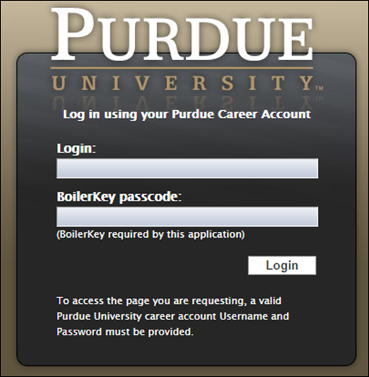

Viewing Your Pay Statement
Scroll down to the My Info section  Click the My Profile tile | 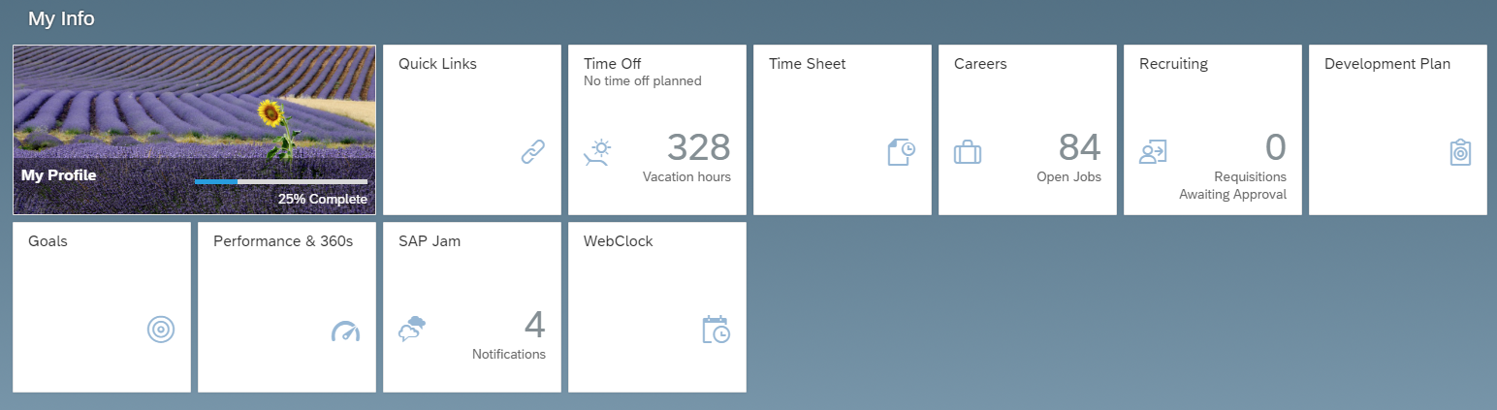
Click the PAYROLL INFORMATION tab  Click Pay Statement | 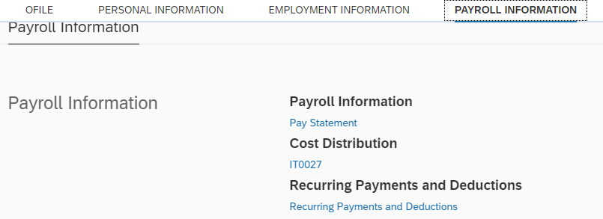  1  2

Recording Time - Positive Duration or Negative Duration
This section applies to individuals who utilize Positive Duration Entry or Negative Duration Entry timekeeping. For detailed resources and instructions for time entry, please visit www.purdue.edu/timehelp.
Scroll down to the My Info section

Click the Time Sheet tile

Recording Time - Webclock
This section applies to individuals who utilize Webclock timekeeping. For detailed resources and instructions for time entry, please visit www.purdue.edu/timehelp.
Scroll down to the My Info section

Click the Webclock tile

Requesting Time Off
The example below is a basic Time Off request. Detailed resources and documentation related to Time Off requests, including cheat sheets and video demonstrations, can be found on the SuccessFactors Training Page, found at https://www.purdue.edu/hr/successfactors/training/index.php.
Scroll down to the My Info section

Click the Time Off tile

- Click the type of leave being requested  - Select from the calendar or enter the date(s) being requested  - In the Requesting field, select the amount of time being requested  - Optional: Enter a comment for your supervisor  - Click Submit. | 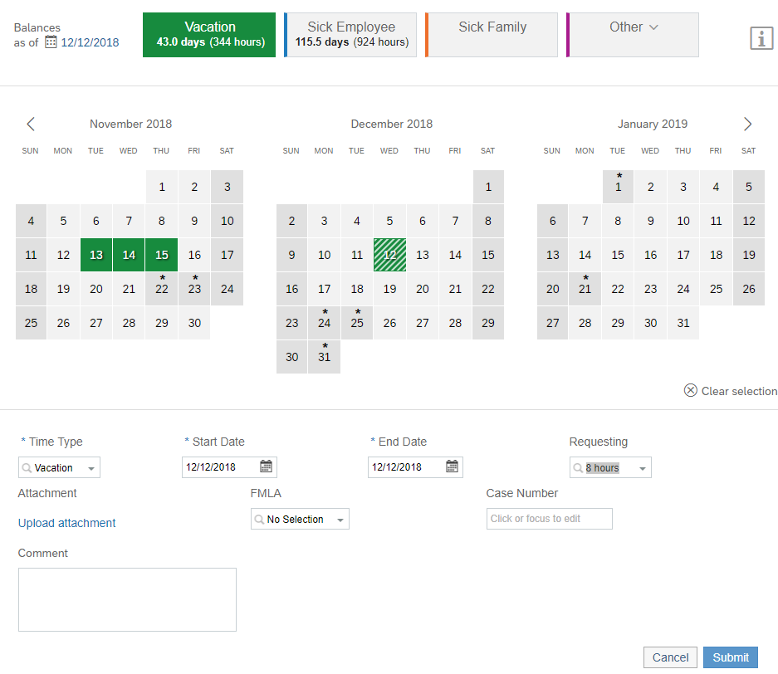  5  4  3  2  2  1

Editing Personal Information
Scroll down to the My Info section

Click the My Profile tile

Click the PERSONAL INFORMATION tab | 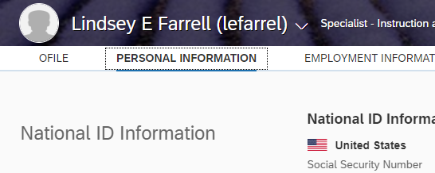
Only the following information is editable:  - Home Address  - Home Phone Number  - Emergency Contact  Use the pencil icon to edit the fields. | 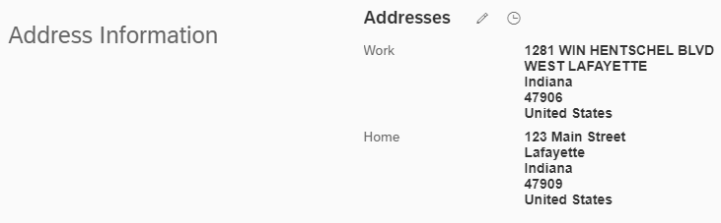

Editing Bank Information
Scroll down to the My Info section

Click the My Profile tile

- Click the PAYROLL INFORMATION tab  - Click Bank ESS | 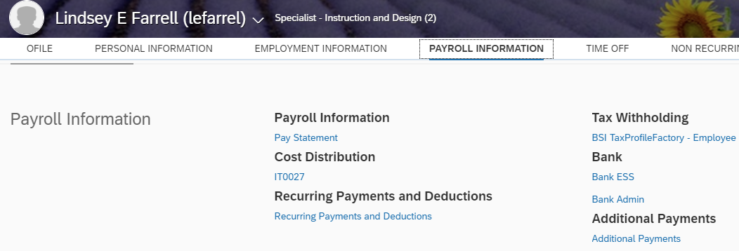  2  1
Click the Pencil icon to edit bank info.  Click Other bank to add new bank. | 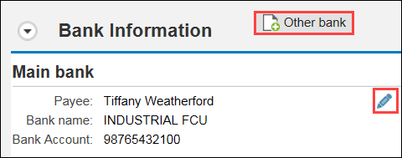

Editing Tax Information
Scroll down to the My Info section

Click the My Profile tile

- Click the PAYROLL INFORMATION tab  - Click BSI TaxProfileFactory – Employee  Make any necessary adjustments and submit. |  | 2  1

