This QRG outlines the steps to move a selected candidate from the Recruiting module in to the Onboarding module.

Access SuccessFactors
Visit OneCampus and select Employee Launchpad. | https://one.purdue.edu/
Log in using Purdue Career Account ID and BoilerKey passcode. | 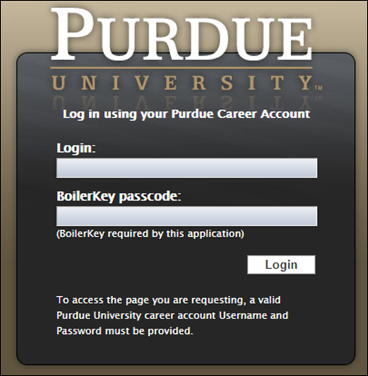

Candidate Profile
From the Success Factors home page, click the Home drop-down menu and select Recruiting. | 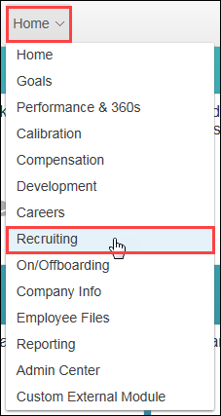
The list of Job Requisitions is displayed. | 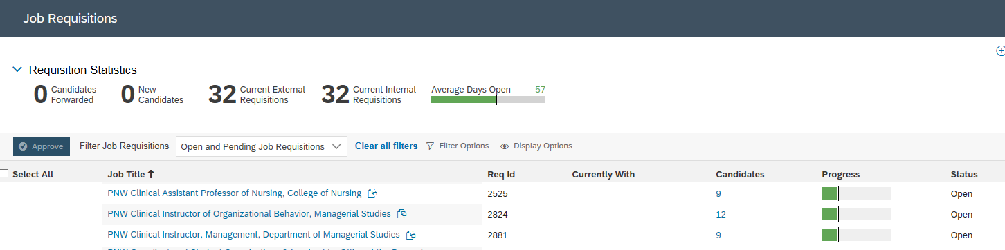
Click Number link under the Candidates column corresponding to the Job Requisition.
You will need to move the candidate to the Ready to Hire bucket in the Talent pipeline in order to initiate onboarding.

Check mark the candidate’s name, click the Action, select Move candidate, select Ready to Hire.
Click Ready to Hire status on the Talent Pipeline. | 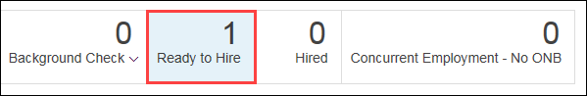
Click candidate Name to open details. | 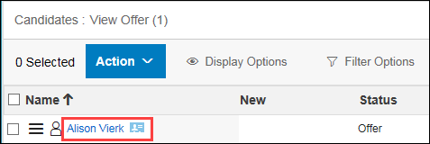

Initiate Onboarding and Post Hire Data Verification
From the candidate profile, click Take Action.  Select Initiate Onboarding. | 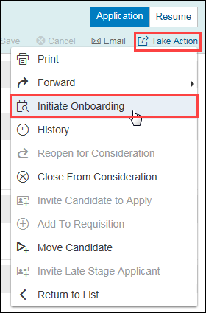
Click Confirm. | 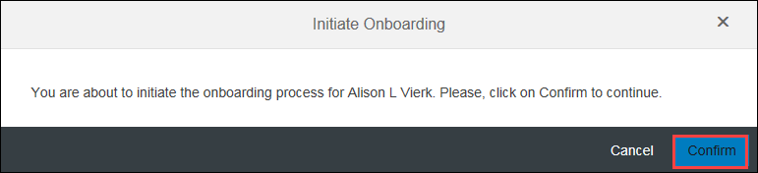
A notification that Onboarding has been initiated is displayed.  Click OK. | 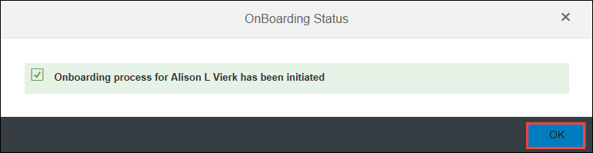

Post-Hire Data Verification
Go to the drop down box located on the top of your screen/dashboard and select Onboarding | 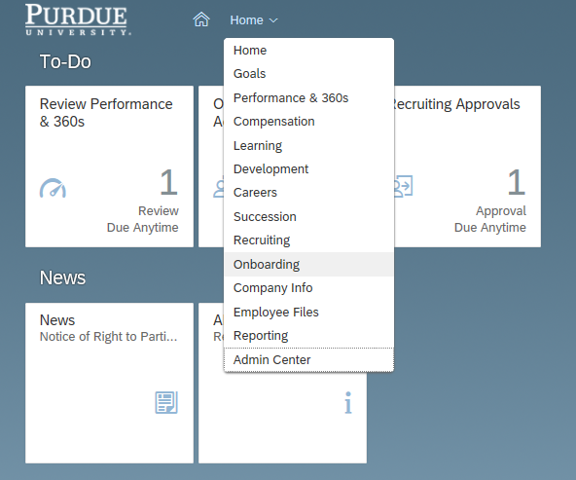
The Onboarding dashboard is displayed. Find your new hire’s name and click on his/her line of information. | 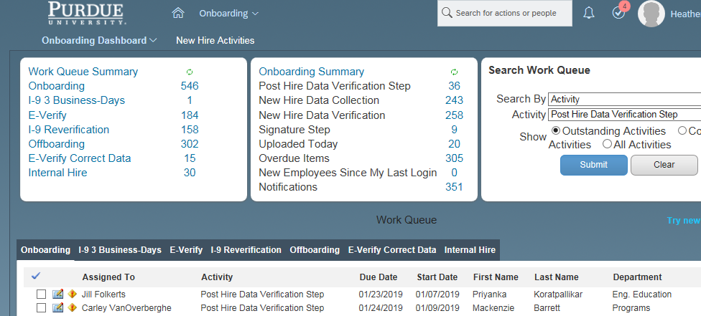
Click the link of the desired new hire to open My Tasks For New Hire. | 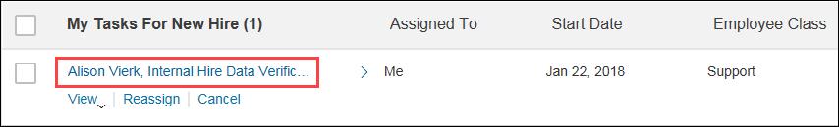
Review and verify the following:  - New Hire Name  - Dates  - Hire Information  Is new hire a remote employee –  Yes = Employee will live outside the state of Indiana  No = Employee resides within Indiana | 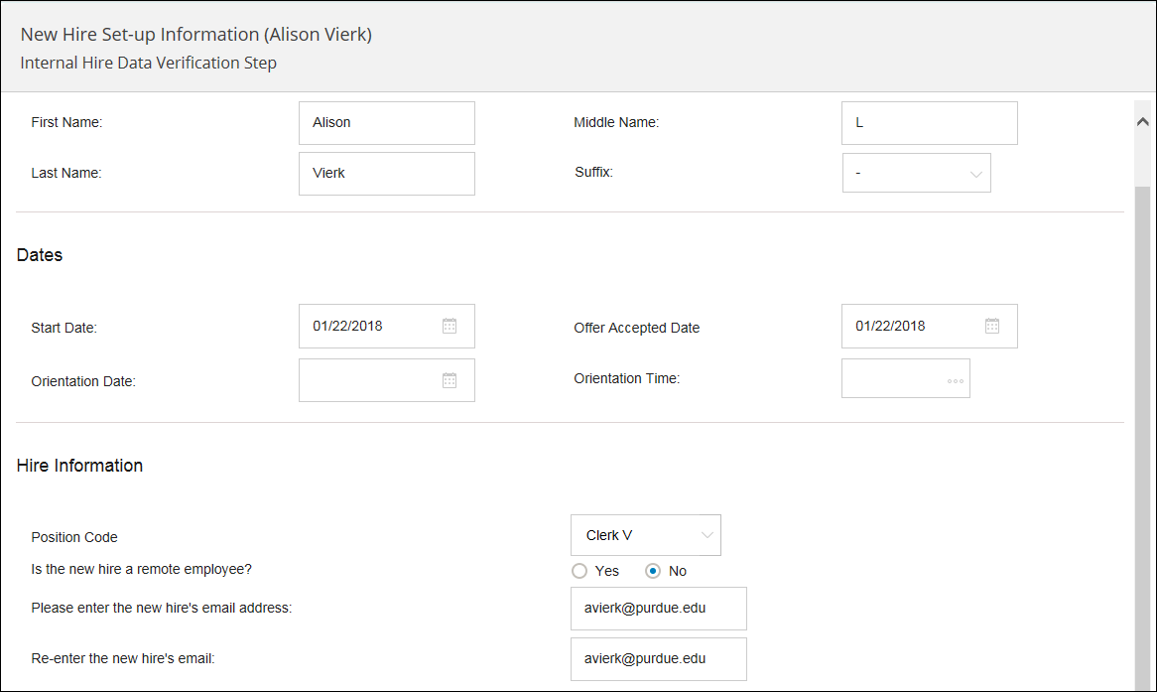
Click Next.
Review and verify the following:  - Job Location  - Position Information  Input Tania Sanders as the Onboarding Coordinator | 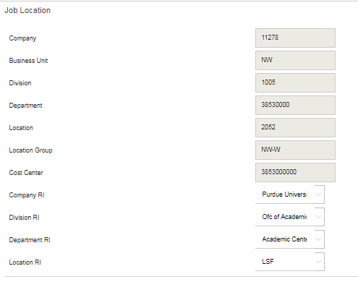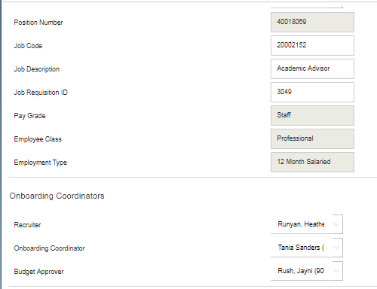
Click Next.
Review and verify the following:  - Salary = Monthly pay rate | 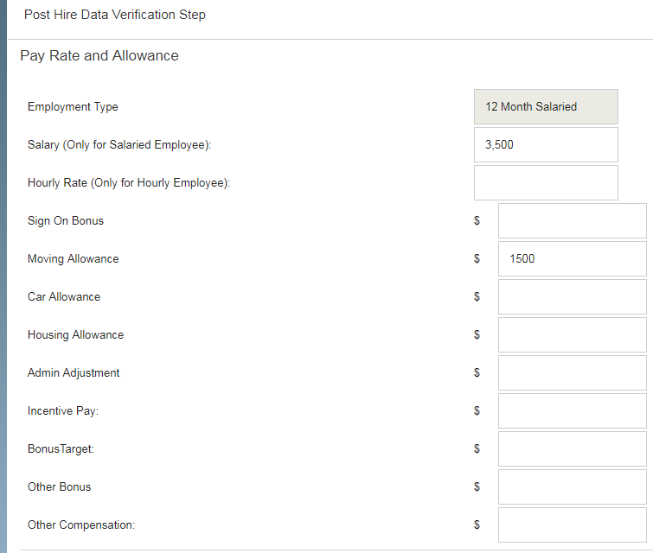
Click Finish. | 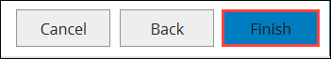
Scroll to conduct a final review of the new hire data. | 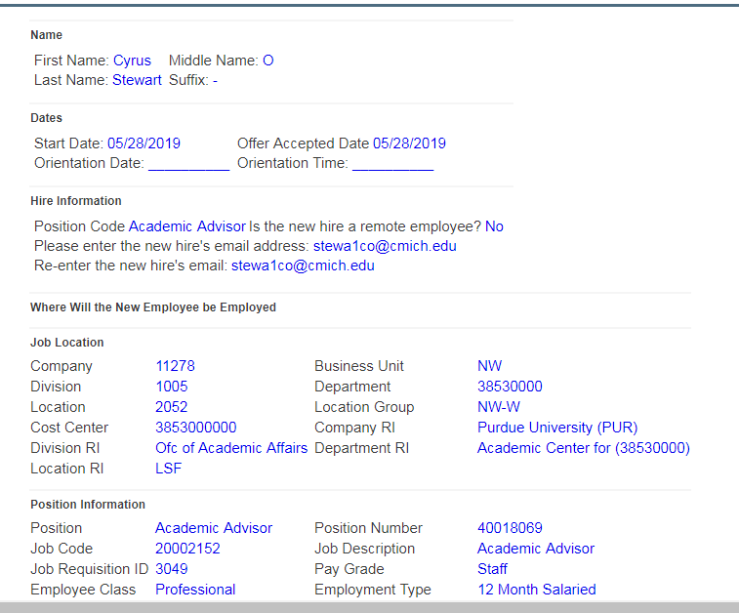
Click Finish.
Onboarding is now triggered for the new employee, which includes sending new employee their online new hire paperwork.

