This QRG outlines the steps a Department Recruiter would follow to prepare the Offer Approval details and route for proper approvals.
The Offer Approval must be created and approved before extending the Offer Letter to the selected candidate.

Access SuccessFactors
Visit OneCampus and select Employee Launchpad. | https://one.purdue.edu/
Log in using Purdue Career Account ID and BoilerKey passcode. | 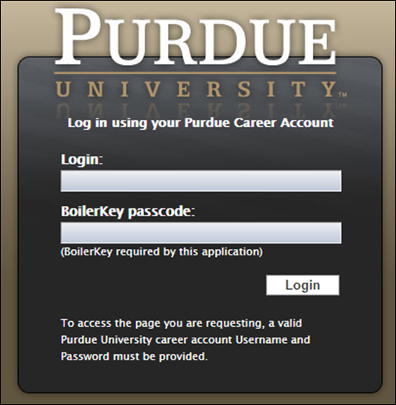

Job Requisition
From the Success Factors home page, click the Home drop-down menu and select Recruiting. | 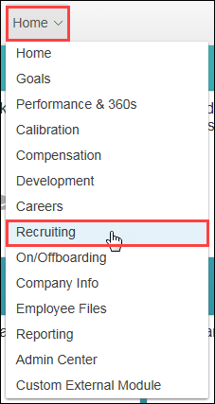
The list of Job Requisitions is displayed. | 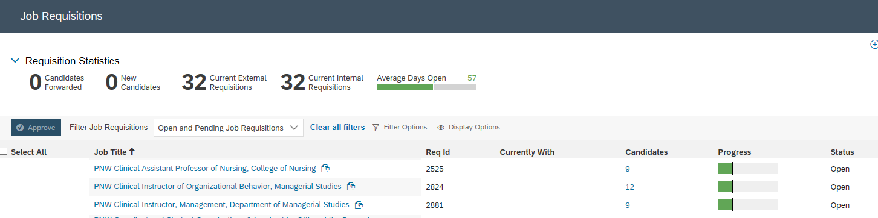

Move Candidate
Click Number link under the Candidates column corresponding to the Job Requisition.
Click candidate Name and drag and drop candidate into the Offer status of the Talent Pipeline. | 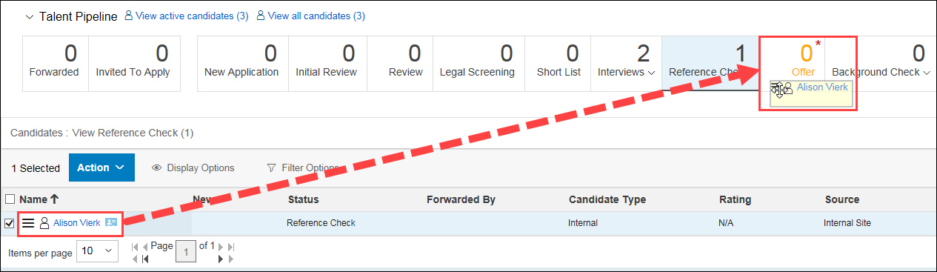
Click Apply Updates. | 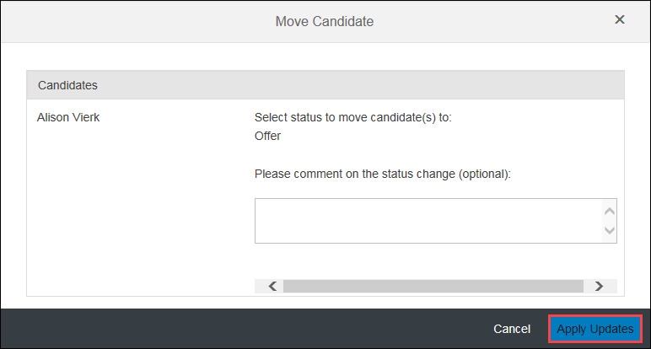

Create Offer Approval Details
Click candidate Name to open details. | 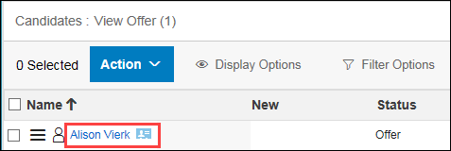
The candidate application is displayed. | 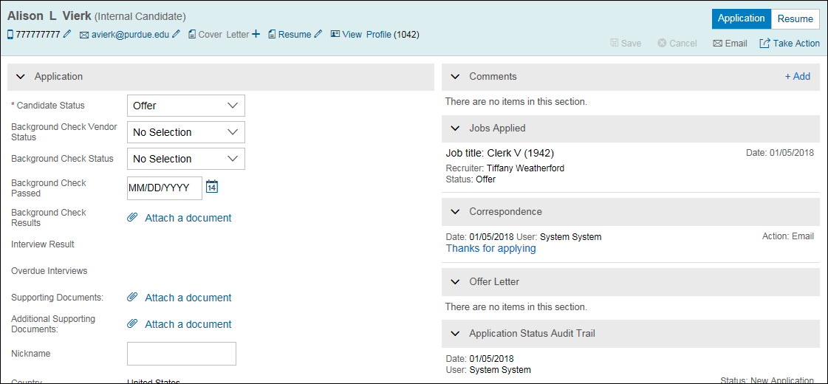
Click Take Action.  Hover over Offer.  Select Offer Approval. | 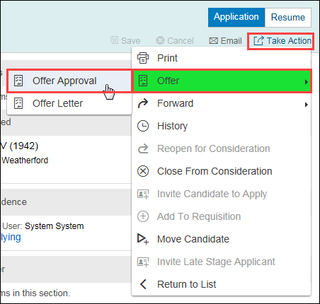
Select Faculty Offer Details from drop-down. | 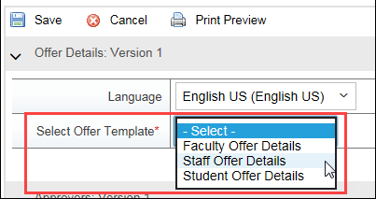
Complete Offer Details.  Required fields will be marked with a red asterisk (*).  EC Position Number is the same number as Position Number. Copy and paste the Position number into the EC Position Number Box  Will the employee be a remote employee –  Yes = Employee works outside the state of Indiana otherwise “No”. | 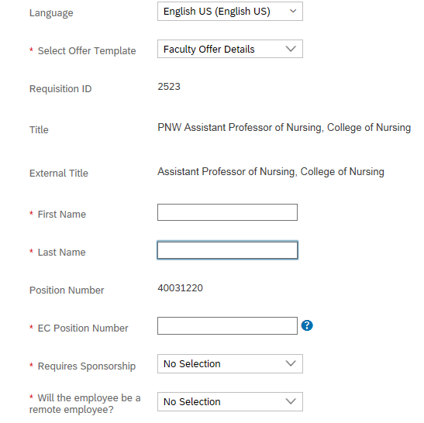
Input the monthly salary amount into the Period Rate box | 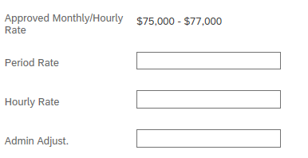  6,250
Next to Offer Letter, click Attach a document. | 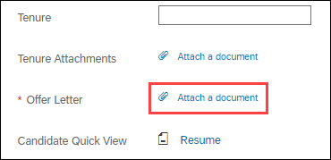
Click Choose File. | 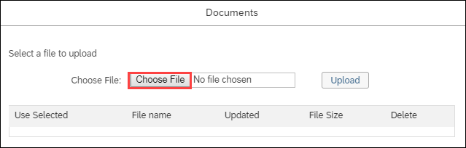
Click on a document to upload as a placeholder to move forward in the offer approval process.
Click Upload. | 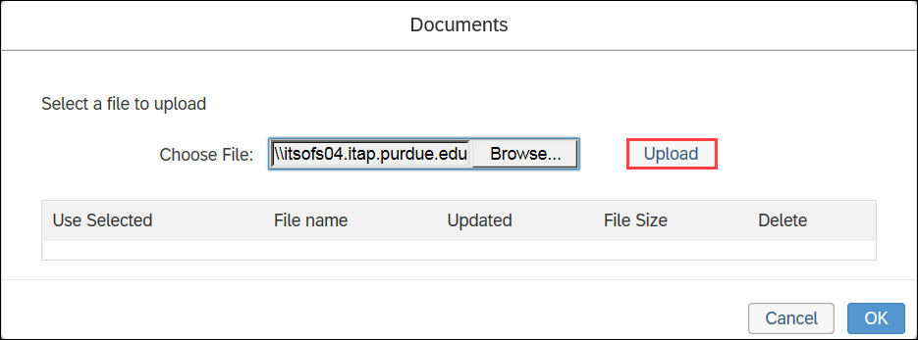
Click the Use Selected checkbox to attach. | 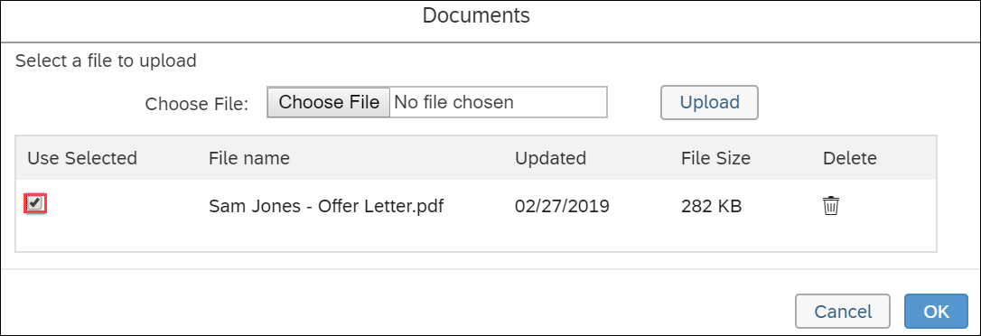  Placeholder doc.
The input the Approvers for the Offer Approval.  Add Comments, as needed. | 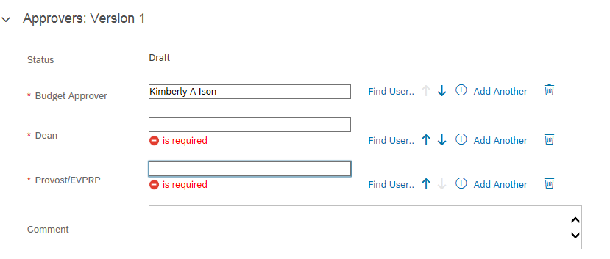  Elizabeth Depew  Tania Sanders  Dean’s Name
Click Send For Approval to route to first approver.

Click Save to save changes, but not kick off the approval workflow.
Click Yes to continue. | 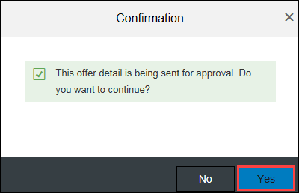
The Offer Details are now in the approver’s queue to review and approve, or send back with edits.

