Requesting Time Off in SuccessFactors Quick Reference Guide

Last Updated: 09/05/2019

This guide outlines the steps required to request Time Off.

For additional information concerning Time Off policies and procedures, please refer to the Purdue Human Resources Benefits website: https://www.purdue.edu/hr/Benefits/currentEmployees/leaves/leaves.html
Note: The Time Off request feature does not replace conversations and planning between employees and supervisors.

Contents
Accessing SuccessFactors 1
Note for Employees with Multiple Appointments 1
Accessing Time Off Module / Screen Overview 2
Time Off: Requesting, Editing, and Cancelling Requests 4

Accessing SuccessFactors
Visit OneCampus and select Employee Launchpad. |  | https://one.purdue.edu/
Log in using Purdue Career Account ID and BoilerKey passphrase.  For assistance using or stetting up BoilerKey, please contact ITaP at itap@purdue.edu or 765-494-4000. |  | 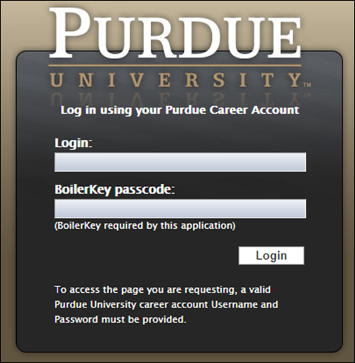

Note for Employees with Multiple Appointments
If you hold multiple positions, use the Change Selected Employment menu to select the position for which you would like to record time | 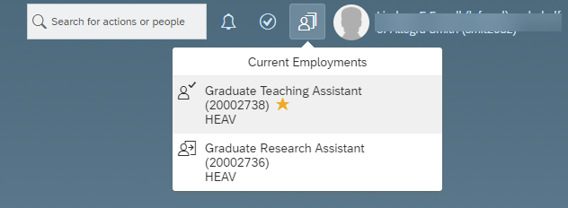
If you hold multiple positions and they are similarly named, click My Profile to validate that the correct position has been selected | 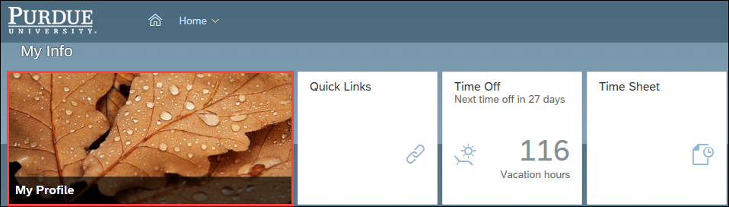
If you hold multiple positions and they are similarly named, click the Employment Information tab to view the details of the position selected in order to ensure time off is requested for the correct position.  Click the Home icon at the top of the page to return to the SuccessFactors home page. | 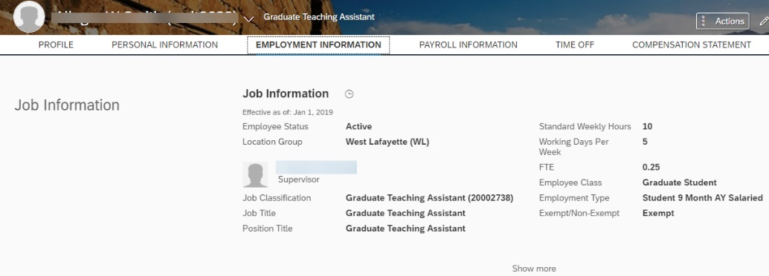

Accessing Time Off Module/Screen Overview
After logging in to SuccessFactors and selecting the appropriate position (if applicable) scroll down to the My Info section and click the Time Off tile. | 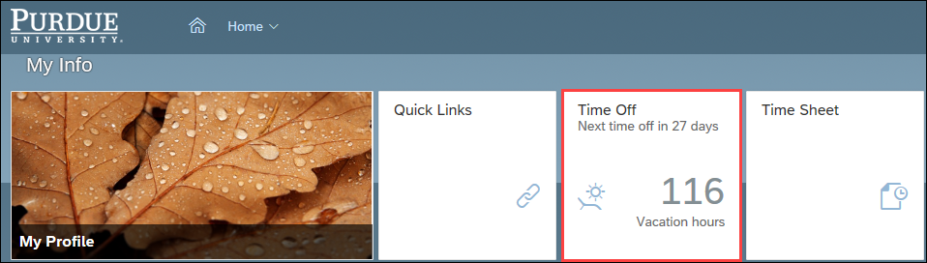
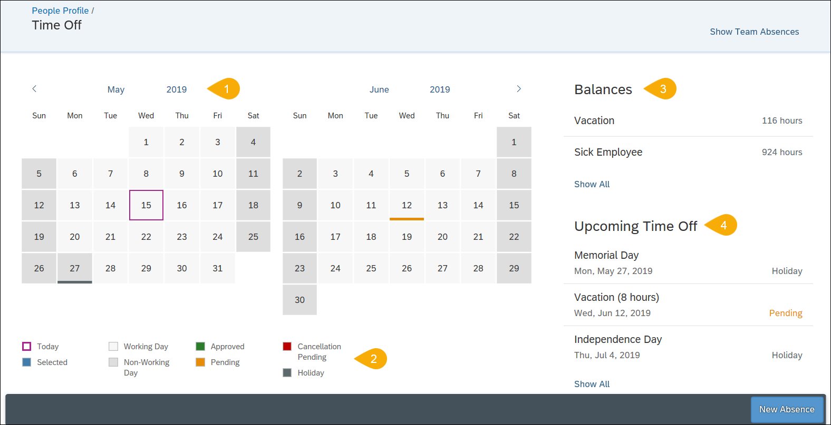
- Calendar | Displays the current and next month; dates with scheduled time off are indicated by colored bar.
- Calendar Legend | Describes each color notation that indicate various leave statuses.
- Balances | Displays Vacation and Sick Employee balances as of today’s date.
- Upcoming Time Off | Displays the next three time Absense and Holiday time off entries.

Time Off: Requesting
From the Time Off screen, click New Absence. | 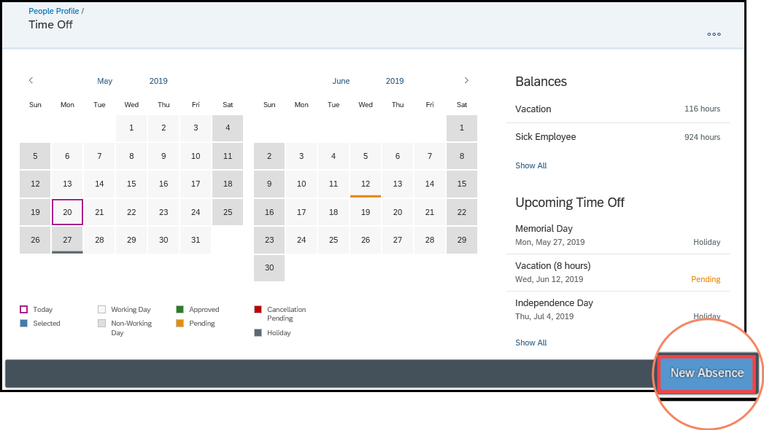
All fields marked with an asterisk (*) in this document are required.
Scroll to the bottom of the page and complete all required or applicable fields before clicking Done.
- Click on the Time Type dro-down to select the desired leave type.  - Enter or select from the calendar the Start and End Date for the leave request.  - The Requesting field should be left as-is. The leave does not calculate hours, please ignore this field.  - Enter any information you would like to provide to your supervisor in the Comments text entry box.  - Click the + (Plus Sign) to upload and attach any supporting documentation.  - Indicate the Address of where you will be residing during the time off.  - Enter the Percentage on Leave for the time off.  - Select Yes or No to indicate if you Will be traveling internationally. If you indicate yes this will send a notification to the Risk Management department so they are aware of all international travel. | 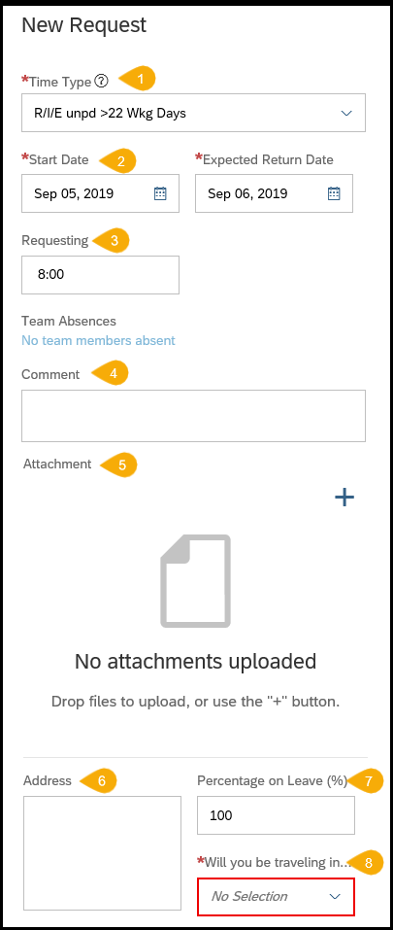
- Primary country while on leave – Select the country you will primarily reside in during your time off.  - Secondary country while on leave – Select the any other country you will traveling to during your time off  - Location(s) On Leave – Indicate all locations you will be at during your time off  - I have read and agree to Policy I.A.1 outlined on the Time Off screen – Indicate yes or no  - I have read and agree to the University Sabbatical Policy – Indicate yes or no  - Provide a description of the leave that includes the goal of the leave – Type description here or indicate “In attachment”  - Provide a description of how your campus duties will be covered while on leave (teaching, supervision of students, etc.) – Type description here or indicate “In attachment”  - Please provide a description of how the leave will benefit the University – Type description here or indicate “In attachment”  - Will you continue to serve as a PI or Co-PI while on leave? – Indicate Yes, No or N/A  - In your attachment did you provide an oversight plan for each of your active sponsored projects? – Indicate Yes, No or N/A  - Will your leave cause a change in scope for your sponsored project? – Indicate Yes, No or N/A  - Compensation – Indicate Time Off is with partial pay, with pay or without pay  - Effort – Indicate Full Time or Half Time | 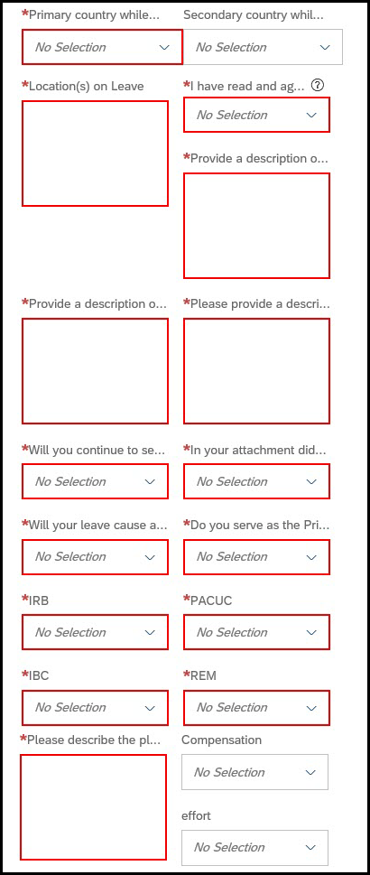
- WBSE 1, WBSE 2, WBSE 3, WBSE 4 (multiple fields) – Indicate up to four (4) Work Breakdown Structure Elements associated with this time off request  - WBSE 1 Percent, WBSE 2 Percent, WBSE 3 Percent, WBSE 4 Percent (multiple fields) – Type the percentage associated with each WBSE entered  - Internal Order 1, Internal Order 2, Internal Order 3, Internal Order 4 (multiple fields) – Indicate up to four (4) Internal Orders associated with this time off request  - Internal Order 1, Internal Order 2, Internal Order 3, Internal Order 4 (multiple fields) – Type the percentage associated with each Internal Order entered  - Admin Supplement – Indicate if you currently have an administrative supplement | 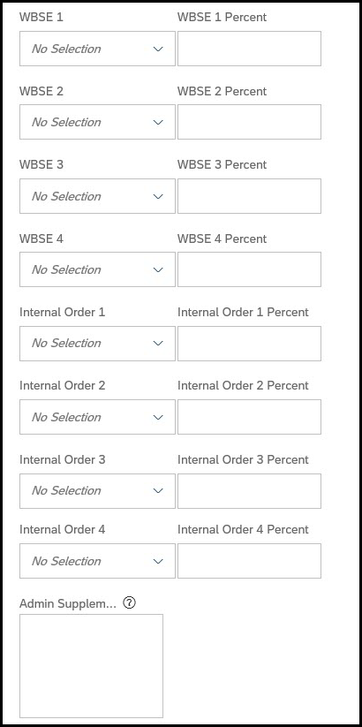
Depending on the type of request, a notification(s) will appear at the top of the request. These notifications relate to policies for the type of time off request.  Review the notification. | 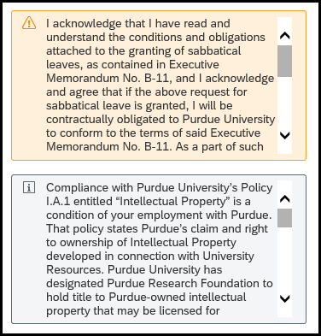
Click Send Request.
- The first approver within the workflow receives an email notification that your request has been submitted.
- All business leaves require several levels of approval as follows: Business Office, Department Head, DFA, Dean, Central HR (leaves group), Sponsored Programs and Provost.
To cancel the request (all completed field information will be lost), click Cancel.

Time Off: Status
After submitting, the request is listed under the Upcoming Time Off heading with a status of Pending.  The request is also now indicated as Pending with a gold line on the date on the Calendar. | 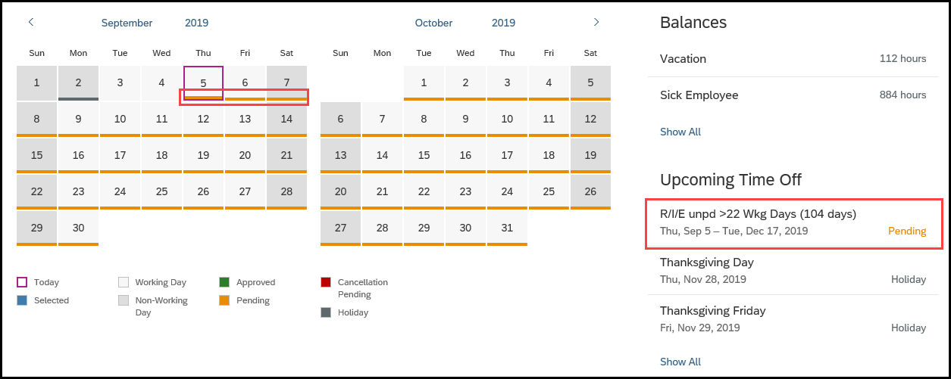
Once a leave has been approved, the status will change from Pending to Approved. | 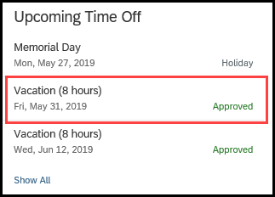
Comments added by the employee or approver can be viewed by clicking the desired request under the Upcoming Time Off heading. | 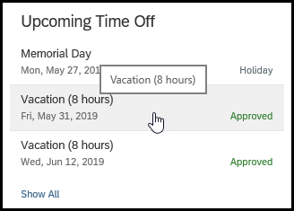
The Request Details opens and all Comments are displayed. | 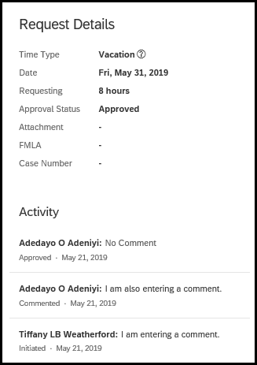

Time Off: Editing
The submitted request can be accessed by clicking the Date on the Calendar, or by clicking the Absence listed under the Upcoming Time Off heading. | 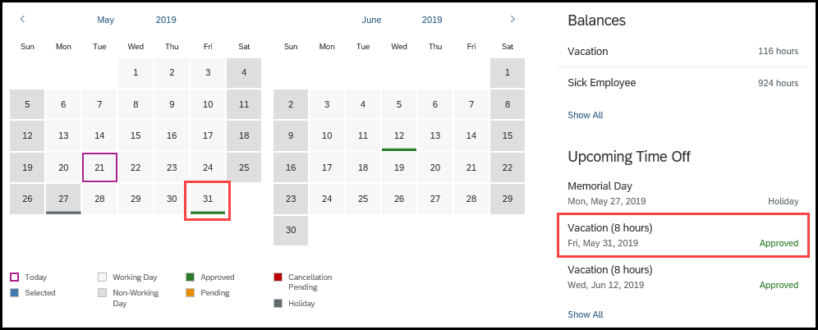
If using the Calendar, click the Pencil icon to edit. | 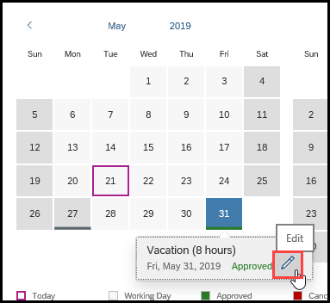
If accessing through Upcoming Time Off, click Edit Absence. | 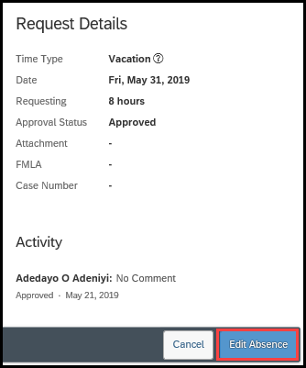
Make necessary edits to the request. | 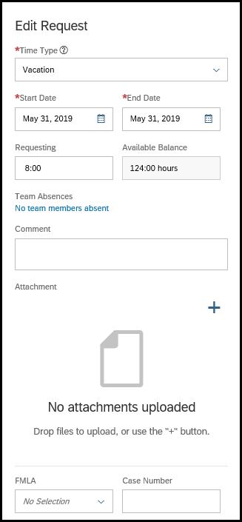
Click Send Request.  NOTE: The edited request will be routed for approval only if the original request was already approved. | 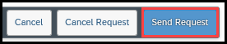

Time Off: Cancelling
The submitted request can be accessed by clicking the Date on the Calendar, or by clicking the Absence listed under the Upcoming Time Off heading.
If using the Calendar, click the Pencil icon to edit.
If accessing through Upcoming Time Off, click Edit Absence.
Click Cancel Request.

NOTE: The cancelled request will be routed for approval only if the original request was already approved.
Click Yes to confirm cancellation.  Click No to exit from the cancellation request without submitting. | 