This QRG outlines the steps for Department Recruiters to review initial applications, perform an initial employment screening, and move candidates through the Talent Pipeline to document candidate selection and interview process.

Access SuccessFactors
Visit OneCampus and select Employee Launchpad. | https://one.purdue.edu/
Log in using Purdue Career Account ID and BoilerKey passcode. | 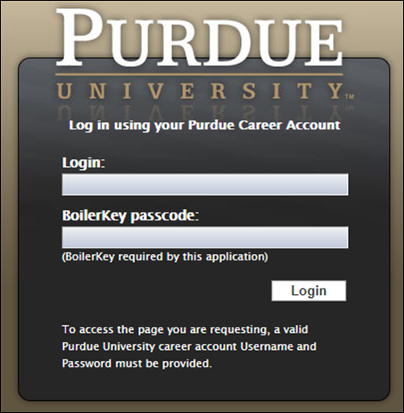

Job Requisition
From the Success Factors home page, click the Home drop-down menu and select Recruiting. | 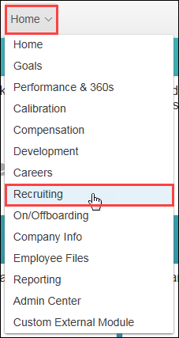
The list of Job Requisitions is displayed. | 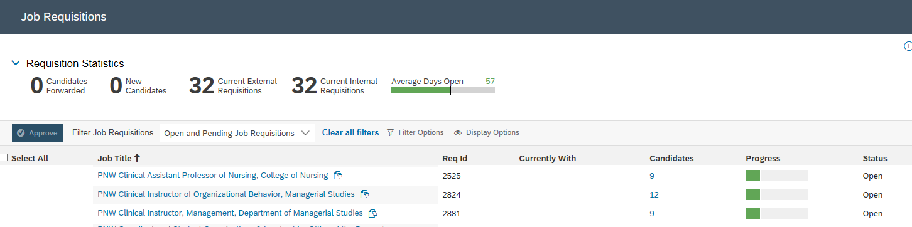

Initial Review & Screening
Click Number link under the Candidates column corresponding to the Job Requisition.
Click New Application status on the Talent Pipeline. | 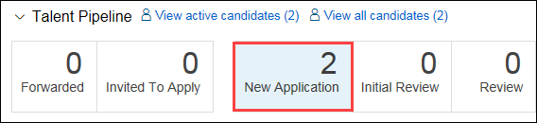
Click candidate Name. | 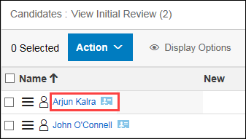
Review candidate Application and Screening Details. | 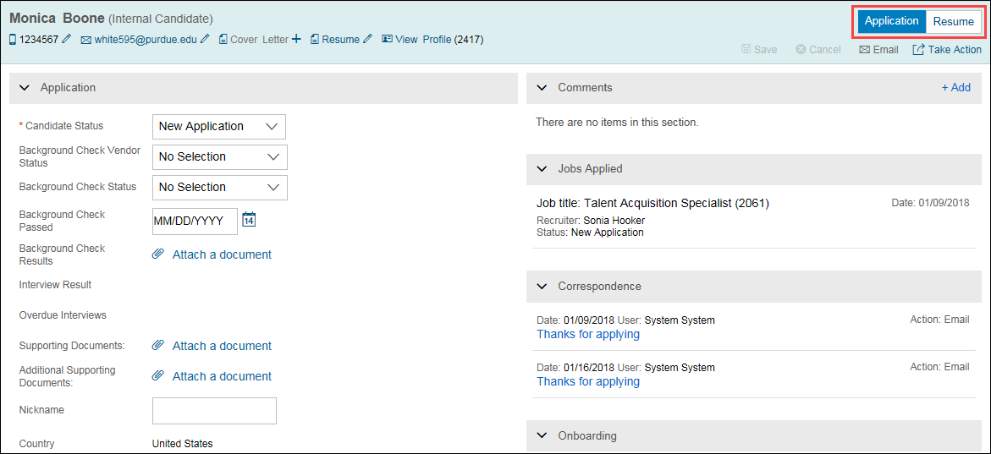
Your candidate list is located on the left of the screen. You can select the next name on the list to review and evaluate.
As you make decisions on candidates, you can move them across the Talent Pipeline | 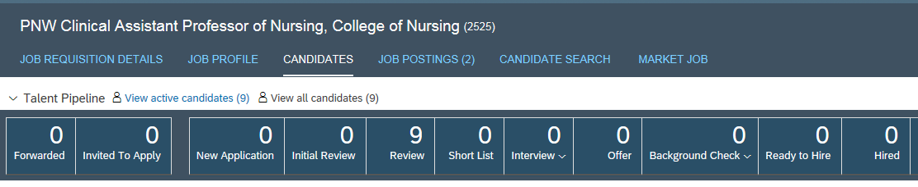
To move candidates to the next stage in your interview process, check mark the candidate(s) name, click the Action, select Move candidate, select the appropriate status from the dropdown menu.

Enter Comments, if necessary.  Click Apply Updates. | 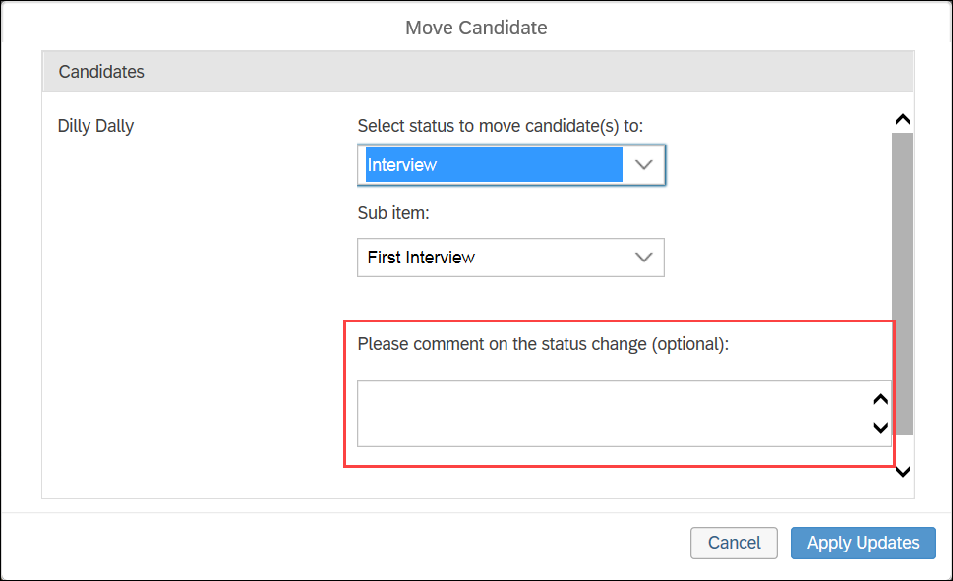

Remove from Consideration
To remove a candidate from consideration, click on Not Selected. Select a status from the drop-down list

Click Apply Updates

Print or Save Application Materials
Click the Action, select Print or Save from the dropdown menu
Select items to Print or Save. Click Print Preview then print. Or click Save to File to download the information to your computer. | 