This QRG outlines the steps for the OIE Recruiter to review and approve a pending job requisition.

Access SuccessFactors
Visit OneCampus and select Employee Launchpad. | https://one.purdue.edu/
Log in using Purdue Career Account ID and BoilerKey passcode. | 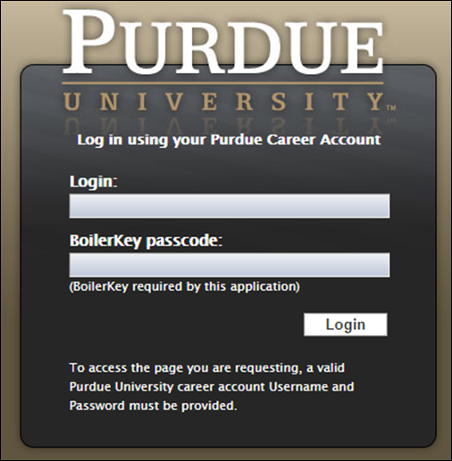

Review Job Requisition
From the Success Factors home page, click the dropdown box by the Home Icon and click on Recruiting | 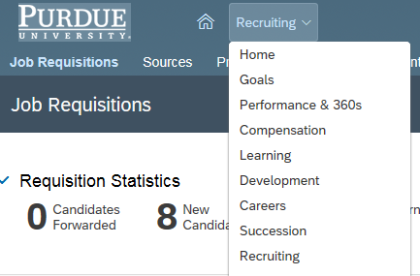
Click on the job title to open up the requisition for review.
Click on External Posting Preview to review posting | 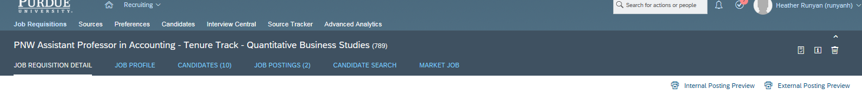

Click Close Preview when finished
Scroll to the bottom of the requisition and click Send to Department to approve requisition and release it for posting.

Click Send to Previous Step to reroute for additional edits.

The requisition Route Map is displayed.  Enter any Comments, as necessary.  Click Send to Department. | 