This QRG outlines the steps for the Department Recruiter to download and save a copy of the offer letter. A copy of the offer letter is required Faculty hiring.

Access SuccessFactors
Visit OneCampus and select Employee Launchpad. | https://one.purdue.edu/
Log in using Purdue Career Account ID and BoilerKey passcode. | 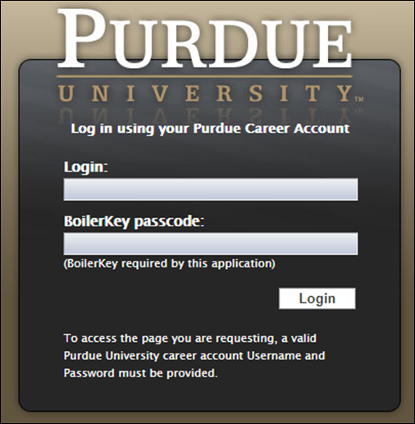

Save Offer Letter
From the Success Factors home page, click the Home drop-down menu and select Recruiting. | 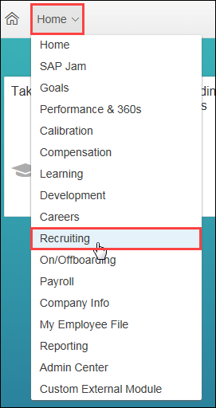
Click the number of Candidates to open the Talent Pipeline.
Click on the Offer status. | 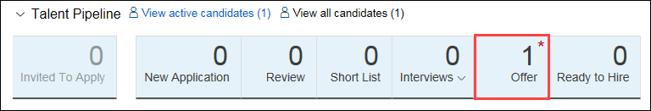
Click candidate Name to open profile. | 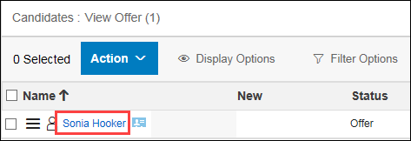
Under the Offer Letter section, click Conditional Offer of Employment. | 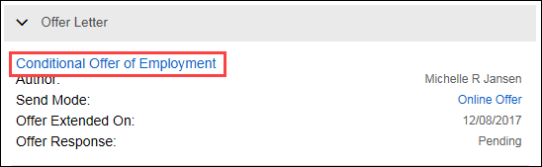
A new window opens displaying the offer letter.  Click Download PDF to save a copy of the letter. | 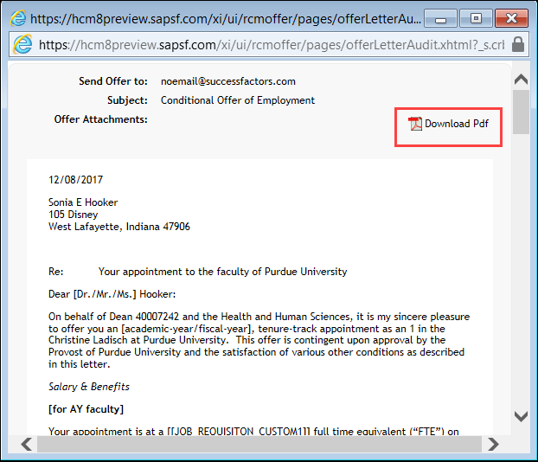
Click Save. | 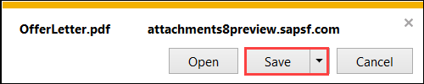

Send Offer Letter
Attach the PDF download of the Offer Letter to an email and send to designated Payroll Specialist and Executive Assistant to the VC for Academic Affairs.

