Purdue Webclock
Guide
Recording and Editing Time

Contents
Policies & Concepts 3
Employee Responsibilities 3
Supervisor Responsibilities 3
Resources 3
Support 3
Technical Requirements 3
Notifications 4
Rounding 4
Overtime 4
Holidays, Moving Holidays, Holiday Emergency Work 5
WebClock Functionality 5
Accessing Purdue Webclock 5
Record Time; Address Missed Punches 6
View History, Add or Edit Time Pairs 8
View History 8
Edit Time Pairs 9
Add Time Pairs 11

Policies & Concepts

Employee Responsibilities
In Purdue Webclock Employees are responsible for:
- Accurately recording time worked using the appropriate access point
- Selecting the appropriate job when recording time (if employee records time for multiple jobs using the webclock)
- Proactively working with their supervisor to resolve issues as needed (i.e. missing time, missed punches, etc.)
- Ensuring that their time is recorded completely and accurately for each pay period by the deadline required by their supervisor
- Remember: The time entered into the system will be considered true and accurate as of the end of an employee’s pay period. It is the employee’s responsibility to review their time often (at least at the end of each shift and at the end of the pay period) to make sure the recorded hours are true and correct; and to review and confirm the accuracy of any changes that a supervisor makes to time entries.

Supervisor Responsibilities
In Purdue Webclock, Supervisors are responsible for:
- Proactively working with their employees to resolve issues as needed (i.e. missing time, missed punches, etc.)
- Reviewing/approving all time pairs for all of their employees by 12:00pm on the Tuesday following the end of each pay period
- Proactively working with their business office to update employee work schedules and report costing exceptions for their employees’ time worked
- The Purdue Webclock inherits SAP Org Structure. Supervisors are only responsible for and able to access/edit time pairs of employees of whom which they are the supervisor of record in SAP.
- Remember: The time entered into the system will be considered true and accurate as of the end of an employee’s pay period. It is the employee’s responsibility to review their time often (at least at the end of each shift and at the end of the pay period) to make sure the recorded hours are true and correct; and to review and confirm the accuracy of any changes that a supervisor makes to time entries.

Resources
The most current versions of all timekeeping resources for Employees and Supervisors can be found on the Payroll’s SuccessFactors Timekeeping website. https://www.purdue.edu/timehelp

Support
Please contact your supervisor with any Webclock-related questions or concerns.

Technical Requirements
Supported browsers: Chrome, Safari, Edge, Firefox, Internet Explorer
Mobile access: Device must have a web browser and a WIFI or data connection

Notifications
The WebClock provides a Notification Center for Employees (one Notification Center per position held).
Employees receive notifications when a time record is changed (edited/added), time pairs are approved, time pairs are rejected, and when punches are missed.
Supervisors do not receive notifications.

Rounding
- The webclock utilizes interval rounding: each employee’s total time for the day is calculated and then rounded to the nearest tenth for payroll processing.
- Adjustments/management of an employee’s hours in order to exactly match their full CUL (or FTE) is not required.
Minutes Translated to Decimals | Rounding to the Nearest Tenth of an Hour | Example  Punch Time Punch Type Time Recorded  7:05 AM IN 7:05 AM  12:02 PM OUT 12:02 PM  1:06 PM IN 1:06 PM  3:55 PM OUT 3:55 PM  = 7:48  Recorded Daily Total 7.8 Hours
0:06 = .1 | 3 minutes to 8 minutes = .1
0:12 = .2 | 9 minutes to 14 minutes = .2
0:18 = .3 | 15 minutes to 20 minutes = .3
0:24 = .4 | 21 minutes to 26 minutes = .4
0:30 = .5 | 27 minutes to 32 minutes = .5
0:36 = .6 | 33 minutes to 38 minutes = .6
0:42 = .7 | 39 minutes to 44 minutes = .7
0:48 = .8 | 45 minutes to 50 minutes = .8
0:54 = .9 | 51 minutes to 56 minutes = .9
1:00 = 1.0 | 57 minutes to 2 minutes = 1.0

Overtime
The Purdue Webclock adheres to the University policy regarding overtime. When a full time employee works over 40 hours in a workweek, the time is will be designated as overtime when it transfers to SuccessFactors for payroll. “Hours worked” in a work week will consist only of hours actually worked. (Exception: Worker’s Compensation, University Holidays).

Overtime for employees with multiple positions will be calculated when the time recorded using the webclock is moved to SuccessFactors prior to Payroll running. Overtime will be charged to each position based on the ratio of hours worked across the employee’s positions for that week.

Holidays, Moving Holidays, Holiday Emergency Work
Holidays
Holiday premiums are auto-calculated when time recorded using the webclock is moved to SuccessFactors to be paid.

Moving Holidays
Moving Holidays takes place within SuccessFactors Time Off tile (not within <<application name>>. Individuals whose work schedule does not include a given University Holiday can use the time off feature within SuccessFactors to request Holiday on any day during the week (Sunday through Saturday) of the holiday. Exception: Police and Fire may request Holiday leave at any time throughout the year.

Unplanned Work on a Holiday or During an Emergency
Per University policy, when an employee works during an emergency or unscheduled holiday work, they qualify for their hours to be paid at time and a half. In the event that an essential personnel are required to work during an emergency or unscheduled on a holiday, the employee or their supervisor must enter the time on the employee’s timesheet in Employee Central Time (ECT) using time type Campus Service Disruption. (In addition to recording time in the webclock. For details on how to enter time in ECT, see the SuccessFactors training page (Timekeeping & Payroll tile).

WebClock Functionality

Accessing Purdue Webclock
The Purdue webclock can be accessed via three different access points. Your department will designate a best practice as far as which access method you should utilize.
Employee Launchpad  SuccessFactors | Web Browser | Kiosk
Using a web browser, navigate to the One Campus Employee Portal (www.one.purdue.edu)  Click Employee Launchpad.  Log in using your BoilerKey.  On the homepage, click the WebClock tile. | On your computer or mobile device’s web browser, navigate to webclock.purdue.edu  Log in using Purdue User ID and BoilerKey passphrase. | At the kiosk, swipe your Purdue ID Card through the card reader.

Record Time; Address Missed Punches
Access the Purdue Webclock
Access the webclock via the Desktop, Mobile Device, or Kiosk access point, as appropriate.
Note: If using a mobile device, enable location services (steps vary by device – typically in Privacy settings).
Clock In or Clock Out
If you hold multiple positions, tap or click the position toward which you wish to record time. | 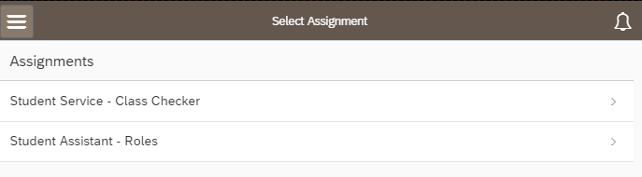
If you supervise others who utilize the webclock to enter time,  Click to open the menu in the upper left corner of the screen.  Under Employee View, click My Time. | 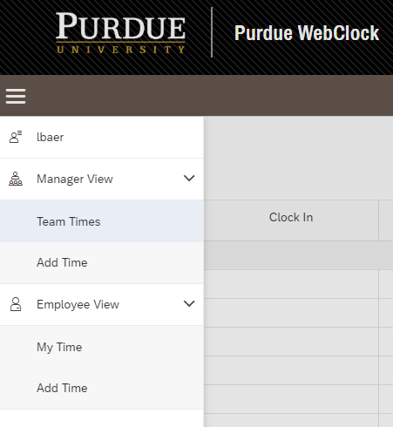  2  1
For 2 hour Call Back premium: If the time to be recorded is eligible for Call Back pay, tap the slider so that YES is displayed.  Click or Tap Clock In (or Clock Out)  - After Clock In has been clicked or tapped, the button will change to read Clock Out.  - Note: On the Kiosk, users are automatically logged out after Clock In or Clock Out is tapped. | 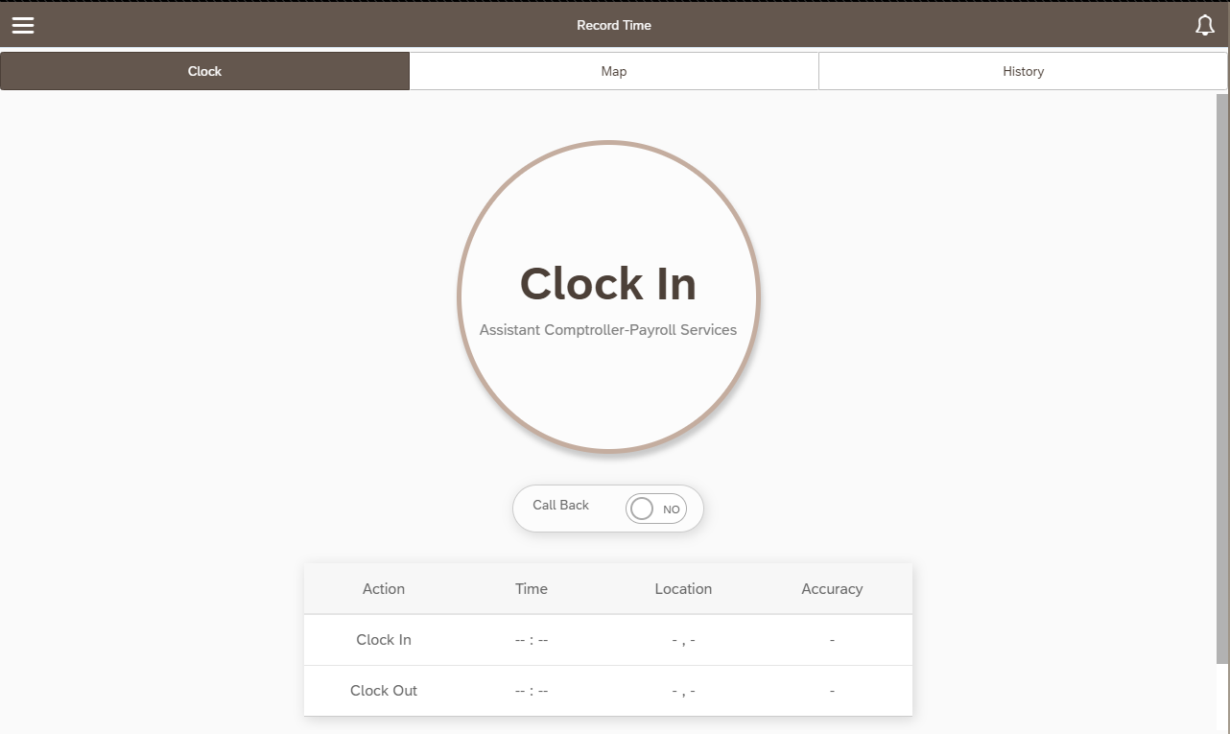  2  1  (if applicable)
Missed Clock In / Clock Out
If a punch is missed and is not corrected prior to the payroll deadline, time for that day will not be paid. Time for all other days in the pay period will be paid.
- If Clock In was missed: Clock In and then immediately Clock Out. Use Edit Time Pair steps to manually change the Clock In time.

- If Clock Out was missed: Clock Out (to end the too-long time pair), Clock In (if applicable, to begin new shift), use Edit Time Pair steps to edit the too-long time pair.
  - Note: If a user Clocks In and does not Clock Out within 12 hours, a notification will display the next time the user accesses the system suggesting that a punch may have been missed.
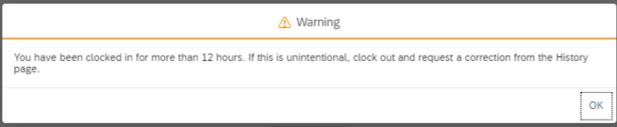

View History, Add or Edit Time Pairs
History contains the time pairs recorded per position for the current pay period and one pay period previous. It can be thought of as the timesheet.
Please select low-volume usage times if completing any of these tasks on a kiosk or other shared device.
Access the Purdue Webclock
Access the webclock via the Desktop, Mobile Device, or Kiosk access point, as appropriate.

View History
If you hold multiple positions, choose the position for which you wish to view History.
Click or tap History in the menu bar. | 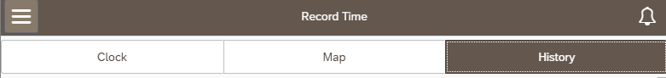
Time pairs for the current and previous pay periods are displayed.  Status column indicate whether or not supervisor has reviewed the time pair. (Possible values are PENDING, APPROVED, DECLINED)  Note: For employees with multiple positions, if time is recorded toward the wrong position, the employee must request that the supervisor of the position for which time was incorrectly recorded decline the time pair. The employee must use then Add Time feature to add a time pair to the other position. See Add Time Pairs for additional details. | 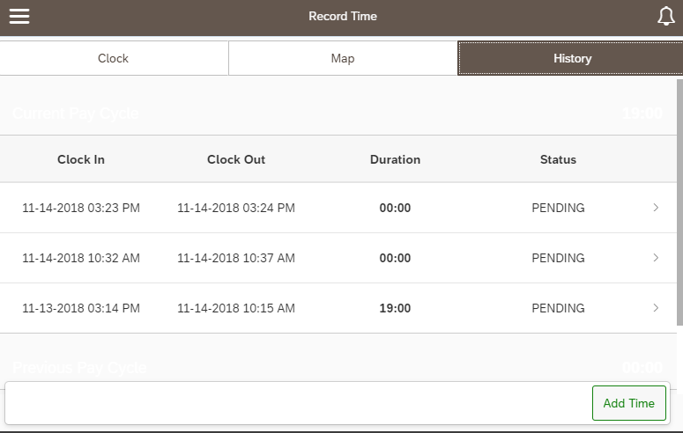

Edit Time Pairs
Employees can edit time pairs at any time within the current and previous pay period.

Please select low-volume usage times if completing any of these tasks on a kiosk or other shared device.

Time Pairs are edited due to incorrect punches (early or late, in or out).

Newly edited pairs will in the supervisor’s queue as PENDING.

If completing this task after you suspect your supervisor has done their final review prior to the Payroll deadline, please notify them that you have made a change so that they are prompted to review the change.
Click or tap History in the menu bar.

Tap or click the line that lists the pair you wish to edit

Use the drop-down menu to choose the reason for the edit |  | 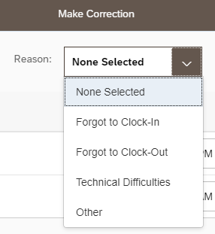
Tap or click the calendar icon on the appropriate line to edit the Clock In or Clock Out time. |  | 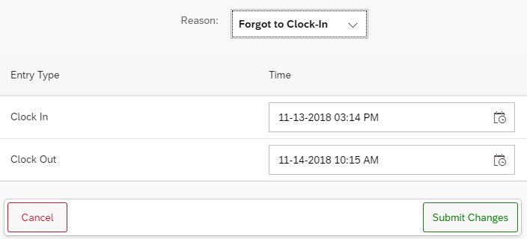
Use the calendar and time slider to indicate the adjusted date and time.  Click or tap OK |  | 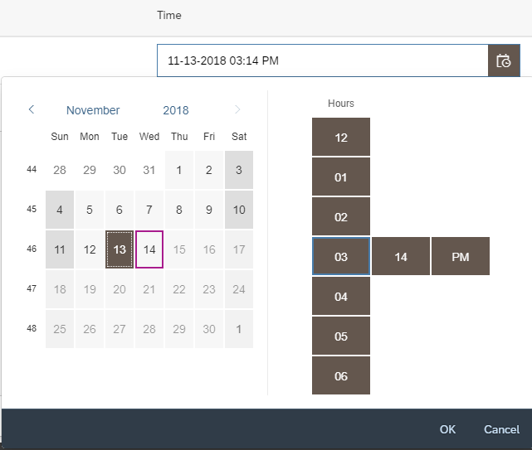
Click Submit Changes |  | 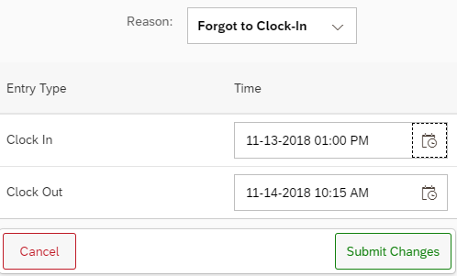
The edit and reason selected will be visible to the supervisor when they approve your time. |  | 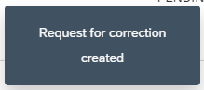

Add Time Pairs
Employees can add time pairs at any time within the current or previous pay period.

Please select low-volume usage times if completing any of these tasks on a kiosk or other shared device.

Time Pairs are added due to 1) missed punches and 2) when an employee with multiple positions erroneously records time toward the wrong position.
    - For employees with multiple positions, if time is recorded toward the wrong position, the employee must notify the supervisor of the position for which time was incorrectly recorded to decline the time pair. The employee must use the Add Time feature to add a time pair to the other position.

Newly added pairs will in the supervisor’s queue as PENDING.

If completing this task after you suspect your supervisor has done their final review prior to the Payroll deadline, please notify them that you have made a change so that they are prompted to review the change.
Click or tap History in the menu bar.

Tap or click Add Time | 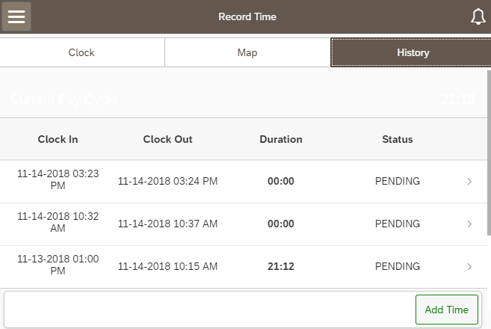
Tap or Click the calendar icon on the appropriate line to edit the Clock In date and time. | 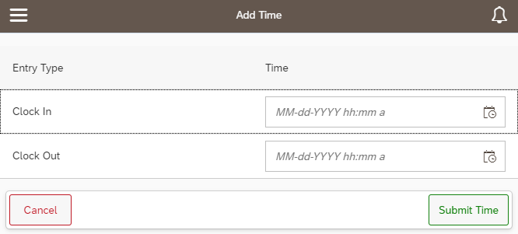
Use the time sliders to indicate the date and the “In” time.  Repeat this process for the Clock Out field.  Click OK | 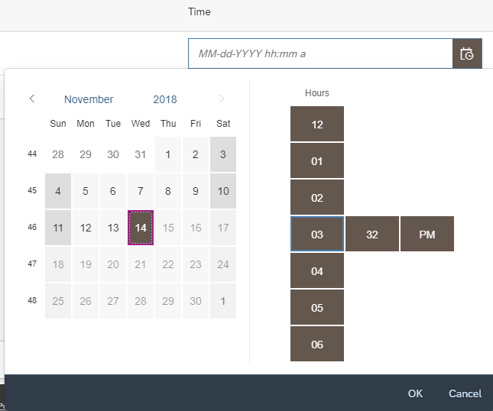
Click Submit Time  The added time pair and reason selected will be visible to the supervisor when they approve your time. | 