This QRG outlines the steps to create a job requisition for a vacant position and route for approval. This process will be executed by the Initiator (Dean and/or Administrative Assistant).

Access SuccessFactors
Visit OneCampus and select Employee Launchpad. | https://one.purdue.edu/  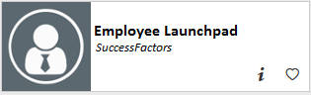
Log in using Purdue Career Account ID and BoilerKey passcode. | 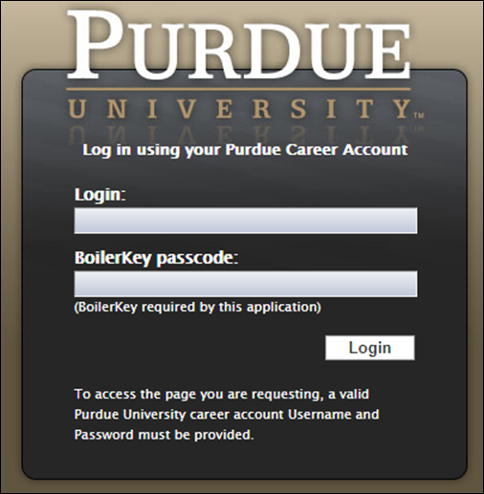

Identify Vacant Position
From the Success Factors home page, click the Home drop-down menu and select Company Info. | 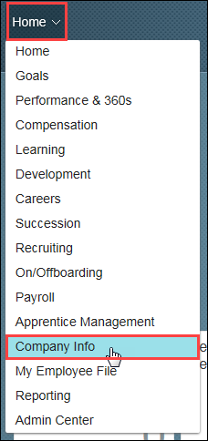
Click Position Org Chart.
All direct report positions are displayed. | 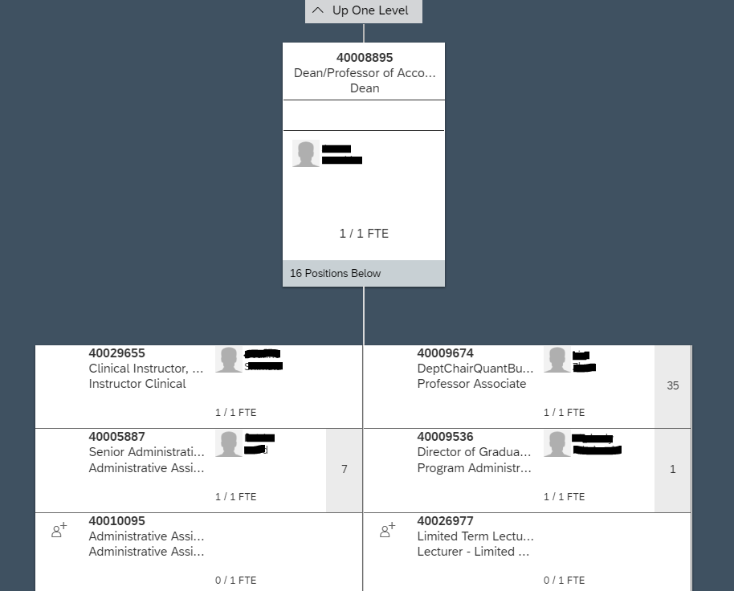
If the position to fill is not displayed, search for it by entering the position number in the Search field. | 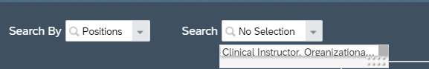  40030417

Create Requisition
Click the To be hired icon on vacant position. | 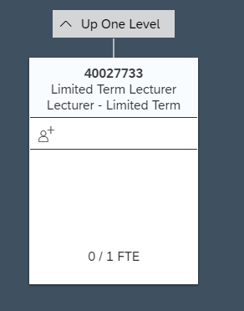
Click the Show Menu icon (3 horizontal lines).  Select Create Job Requisition. | 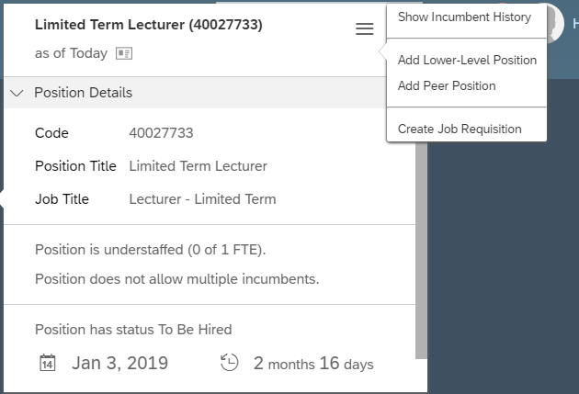
NOTE: Both of these fields have default settings based on the position selected.  Click Create. | 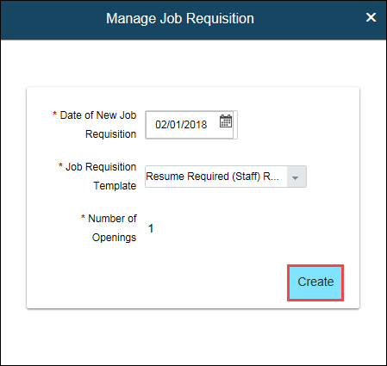  Faculty Requisition
Click the Job Requisition – Status pre-approved icon to complete requisition details. | 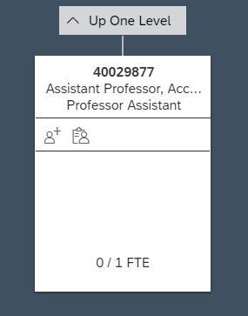
Click the Open Job Requisition icon. | 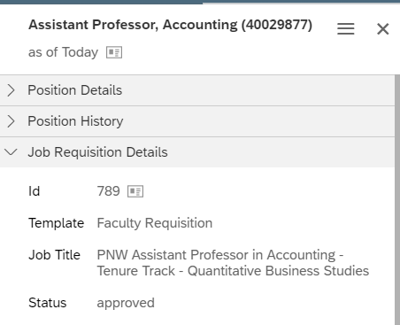
Scroll to view and complete the Job Requisition filling in all required fields.  NOTE: Required fields are marked with a red asterisk (*). Most of these boxes will already be prepopulated with information from Success Factors.  Input the Targeted Monthly  Salary for your position  Faculty Limited Search/Waiver = Select Standard Posting from the dropdown box  Internal Job Title = PNW Job Title, Department  Example: PNW Clinical Instructor, Management  Including “PNW” in Internal Job Title will ensure internal applicants easily locate PNW vacancies on SuccessFactors Career Page.  External Job Title = Job Title, Department  Example: Clinical Instructor, Managerial Studies  This title will be reflected on our PNW Careers Faculty website.  Funding End Date = Open  FTE = 1.0  Select State from dropdown  City = Hammond and Westville  Travel Required = Yes (in between campuses)  Select appropriate Physical Requirements  Select appropriate Sponsorship Immigration Authorization | 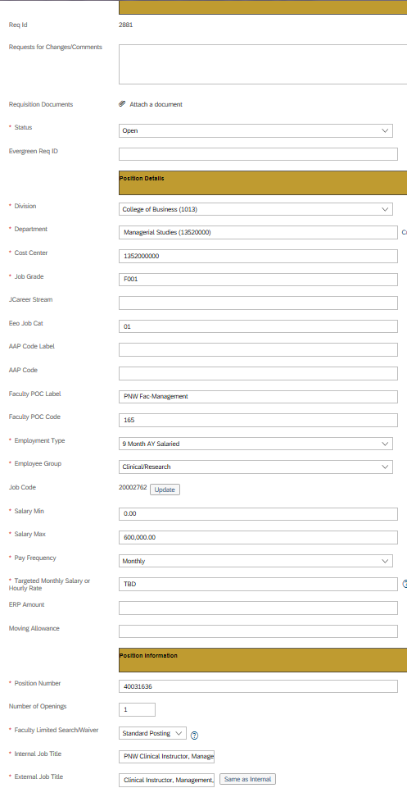  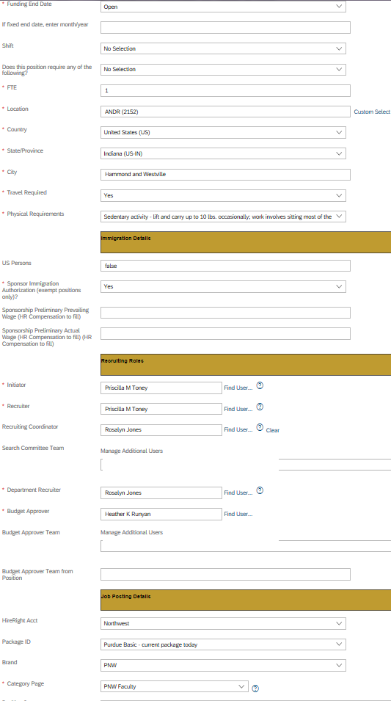
Complete Recruiting Roles Section  Initiator = Autopoulates with your name.  Recruiter = Melissa Ramos  Recruitment Coordinator = Leave Blank  Search Committee Team = Input the names of the search committee  Department Recruiter = Deans Administrator Assistant or Department Chair Support Staff  Budget Approver = Elizabeth Depew | 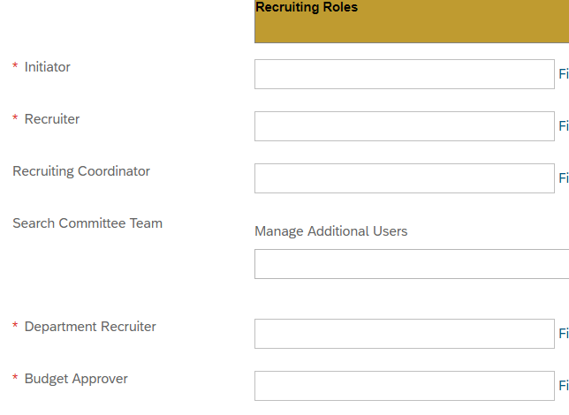  Search committee members  Leave Blank  Marty Denkhoff  Deans Admin Asst or Dept Chair Support Staff  Melissa Ramos  Auto populates with your name
Completing Job Posting Details Section  Input background check information:  HireRight Acct = Northwest  Package ID = PNW Basic Widescreen Plus  Brand = PNW  Category Page = PNW Faculty | 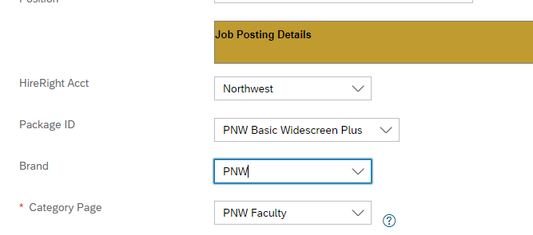
Input your Recruitment Strategy You must input something into the Recruitment Strategy box to move forward.
Scroll back up to the top of the page and click Save icon | 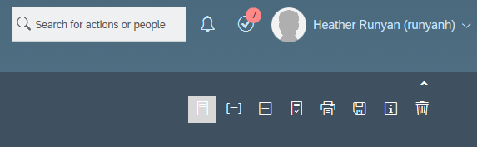
Click on Job Profile to input your advertisement. | 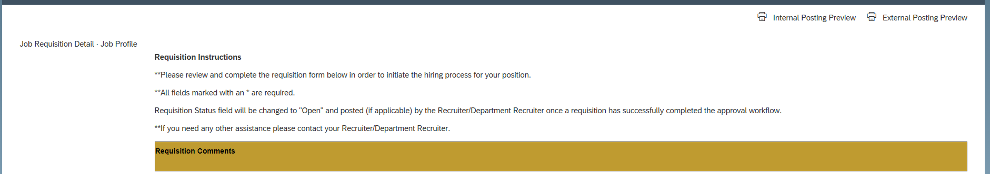
Input information into the following sections:  - Job Summary  - Education  - Experience  Do not change information in the following sections as they are already prepopulated with system information.  - Job Family  - Job Sub Family  - Employee Class  - Career Stream  - Benefit Eligibility  - FLSA Status | 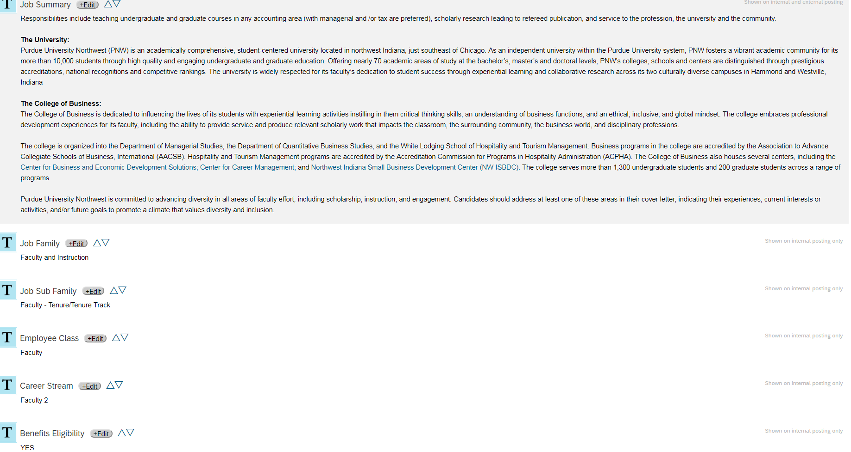  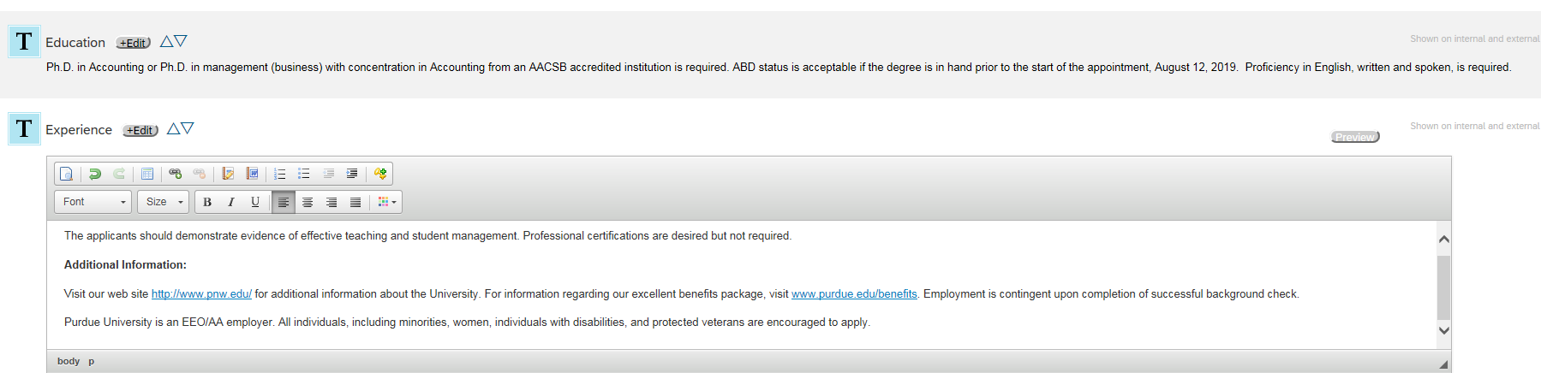
Click Save at the bottom of screen.
You can preview your posting by clicking External Posting Preview in the upper right corner. | 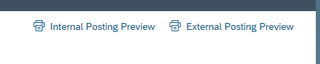
To go back to the details of the job requisition, go back to the top of the page and click Job Requisition Details | 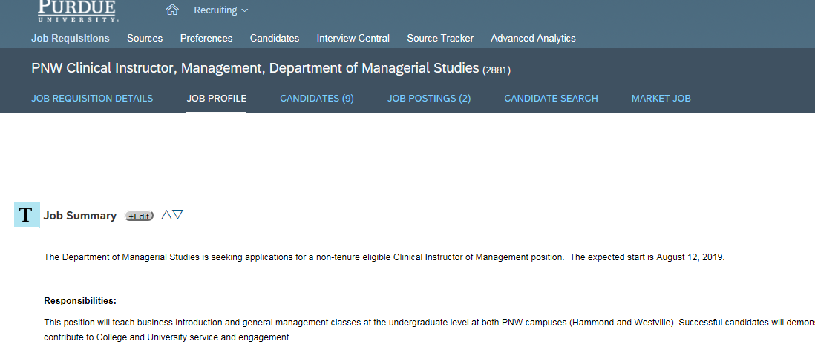

Route for Approval
Scroll down to the bottom of the Job Requisition Details page and click Send to Next Step.
The requisition path is displayed.  The first approver in the path is identified.  Enter any additional information or notes in the Email Notification Comments. | 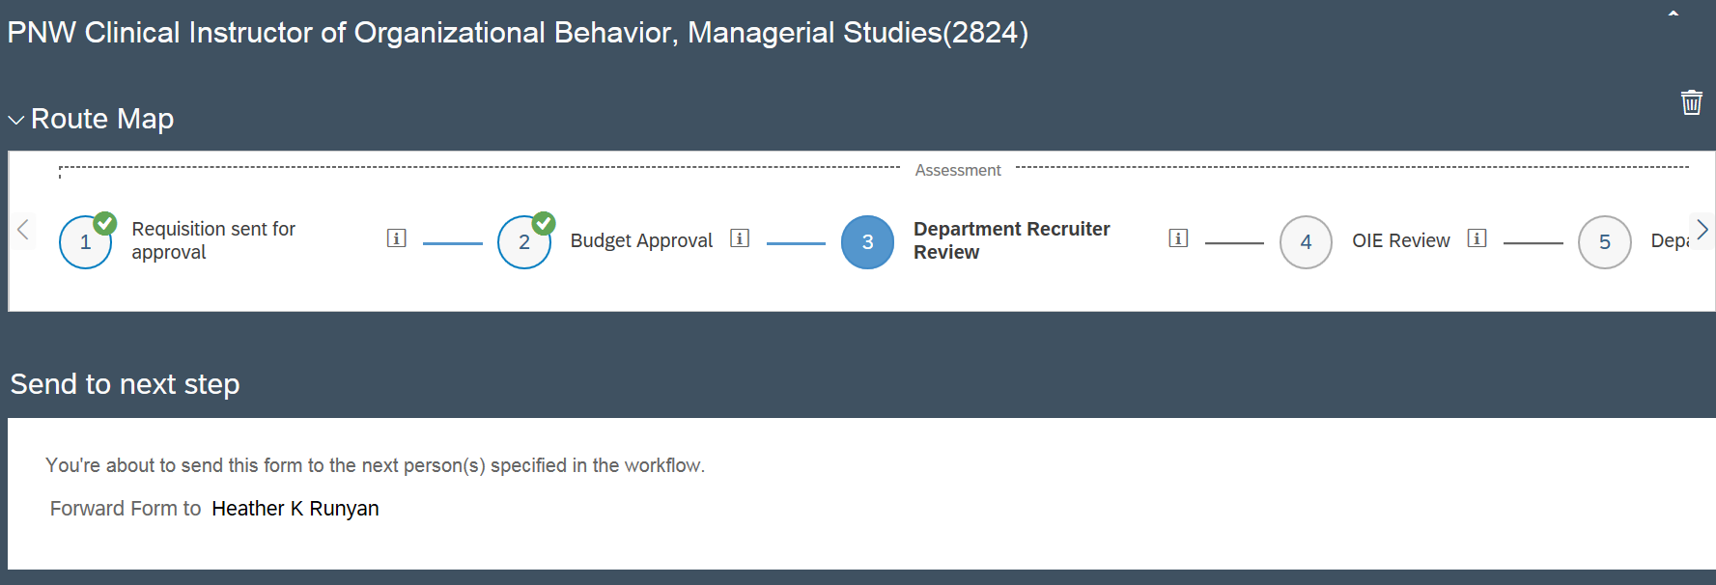
The job requisition moves through the approval workflow. Once approved, the job requisition is posted and ready to receive applications.
You can set up your Job Requisition view to see who the requisitions is currently with to locate where the requisition is during the approval routing.  Click on Job Requisitions  Click on Display Options | 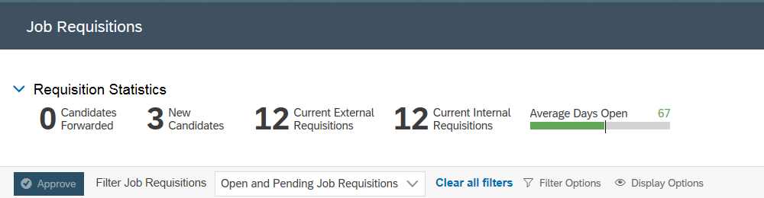
Then click on Currently with | 