This QRG outlines the steps to review a Job Requisition after obtaining all necessary approvals, and how to post the requisition to internal and external sites. This task will be completed by Department Recruiters

Access SuccessFactors
Visit OneCampus and select Employee Launchpad. | https://one.purdue.edu/
Log in using Purdue Career Account ID and BoilerKey passcode. | 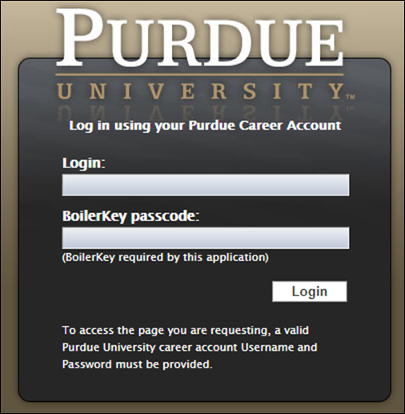

Review Job Requisition
From the Success Factors home page, click the dropdown box by the Home Icon and click on Recruiting | 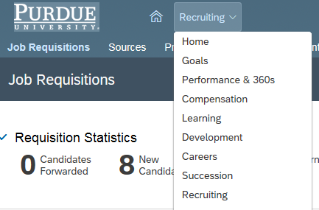
Click on the job title to open up the requisition for review.

Set up Posting Page and Background Check
Scroll to Posting Details  HireRight Acct = Northwest  Package ID = PNW Basic Widescreen Plus  Brand = PNW  Category Page = PNW Faculty. This will post your position on our PNW Careers Website | 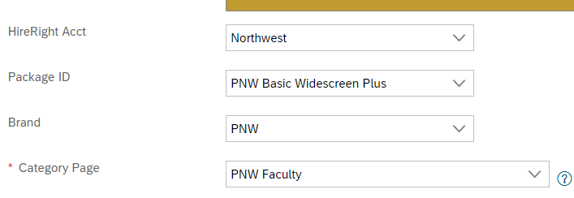

Job Posting

Internal and External, Public and Private
Click on Job Postings
The Job Postings page is displayed for the selected requisition. | 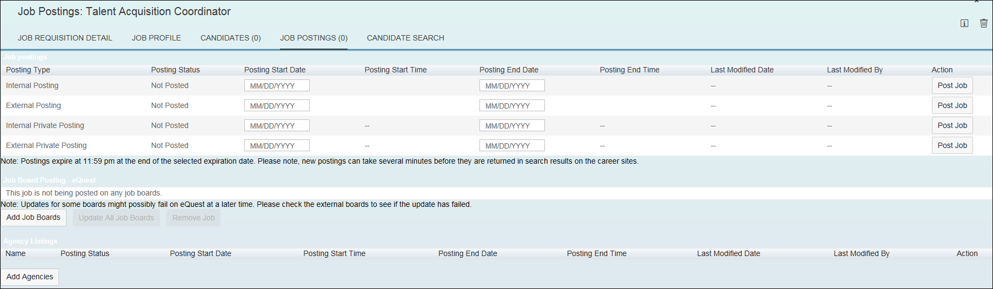
For each desired Posting Type, enter the Posting Start Date. | 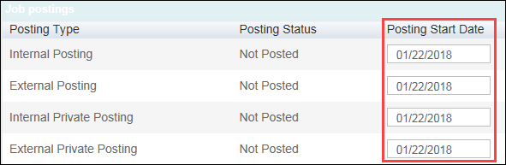
Click Post Job. | 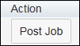
You can hover the cursor over the Posting Type paperclip icon to view the URL link to the posting. You can use this link in your external advertisements. | 