This QRG outlines the steps a Department Recruiter would follow to prepare the Offer Approval details and route for proper approvals.
The Offer Approval must be created and approved before extending the Offer Letter to the selected candidate.

Access SuccessFactors
Visit OneCampus and select Employee Launchpad. | https://one.purdue.edu/
Log in using Purdue Career Account ID and BoilerKey passcode. | 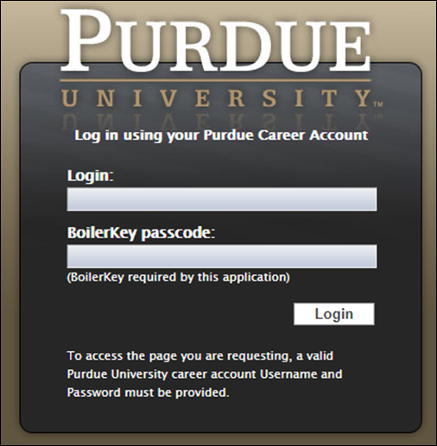

Job Requisition
From the Success Factors home page, click the Home drop-down menu and select Recruiting. | 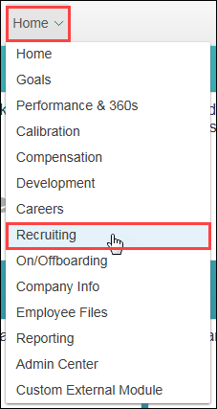
The list of Job Requisitions is displayed. | 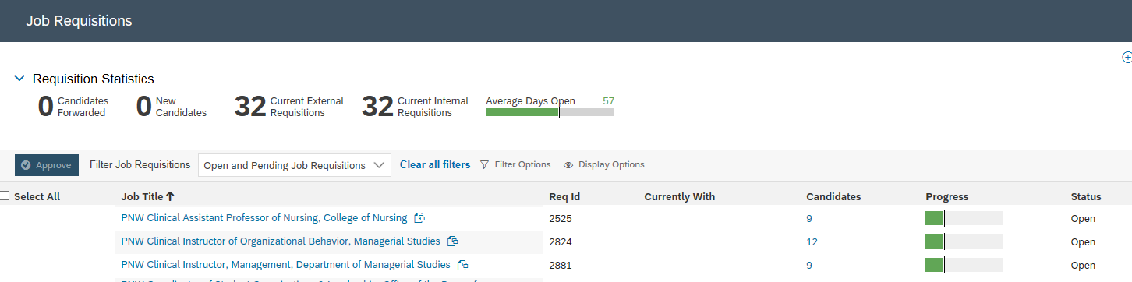

Move Candidate
Click Number link under the Candidates column corresponding to the Job Requisition.
Click candidate Name and drag and drop candidate into the Offer status of the Talent Pipeline. | 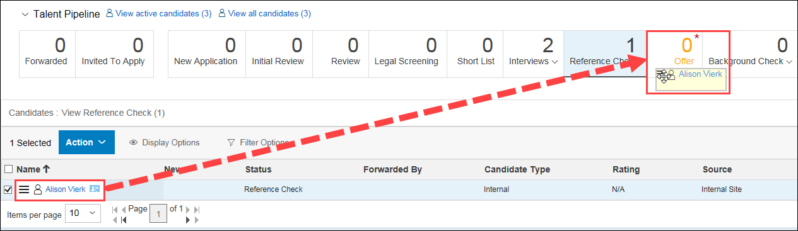
Click Apply Updates. | 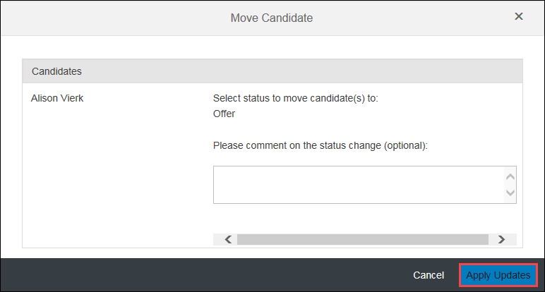

Create Offer Approval Details
Click candidate Name to open details. | 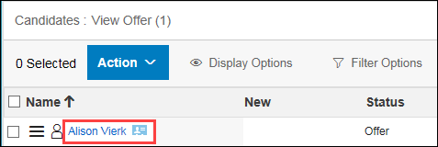
The candidate application is displayed. | 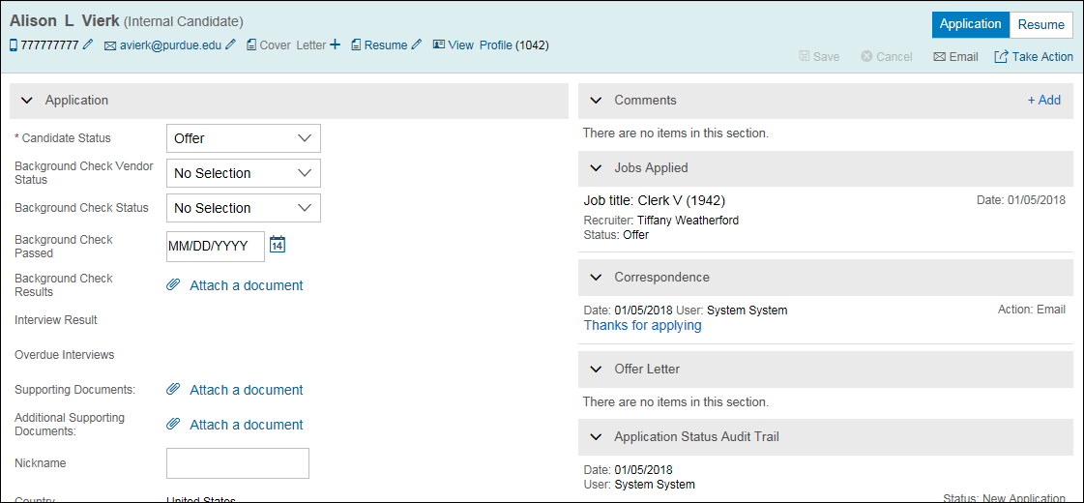
Click Take Action.  Hover over Offer.  Select Offer Approval. | 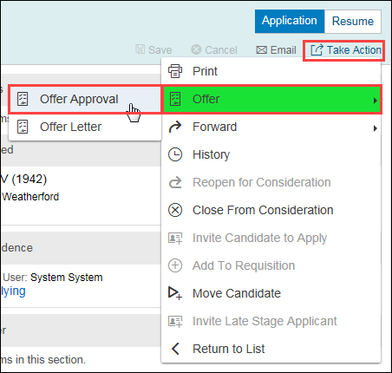
Select Faculty Offer Details from drop-down. | 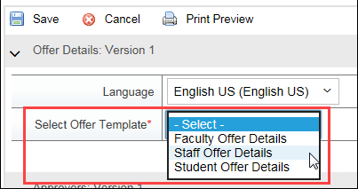
Complete Offer Details.  Required fields will be marked with a red asterisk (*).  EC Position Number is the same number as Position Number. Copy and paste the Position number into the EC Position Number Box  Will the employee be a remote employee?  Yes = Employee works outside the state of Indiana otherwise “No”. | 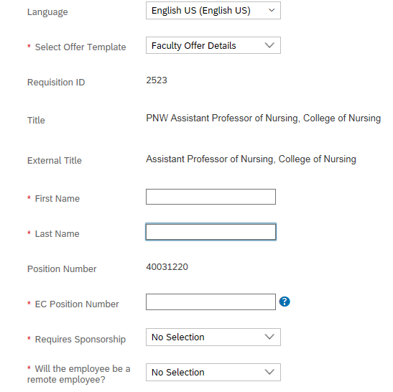
Input the monthly salary amount into the Period Rate box | 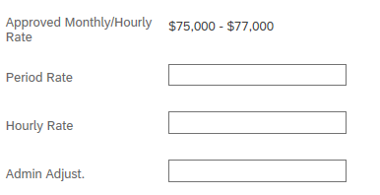  6,250
Input the Approvers for the Offer Approval.  Add Comments, as needed. | 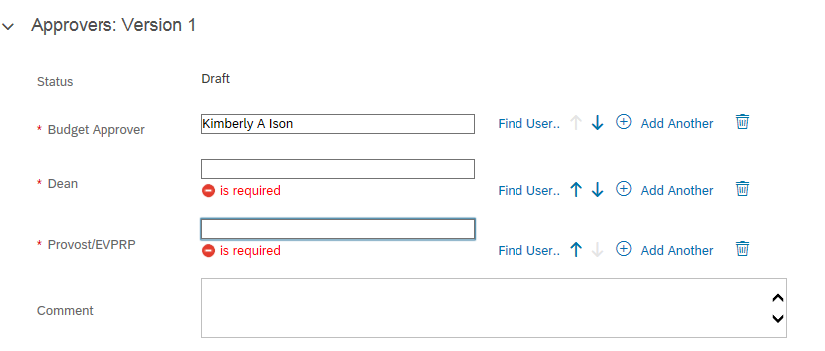  Marty Denkhoff  Debra Grant  Dean’s Name
Click Save to save changes, but not kick off the approval workflow.
Click Back to Candidate

Attaching Draft Offer Letter to Offer Approval
Click Take Action.  Hover over Offer.  Select Offer Letter. | 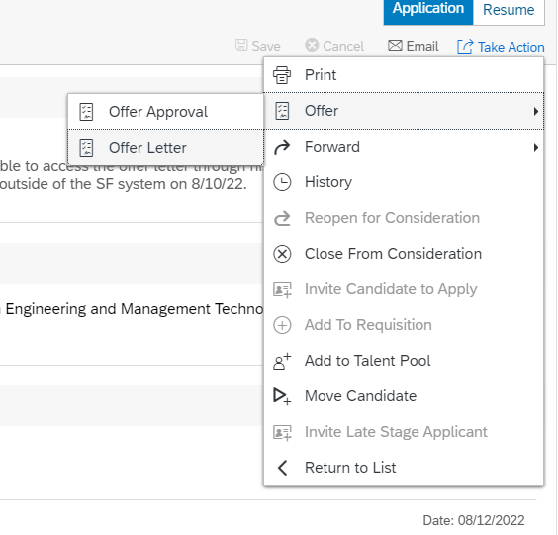
Scroll down and select PNW Template from the dropdown.

NOTE: The offer letter template selected must coordinate with the type of position being offered.

Edit Subject, if necessary.
The Offer Letter template is displayed.  All items highlighted in yellow will be prepopulated from the candidate application and profile data.  Review offer letter template and make revisions, if needed.  You can click Preview to review the populated offer letter  You can click Back to make additional revisions. | 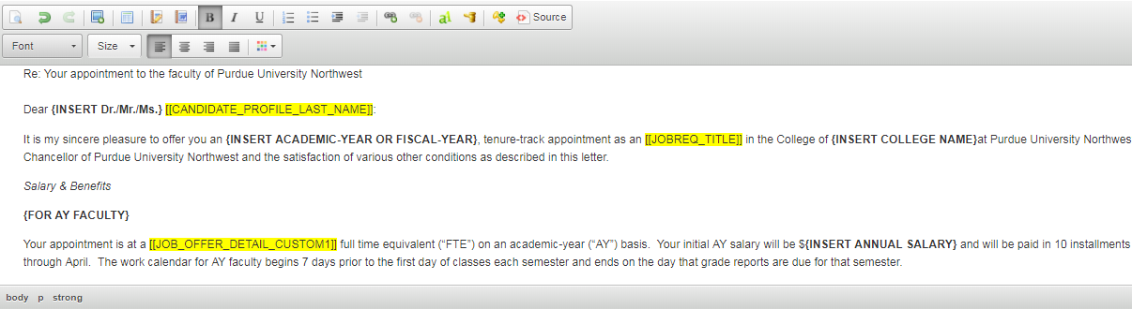  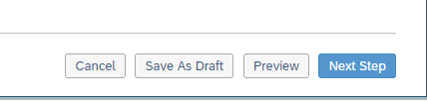  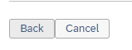
Click Save As Draft.
Prior to sending the online offer letter to the candidate, the Dean will review the letter for accuracy. Make sure you are Back to where you can preview the letter and you see the highlighted yellow items.

Click on Preview
Copy and paste this letter into a Word Document and save to your hard drive.  Do not click on Online offer, Verbal offer, Email as text, email as PDF attachment at this step as it will send the offer letter to the candidate before it is approved. | 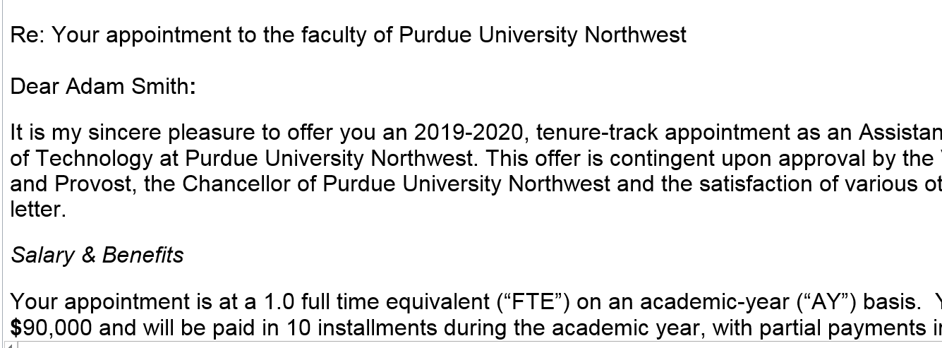
Click Cancel | 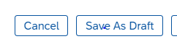
Click candidate Name to open details.
Click Take Action.

Hover over Offer.

Select Offer Approval.
Scroll down to Offer Letter and Click Attach Document. Upload Offer Letter that is saved to your hard drive | 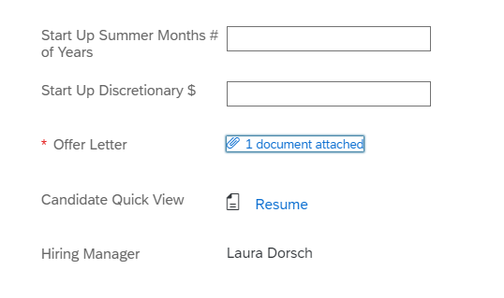
Click Send For Approval to route to first approver.

Click Save to save changes, but not kick off the approval workflow.
Click Yes to continue. | 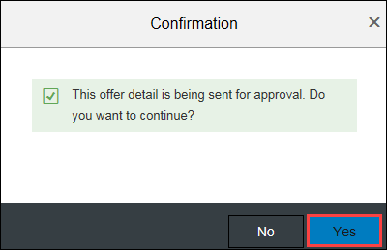
The Offer Details are now in the approver’s queue to review and approve, or send back with edits.

