This QRG outlines the steps for Department Recruiter, as assigned within your department to extend the offer of employment via an online offer letter to the selected candidate. An Offer Letter must be completed for the selected candidate for any Faculty position.

Access SuccessFactors
Visit OneCampus and select Employee Launchpad. | https://one.purdue.edu/
Log in using Purdue Career Account ID and BoilerKey passcode. | 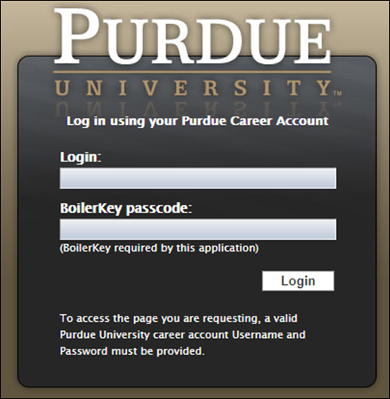

Job Requisition
From the Success Factors home page, click the Home drop-down menu and select Recruiting. | 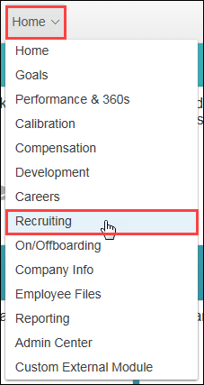
The list of Job Requisitions is displayed. | 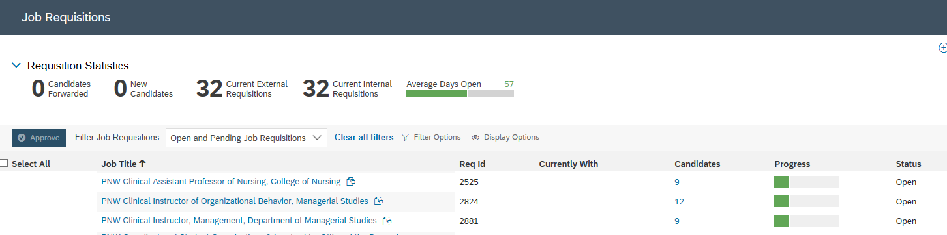

Candidate
Click Number link under the Candidates column corresponding to the Job Requisition.
Click candidate Name to open details. | 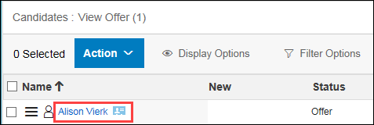
The candidate application is displayed. | 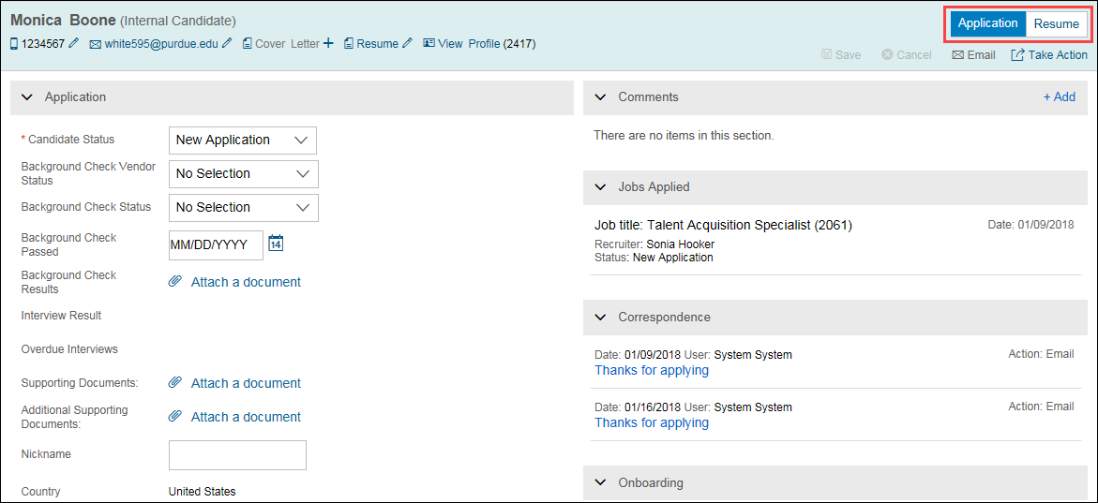
Click Take Action.  Hover over Offer.  Select Offer Letter. | 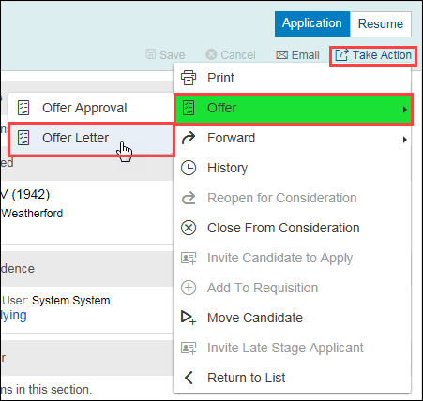

Send Offer Letter
Click Online Offer.
The Offer Letter Email template is displayed.  All items highlighted in yellow will be prepopulated from the candidate application and profile data.  Edit the template to reflect Purdue University Northwest instead of Purdue University  Review email template and make other revisions, if needed. | 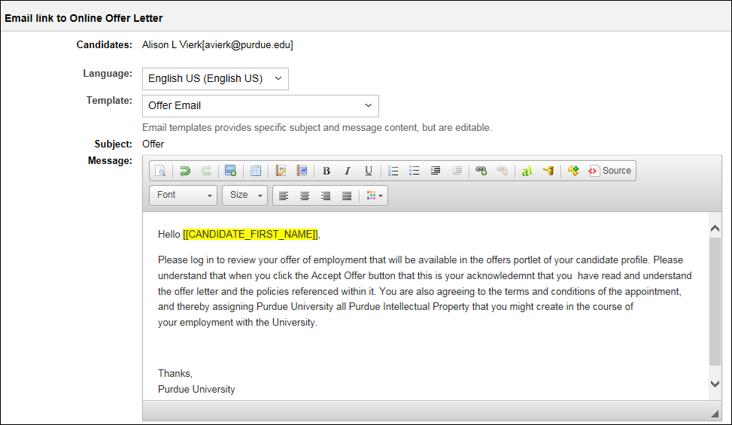
Click Next.
A preview of the Offer Letter Email is displayed.  Perform a final review prior to sending email. | 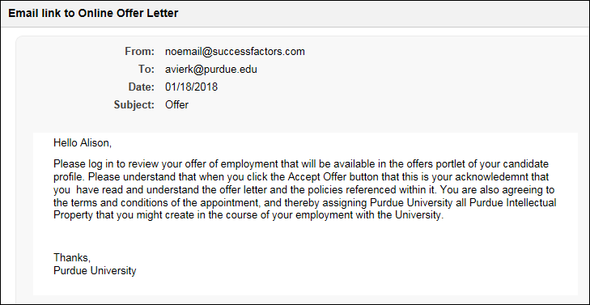
Click Send.
The selected candidate will receive an email notification to log in and review the offer and take action.

Post Offer
Once an Offer of Employment has been accepted, the candidate must be moved to the Background Check status on the Talent Pipeline.
Click candidate Name to select.  Drag and drop in the Background Check status on the Talent Pipeline. | 