This QRG outlines the steps for the Department Recruiter to download and save a copy of the offer letter. A copy of the offer letter must be submitted to the VCAA’s Office and designated Payroll Specialist.

Access SuccessFactors
Visit OneCampus and select Employee Launchpad. | https://one.purdue.edu/
Log in using Purdue Career Account ID and BoilerKey passcode. | 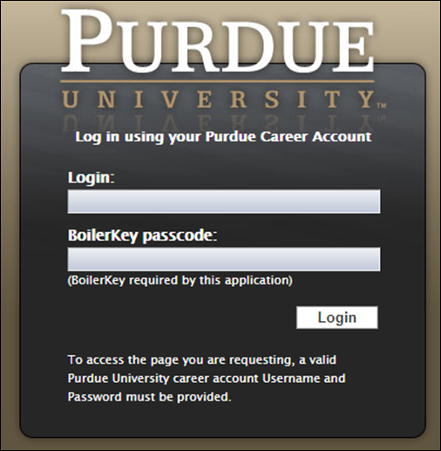

Save Offer Letter
From the Success Factors home page, click the Home drop-down menu and select Recruiting. | 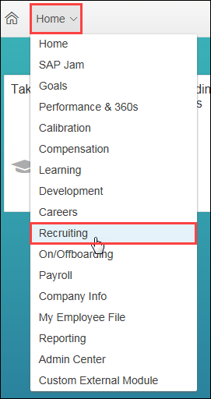
Click the number of Candidates to open the Talent Pipeline.
Click on the Offer status. | 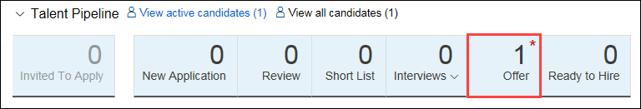
Click candidate Name to open profile. | 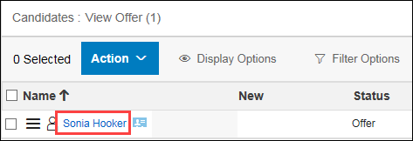
Under the Offer Letter section, click Conditional Offer of Employment. | 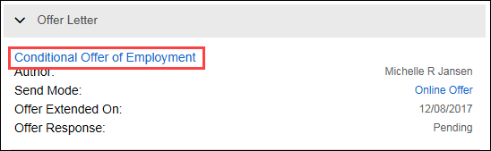
A new window opens displaying the offer letter.  Click Download PDF to save a copy of the letter. | 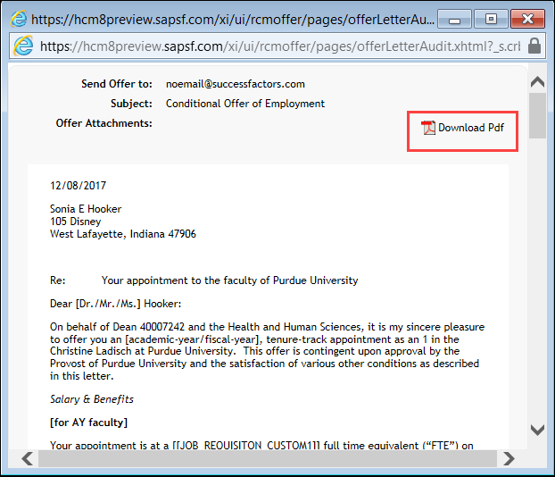
Click Save. | 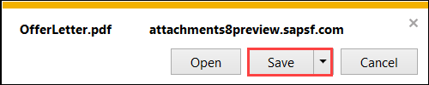

Send Offer Letter
Attach the PDF download of the Offer Letter to an email and send to designated Payroll Specialist and Debra Grant, Interim Executive Assistant to the VC for Academic Affairs.

