Acce ss S uccess Factors
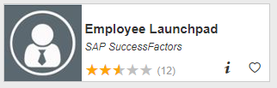
Visit OneCampus Portal (https://one.purdue.edu/) and select SuccessFactors (Employee Launchpad). Log in using your Purdue Username and Boiler Key.
Locate your Self-Assessment
- Click on Home Menu at top of screen and select Performance & 360s  The My Forms dashboard opens and displays items in your In Progress Inbox | 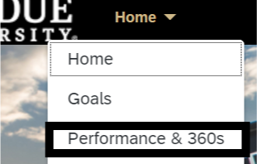
- Locate your performance assessment and Click 2022-2023 Performance Assessment for … | 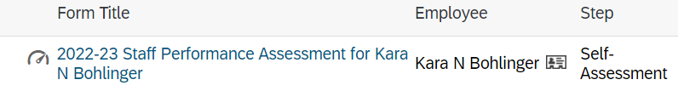
Review the First Three Sections of the Self-Assessment
- The first couple sections of the assessment contain important information about the workflow, assessment resources and the employee:  Route Map -- The route map at the top shows the assessment’s current position in the workflow. (Self-Assessment)  Introduction – Brief statement about Performance Evaluations and links to the System-wide Performance Management resources.  User Information – Employee details | 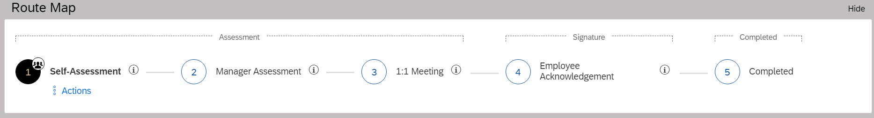  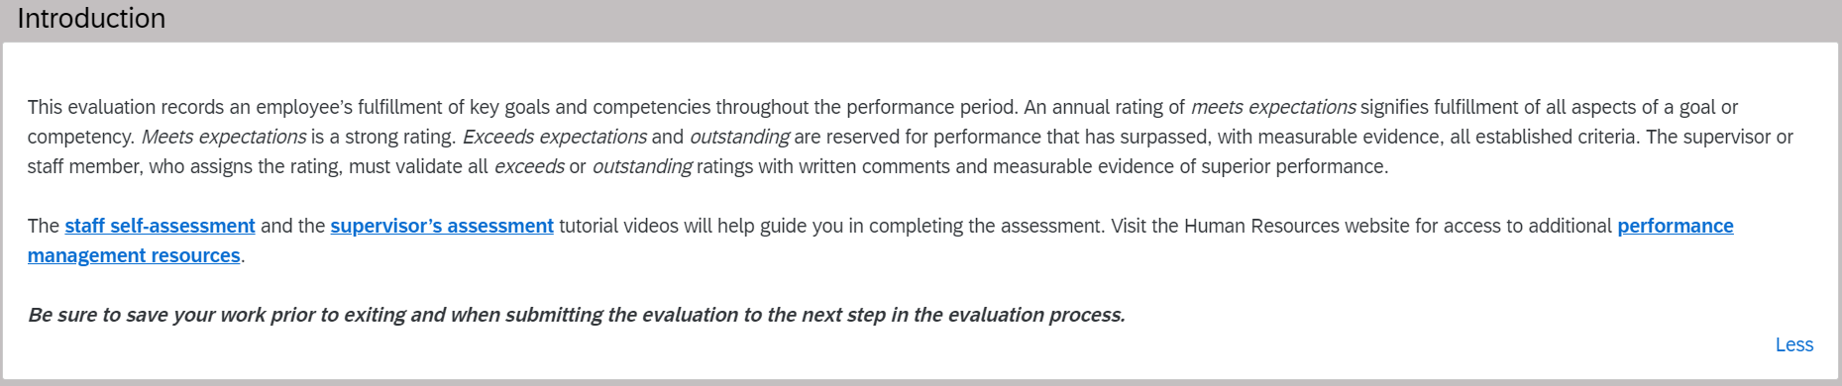  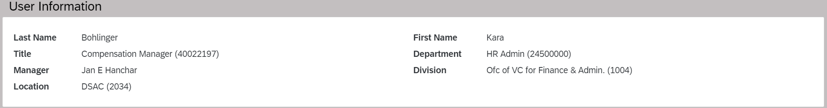
Assess Your Goal Completion
- Scroll down to the Goals section and verify Goals weight. (If you have questions about what the weight should be, speak to your supervisor.) If weighting needs to be updated, Click Edit Section Weight. | 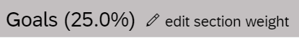
- Update goals and competencies weighting. (25% Goals and 75% Competencies)  Click Save. | 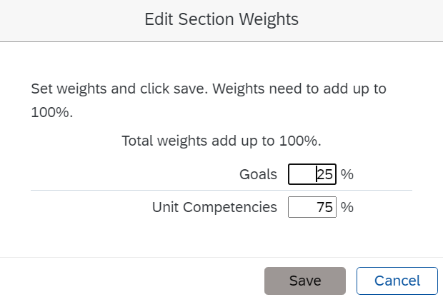
- Scroll to your first goal and click on the pencil to edit the goal.  - Review the goal name, description, metric and due date.  - Enter a % Complete and Status and then click Save Changes.  - Add a Rating for this goal and provide Employee Comments. Repeat for each goal. | 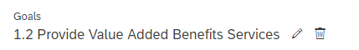  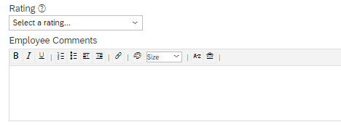
- Scroll down to the Overall Comments on Goal Achievement and enter employee comments. (optional)
Assess Your Competencies
- Scroll down to the Unit Competencies section. If weighting needs to be updated, click Edit Section Weight and update.

- For each competency select a Rating. You are encouraged to enter accomplishments in the Employee Comments section.  Click on the Writing Assistant for help with sample wording.  In the Writing Assistant, language is provided that aligns with three performance levels.  - Click a Performance Level  - Sample language appears in the Preview Quote Below section  - You can Adjust the positivity (-/+) of the sample language.  - Click Place Quote and then click Close  Edit your Employee Comment for this Competency as appropriate.  Repeat above for each competency. | 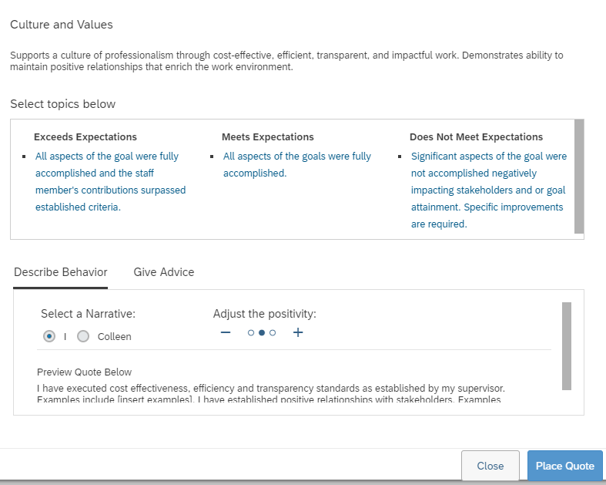  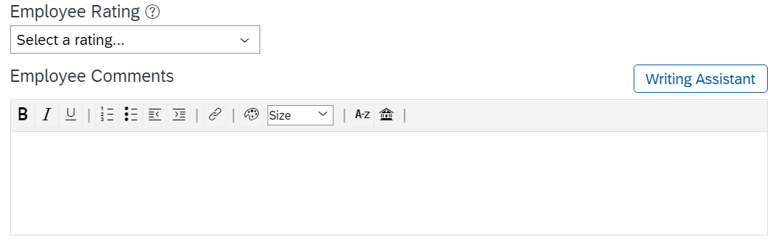
- Scroll down to the Overall Comments on Unit Competencies and enter Employee comments. (optional) | 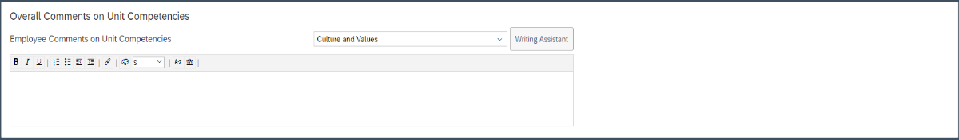
Save and Submit to Manager
- If you wish, you may Save and Close the self-assessment and come back to work on later.
- When your self-assessment is complete, click Submit to Manager for Review.

Your self-assessment has now moved to the next step in the Workflow – Manager Review.

Miscellaneous Actions
Click on Home Menu at top of screen and select Performance & 360s  The My Forms dashboard opens and displays items in your In Progress Inbox. Locate and open your assessment.  In the upper right corner, click on:  Actions – spell check or perform a legal scan  History – access prior years’ performance assessments  Printer – print hard copy or save to PDF  Save – save the assessment  Paperclip – attach supporting documents | 