Acce ss S uccess Factors
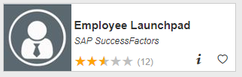
Visit OneCampus Portal (https://one.purdue.edu/) and select SuccessFactors (Employee Launchpad). Log in using your Purdue Username and Boiler Key.
Locate and Open Your Performance Assessment
- After your manager has completed your performance assessment, the final assessment is routed back to you for electronic signature and acknowledgement. Click on Home Menu at top of screen and select Performance & 360s | 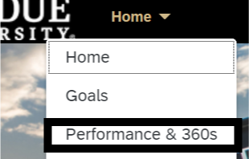
- Locate and open your 2022-2023 Performance Assessment  The Route Map in your performance assessment should indicate Employee Acknowledgement step. | 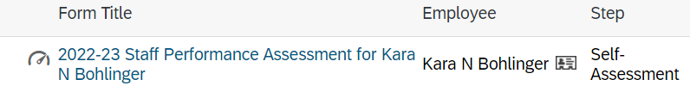  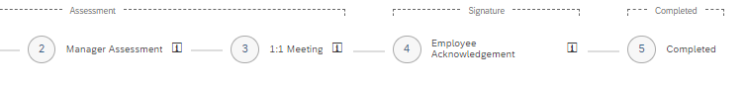
Enter Electronic Signature
- Review your manager’s goal/competency ratings and comments.  - Scroll down to the Signatures section.  - Add Employee Comments regarding the final assessment (optional).  - Click Sign and Acknowledge. | 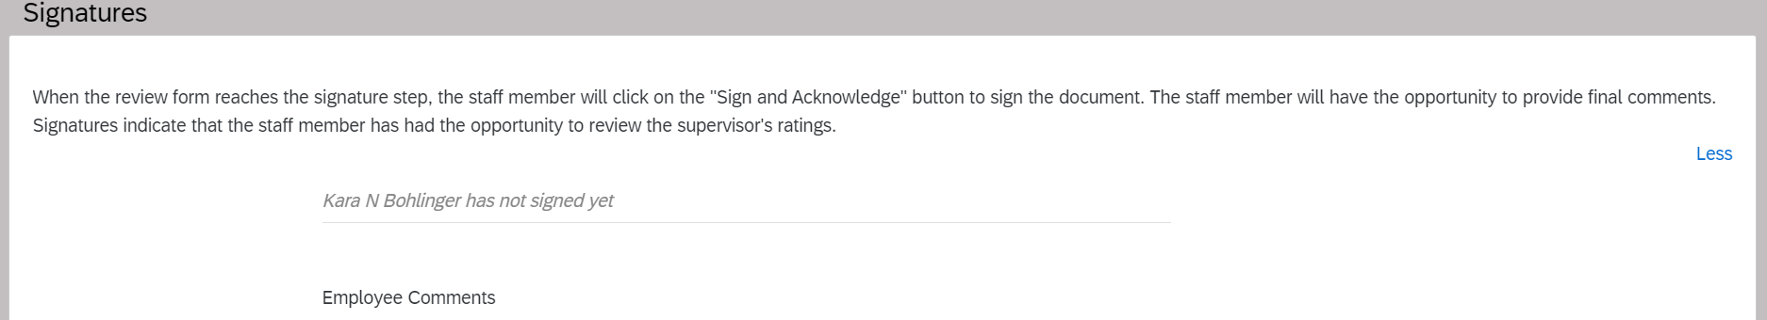
- Confirm by clicking Sign and Acknowledge a second time.

The annual performance assessment is complete.

The completed assessment is stored in the Completed folder in your Performance and 360 Forms Dashboard.

Miscellaneous Actions
You can access the completed performance assessment and print it out or save it as a PDF.  Click on Home Menu at top of screen and select Performance & 360s  The My Forms dashboard opens. Select the Completed folder and open your assessment.  In the upper right corner, click on:  Printer – print hard copy or save to PDF | 