Acce ss S uccess Factors
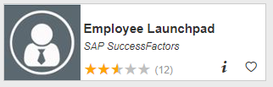
Visit OneCampus Portal (https://one.purdue.edu/) and select SuccessFactors (Employee Launchpad). Log in using your Purdue Username and Boiler Key.
Locate the Employee’s Performance Assessment
- Click on Home Menu at top of screen and select Performance & 360s  The My Forms dashboard opens and displays items in your In Progress Inbox | 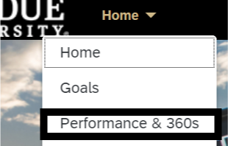
- Click on the employee’s 2022-2023 Performance Assessment | 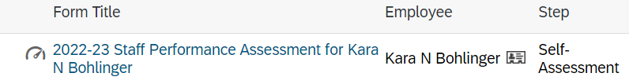
Review the First Three Sections of the Self-Assessment

Sections of the Performance Assessment
- The first couple sections of the assessment contain important information about the workflow, assessment resources and the employee:  Route Map -- The route map at the top shows the assessment’s current position in the workflow. (Manager Assessment)  Introduction – Brief statement about Performance Evaluations and links to the system wide Performance Management resources.  User Information – Employee details | 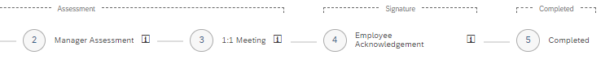  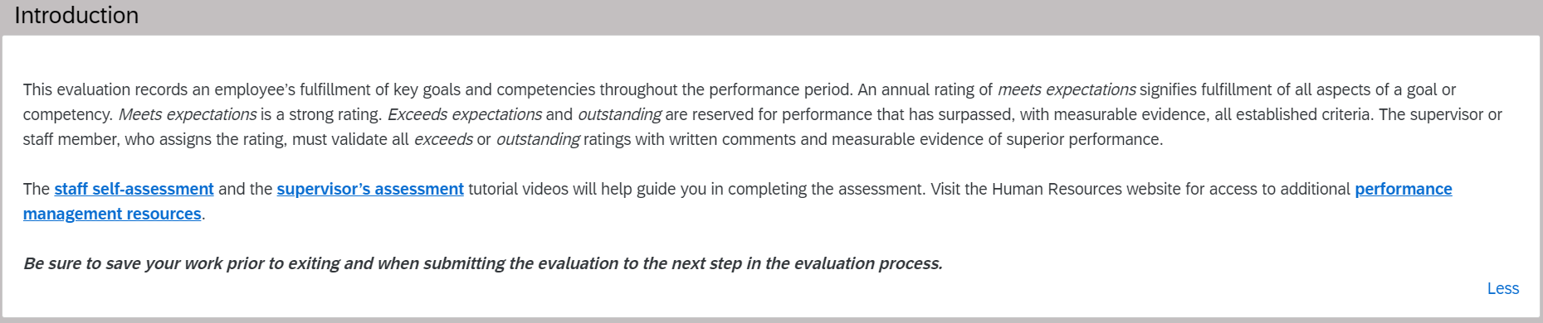  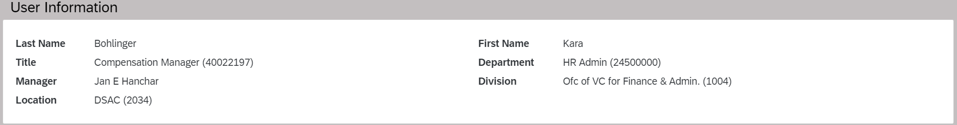
Evaluate Employee’s Goal Completion
- Scroll down to the Goals section and verify Goals weight (25%). If weight needs to be updated, Click Edit Section Weight. | 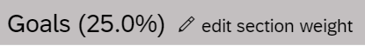
- Update goals and competencies weighting. (25% Goals and 75% Competencies)  - Click Save. | 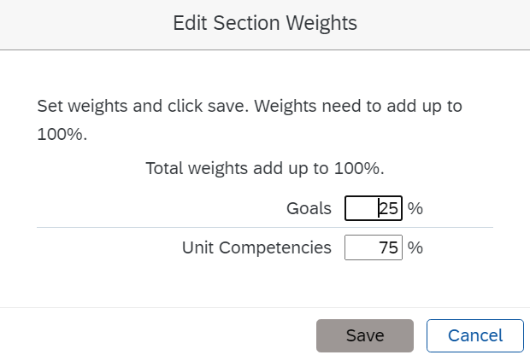
- Scroll to the first goal. If the employee has assessed the goal, the employee’s rating/comments appear to the right. | 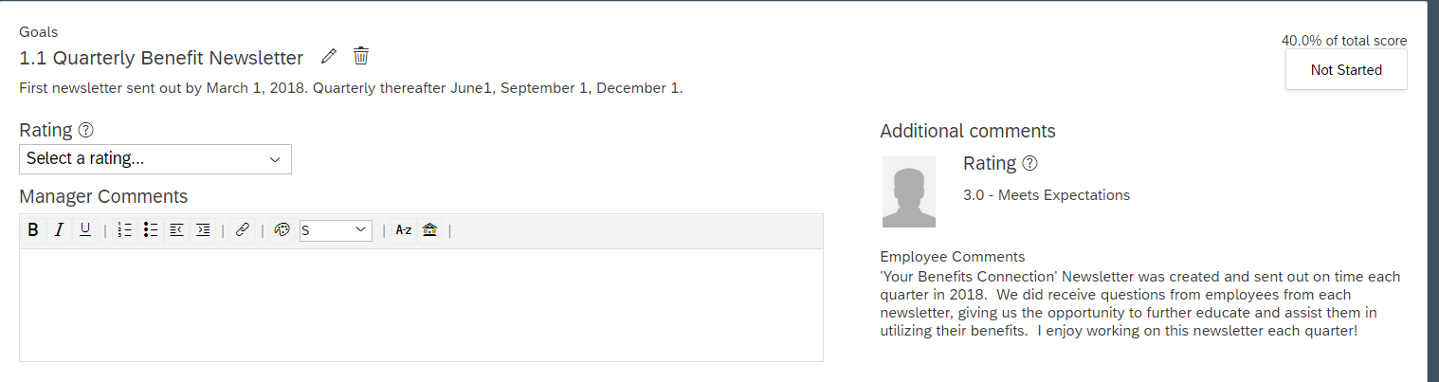
- Click the pencil to review and edit the goal, if necessary.  - Assign a Rating to the goal. Enter Manager Comments to support the rating. Repeat for each goal. | 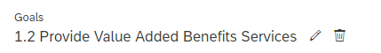
- Scroll down to the Overall Comments on Goal Achievement and enter Manager Comments. (optional) | 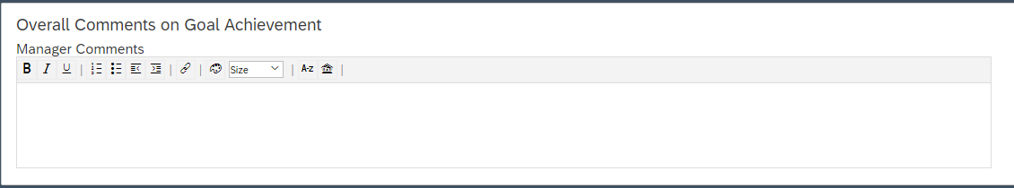
Evaluate Unit Competencies

- Scroll down to the Unit Competencies section. If weight needs to be updated, click Edit Section Weight and update.
- For each competency enter a Rating and Manager Comments. Click on the Writing Assistant for help with sample wording.  Click on the Writing Assistant for help with sample wording.  In the Writing Assistant, language is provided that aligns with three performance levels.  - Click a Performance Level  - Sample language appears in the Preview Quote Below section  - Click Place Quote and then click Close  Edit your Manager Comment for this Competency as appropriate.  Repeat above for each competency. | 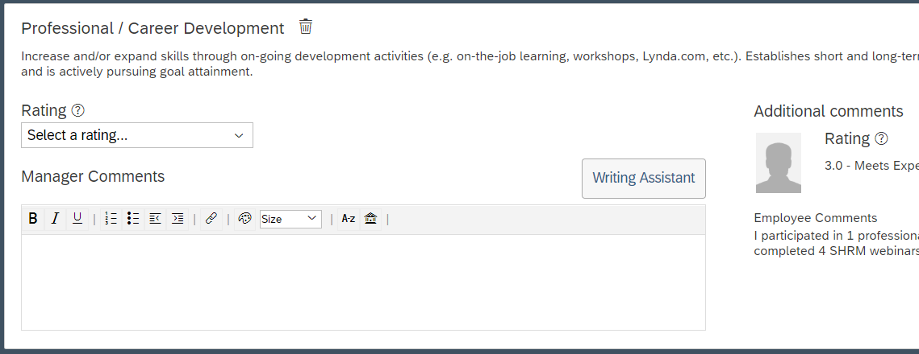  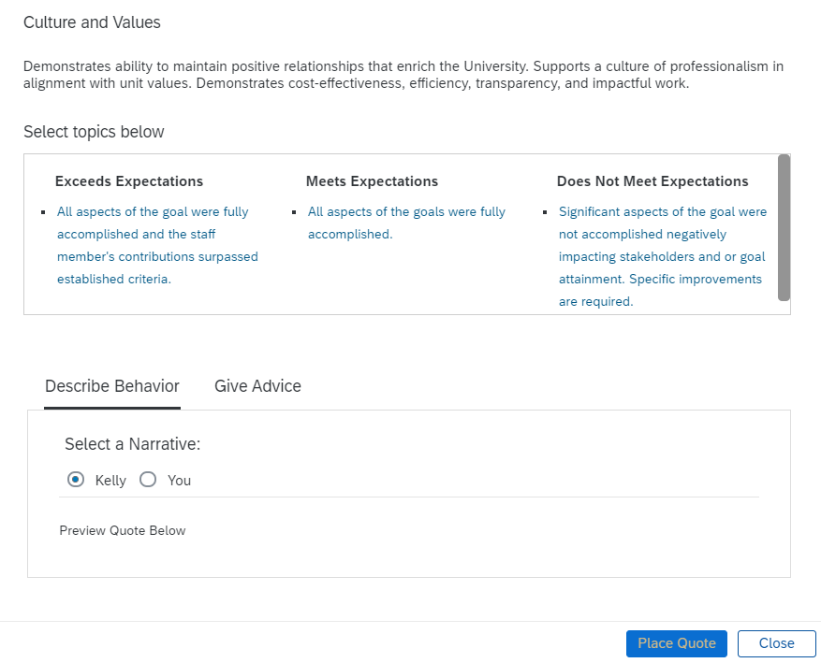
- Scroll down to the Overall Comments on Unit Competencies and enter Manager Comments. (optional)  Note: If you save your work periodically using the save icon at the top right of the page, the overall evaluation rating will update after each “save”. This field is located near the top left portion of the assessment | 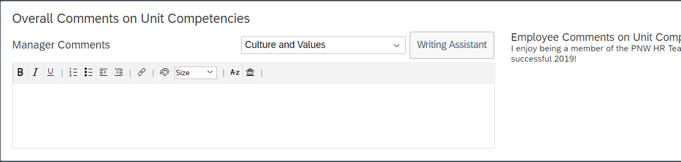  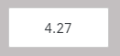
- Scroll down to the Summary. Review the final Rating for each goal and competency.  - Enter Overall Comments on Annual Performance Assessment in the Manager Comments field. (optional) | 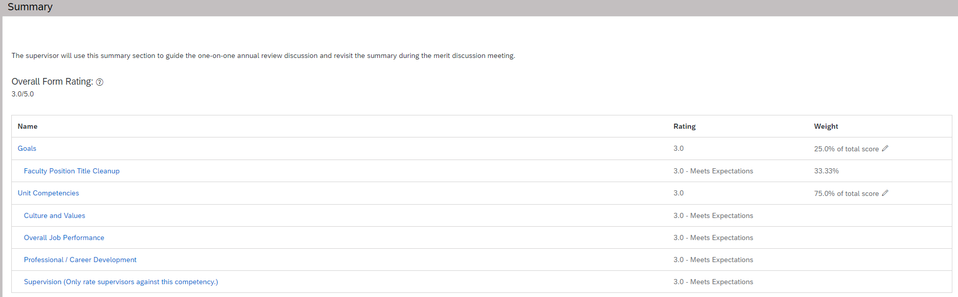  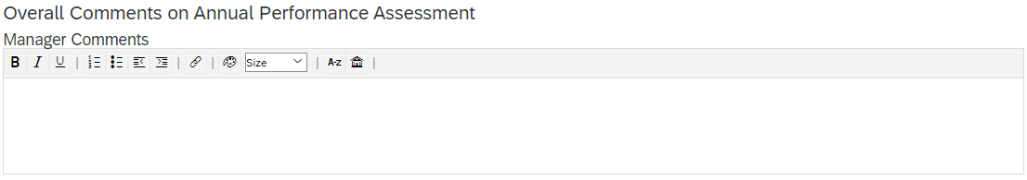
Save and Send to 1:1 Meeting
- If you wish, you may Save and Close and come back later.
- At any time, you can send back to the employee for additional edits. (employee does not see manager’s ratings or comments until after the 1:1 meeting phase)
- When your evaluation is complete, click Send to Next Step.

The assessment has now moved to the next step in the Workflow – 1:1 Meeting
Miscellaneous Actions
Click on Home Menu at top of screen and select Performance & 360s  The My Forms dashboard opens and displays items in your In Progress Inbox. Locate and open the assessment.  In the upper right corner, click on:  Actions – spell check or perform a legal scan  History – access prior years’ performance assessments  Printer – print hard copy or save to PDF  Save – save the assessment  Paperclip – attach supporting documents | 