Acce ss S uccess Factors
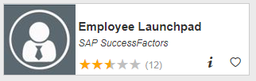
Visit OneCampus Portal (https://one.purdue.edu/) and select SuccessFactors (Employee Launchpad). Log in using your Purdue Username and Boiler Key.
Locate and Open Employee’s 2022-2023 Goal Plan
Click on Home Menu at top of screen and select Goals | 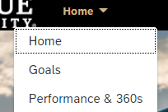
If you are a manager creating the goals -  Click on the arrow next to your name and then select your direct report. | 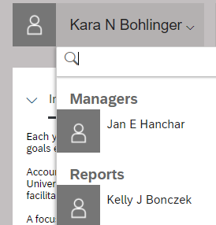
Add Goals to the Goal Plan
On the right hand side of the Goals Dashboard, Click Add Goal  You can add a Blank Goal and create the goal from scratch or you can add a Sample Goal and select from sample goals and metrics. | 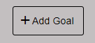  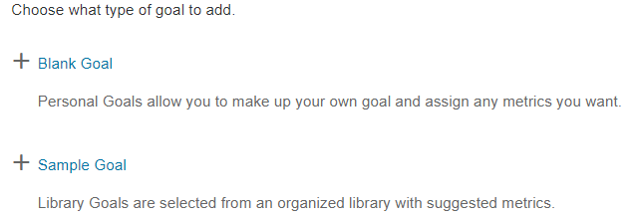
Sample Goal –  Sample Goal enables you to select from four categories of types of goals (Effectiveness/Efficiency, Professional Development, Quality and Quantity, and Time)  Enter a checkmark next to the type of goal you want and Click Add Selected.  Content populates into the Goal Name, Goal Description and Goal Metric. You can now edit the content to customize the goal.  Blank Goal –  The Blank Goal option does not populate any content – goal content is created from scratch. | 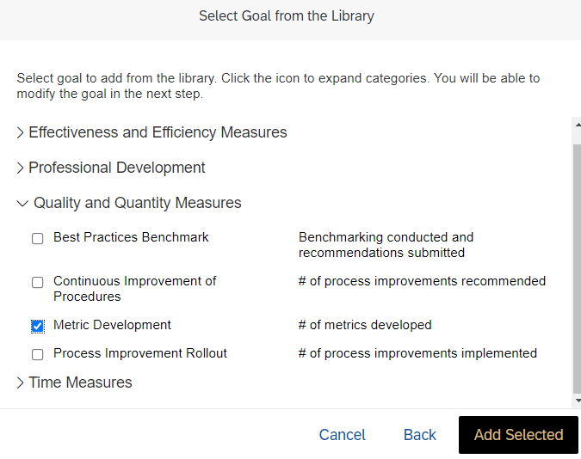  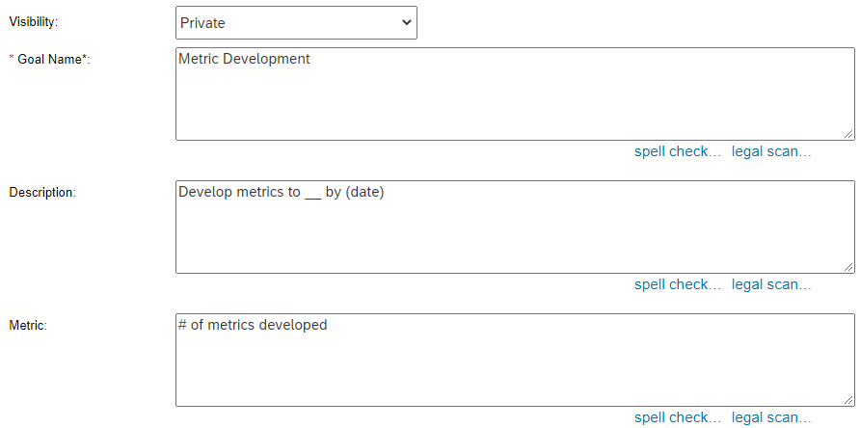
Add/Edit Goal Details  Set Visibility to Private.  Enter a brief Goal Name  Enter a Description of the goal.  Enter a Metric.  (A spell check and legal scan are available. The legal scan flags potentially problematic language.)  Enter Weight of this goal.  Enter the Start Date that work will begin on this goal.  Enter the Due Date for completing the goal.  Leave % Complete blank.  Select Status.  Click Save Changes. | 