To get started:
- From the Video Express Room, log into your account using your Purdue credentials.
- Access your content by pressing the My Content option. Find the video you recorded in the Video Express Room.
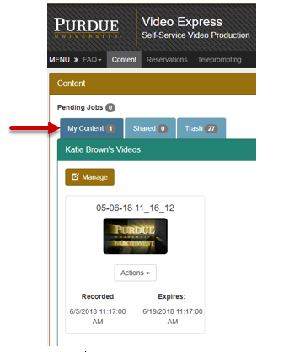
- Press the Actions option and select Upload to Kaltura.
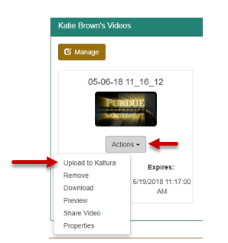
- Give a title for the video and be sure to leave the box checked for close captioning. Then press Submit.
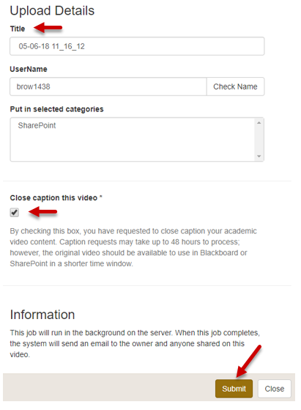
- You will receive an email from Kaltura when the video has finished captioning and is available for edits.
  - NOTE: Captions may take up to 48 hours depending on how busy the system is during the time of your submission.
- View your captioned media by logging into Kaltura, selecting Guest, and pressing Login.
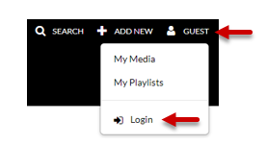
- Press My Media to view your Kaltura videos.
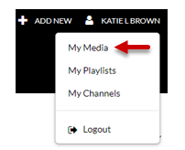
- Find the video for which you requested captions and press the title of the video in blue.
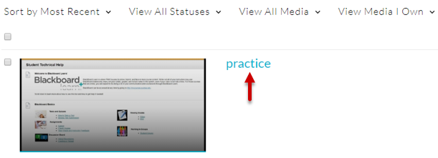
- Choose Actions in order to publish the video for others to see.
  - NOTE: Video settings:
    - Private: visible only to you
    - Unlisted: visible only to those with the link
    - Published: visible to anyone within the Purdue network
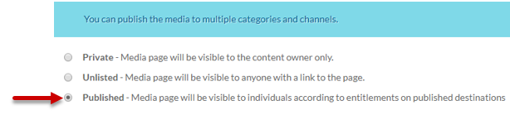

- Press Save.
- Press the CC icon and then Play in order to see the captions display for the video.

