Overview:
- Go to the course menu item where the media will be located (i.e. Learning Materials, etc.…)
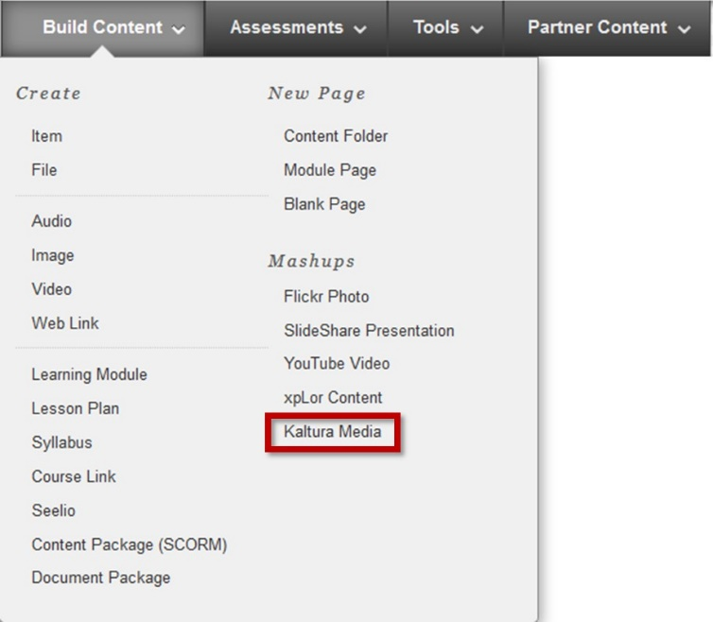

- Click Build Content and select Kaltura Media.
- There are two options to add Kaltura media to Blackboard:
  - You may either upload a video file directly from your computer to Kaltura through Blackboard.
  - You may also select a video that you have already uploaded into Kaltura to place in your Blackboard course.

Upload Directly from Computer
- To upload a video file from your computer: scroll over to the upper right hand part of the screen and select Add New > Media Upload > Choose a file to upload.
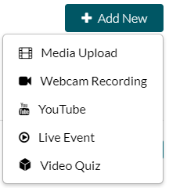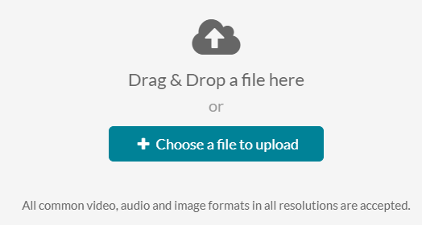
- Once your file is uploaded, click Save and Back when finished.
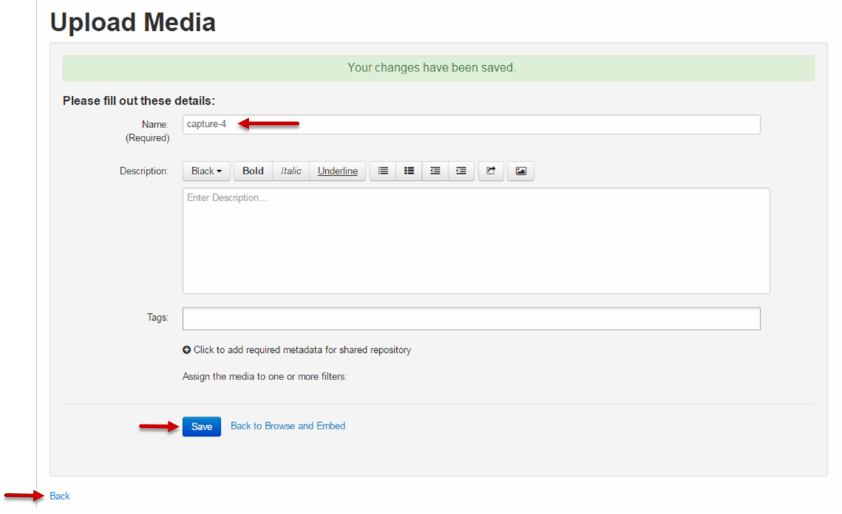
- The most recent video upload will be displayed at the top. If you see a picture of a camcorder, this means the video has not yet been uploaded into Kaltura.
  - Note: Uploading your media into Kaltura can take anywhere from 5 to 20 minutes, depending on the size of your file. You may need to exit this screen and repeat the above steps to complete the upload.
- Your video is ready when you see the play icon, click the blue Select button
- The title you input on this screen will be strictly for the benefit of the students. The description provides further details. Example: you might include where to find notes that go along with this video lecture.
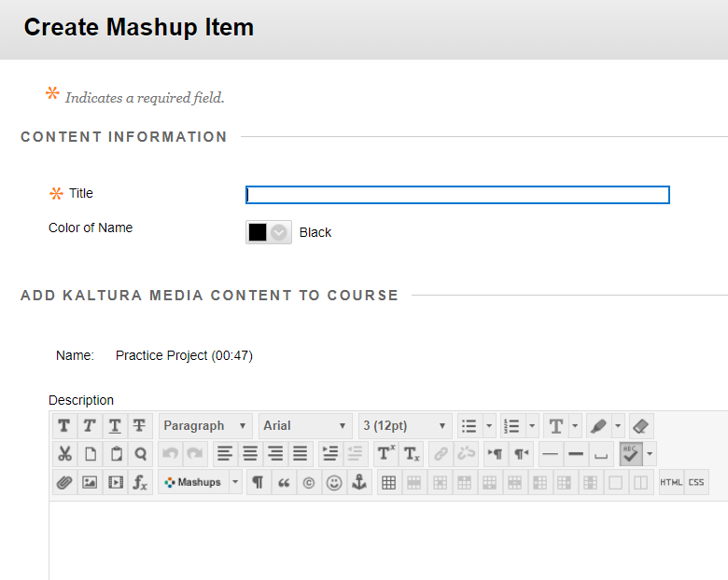

- Set date restrictions and view tracking, if desired. Press Submit when finished.
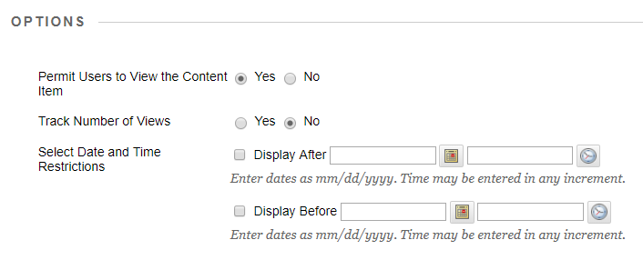

Select Video from Kaltura in Blackboard
- Select the video that you want to add from your Kaltura account.
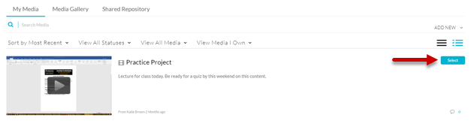
- The title you input on this screen will be strictly for the benefit of the students. The description provides further details. Example: you might include where to find notes that go along with this video lecture.
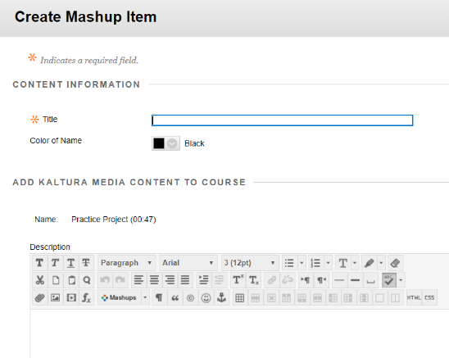
- Set date restrictions and view tracking, if desired. Press Submit when finished.

