Poster Setup
- Open PowerPoint and choose Blank Presentation or one of the templates below.
  - PowerPoint Template 1
  - PowerPoint Template 2

- Go to the Design tab in the toolbar. You can change the color scheme. Please note, we will not print posters that do not have a white background. Color accents, photos and charts are acceptable.

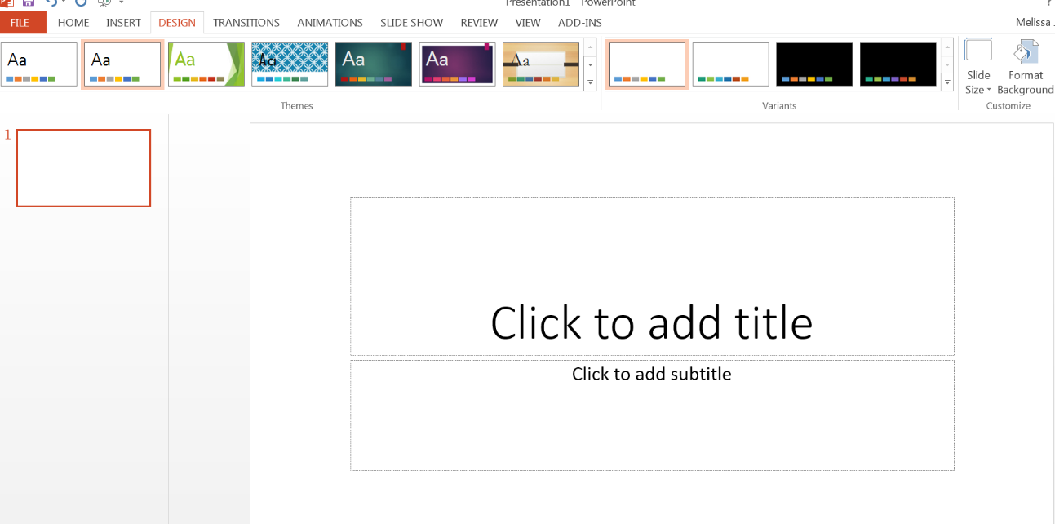

- Poster Dimensions & Setup
  - Your poster will be created as ONE slide in PowerPoint.
  - Under Slide Size, select Custom Slide Size.

  - Once in Slide Size, select the following options:
    - Slides sized for: Custom
    - Width: 48 in
    - Height: 36in
    - Orientation: Landscape
    - Click OK
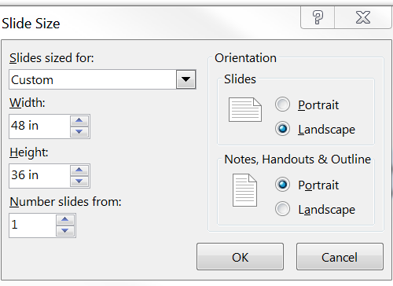
  - You will receive a message stating that you are scaling to a new slide size. Select Ensure Fit.

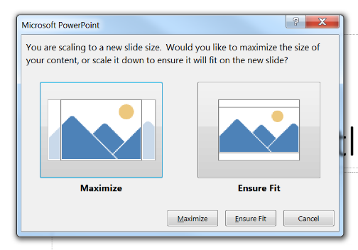

- You must complete the steps above before you create your poster. Your print quality will be grainy if you design your poster and then change the size.

Poster Design
- Proceed with designing your slide
  - Text Tips
    - Insert text with text boxes
    - Rule of thumb for Font sizes: Title 72-120; Subtitle 48-80; Section Headers 36-72; Body Text 24-48.
    - Sans-serif fonts are the best for posters, particularly for the title, subtitle, and headers.
    - If dividing in columns, arrange flow from top to bottom before moving to the next column.
  - Graphics
    - “A picture (or graph/table) can speak a thousand words.”
    - Use high quality images (.jpg, .gif). Note that scaling images will result in lower resolution.
  - Poster design resources:
    - Purdue Online Writing Lab: SURF Workshop Resources: Designing Scientific Research Posters
    - Poster Presentations: Design and Delivery (Joanne Lax, Graduate Technical Communications sand Professional Development Specialist) Purdue Graduate Engineering

Saving and Printing Poster
- Select File, Save As and Select PDF as the file type (please note, your file will not upload if it is not saved as a PDF).
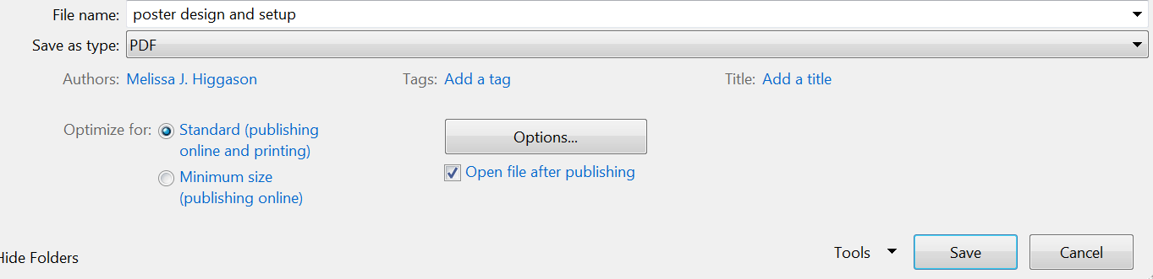
- Submit your poster HERE by no later than Friday, March 24, 2023 @ 11:59pm to have it printed free of charge by the Student Research Office. Please upload only final, proofed versions. We will only print one poster per student or registered team.
- You will be notified when your poster is ready for pickup. Please select the pickup location when you submit your poster.

