Step by Step Guide

- To log in to Blackboard, access mycourses.purdue.edu and click on Purdue Account Login.
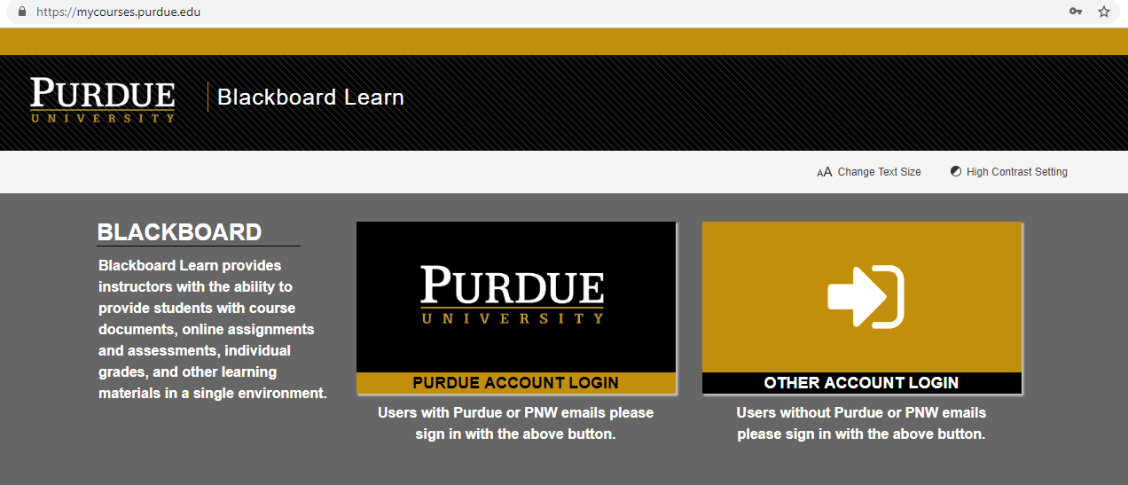

- Insert your username and your password using BoilerKey.
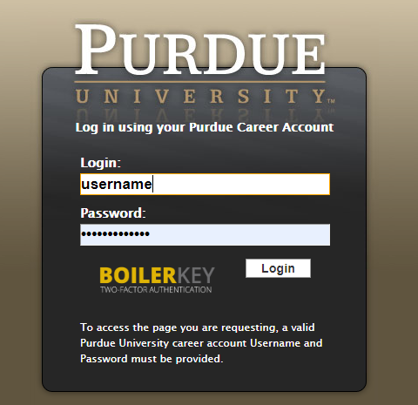

- You are able to find your course in My courses. Click on the course.
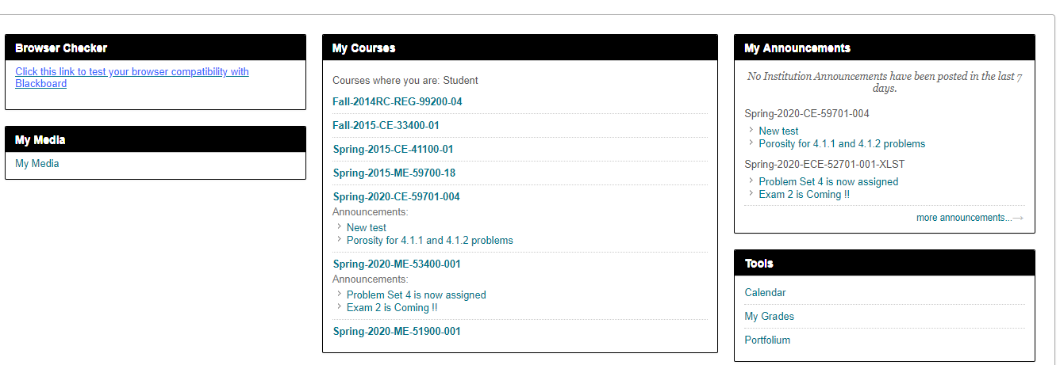

- On the left of the page, you are able to find the announcements, syllabus, learning materials, lectures, homeworks, quizzes, powerpoint slides, discussion board, grades, groups and email.

Helpful links to Blackboard
- Submit an assignment
- Discussions
- Take a test or survey
- Check your Grades
- Contact your instructor
- Blackboard Website for Students
- Video

