Step by Step Guide

- To log in to Brightspace, access purdue.brigthspace.com and click on Purdue University Northwest.

- Insert your username and your password using BoilerKey.
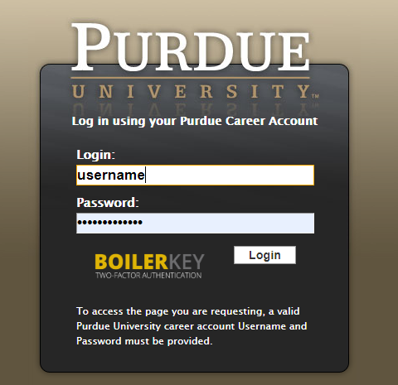

- You are able to find your course in My courses. Click on the course.
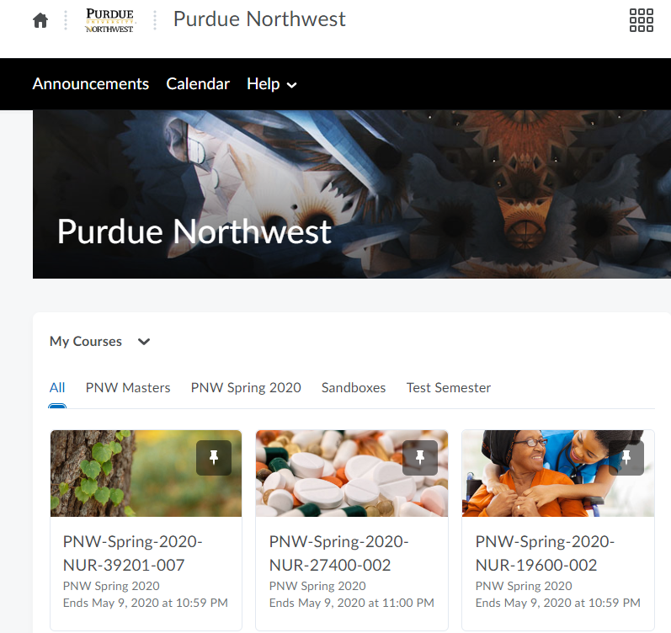

- The navbar provides links to course-specific tools.
- Content displays everything on the course. You are able to find Syllabus, Assignments, Course Schedule and Lectures.
- Classlist you can send email or instant messages
- Grades allows you to check your grades
- Class Progress is a progress summary
- Course tools direct to more functions: assignments, discussions, quizzes, surveys, virtual classroom and kaltura media

Helpful links to Brightspace
- Submit an assignment
- Discussions
- Take a quiz
- Check your Grades
- Contact your instructor
- Brightspace Website for Learners

