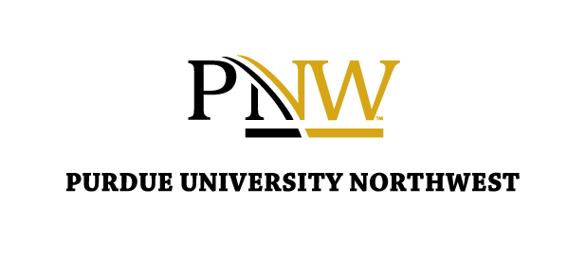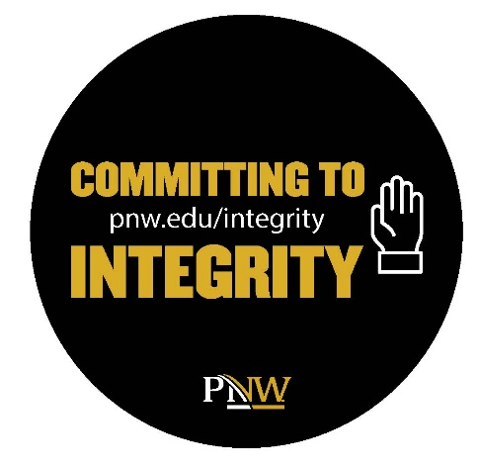

Choose Integrity: Building Trust, Confidence & Character and Earning a Degree You Can Be Proud Of

What Is Academic Integrity?
At Purdue University Northwest, academic integrity means being honest, responsible, and fair in your academic work. It’s about showing what you know and can do — not taking shortcuts or misrepresenting someone else’s work as your own.

Here’s what integrity looks like day-to-day:
- Completing your own assignments and exams
- Giving credit when you use someone else’s words or ideas
- Collaborating only when your instructor allows it
- Asking questions when you’re unsure what’s allowed
- Owning your mistakes and learning from them

What Counts as Cheating?
- Copying from another student’s test or homework
- Using unauthorized notes, websites, or AI tools
- Submitting work you didn’t complete yourself
- Plagiarizing (using someone else’s words or ideas without credit)
- Helping others cheat or sharing answers
- Falsifying lab data or research
If you’re unsure — always ask your instructor before submitting work.

Why Integrity Matters
Integrity is the foundation of your education and your reputation. When you choose integrity, you:
- Develop confidence in your own abilities
- Strengthen your professional credibility
- Contribute to a fair and respectful learning community
- Earn a degree that truly reflects your hard work

Remember: Integrity is a habit — start now, carry it forward.

Need Support or Have Questions?
If you’re unsure about what’s okay, talk with:
- Your instructor
- The Dean of Students Office
- Your First-Year Experience instructor or advisor

Learn more about academic integrity at: pnw.edu/integrity
Choose Integrity. Own Your Work. Earn Your Degree with Pride.

