INSTRUCTIONAL MATERIALS ACCESS (IMA) PROGRAM
Purdue University Northwest | Student Quick-Reference Guide

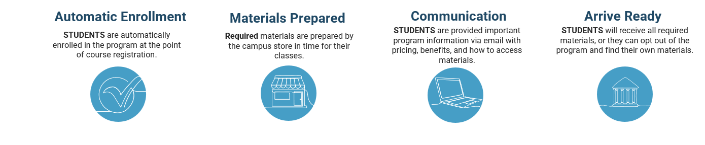

ACCESSING YOUR MATERIALS
Effective Summer 2026, students will see this view when logging into the Instructional Materials Access link — a complete list of course materials for the current term, with direct launch into Kortext.  In your Brightspace homepage, select Instructional Materials Access.  - All of your courses and materials will be displayed.  - Ensure the correct term is selected on the dropdown.  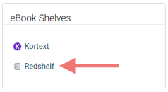 | 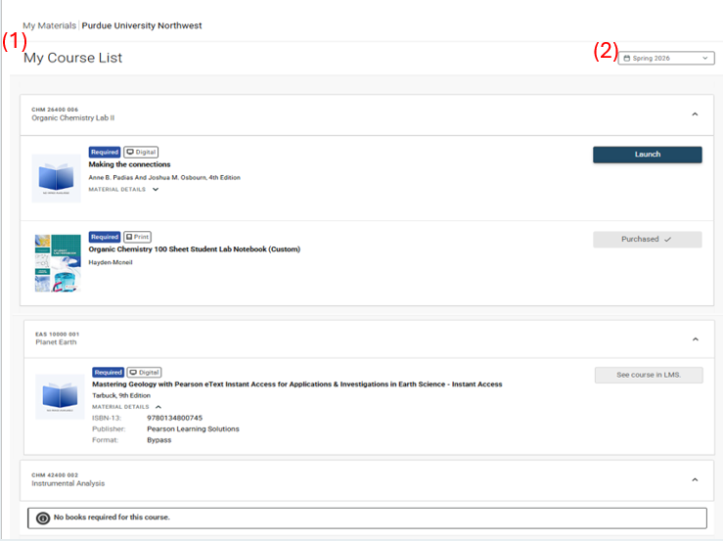  My Course List — Instructional Materials Access
  Need a previously provided RedShelf e-book? No problem — click the RedShelf link under eBook Shelves to access your existing library.

WHAT DO THE COURSE MATERIAL STATUSES MEAN?
LAUNCH: Click to go directly to your digital material. Beginning Summer 2026, Kortext is the new e-reader provider. | SEE COURSE IN LMS: Your instructor sets up materials directly in Brightspace (e.g., McGraw-Hill Connect, Cengage Mindtap). Sign in and click the publisher link to register — first-time users must accept the terms and privacy policy.
PURCHASED: Physical material for pickup at the Bookstore. You will receive a Ready for Pickup email from customerservice@efollett.com.  Westville campus: pick up at Welcome Center (DSAC 1114). | NO BOOKS REQUIRED: Your instructor has not requested material from the Bookstore for this course.

ADDITIONAL NOTES
- Supplies are NOT included in the IMA program (e.g., goggles).
- If you do not wish to participate, visit https://accessportal.follett.com/0154 by the posted deadline to opt out. If you opt out by mistake and wish to opt back in, contact Student Accounts for further assistance.

